DAVID ARNOLD

daverno@au1.ibm.com

Abstract

Instructions to show how to build, run and test custom images/containers for IBM Cloud Pak for Integration components using RHOS core services for build and deploy.  
  
Instruction and an example Tekton pipeline is also included explored on RHOS

IBM Middleware custom Image Builds  
ACE and MQ

Exploring how integration developers can leverage RHOS based tooling for building, deploying and testing custom images on RHOS 4.n (with or without ICP4i) orusing Codeready

Contents

Building and running MQ custom image on RHOS 4.n instance 8

RHOS instance used in this example 8

Credentials and logins you will need for your cluster 8

Instructions to build MQ custom images on RHOS instance 8

C:\openshift>oc login --token=GSTHvr3N9uq08Y9itBtqxktdiB8ZXEvFrnRJ1kVuO30 --server=https://api.cluster-4bfc.4bfc.sandbox890.opentlc.com:6443 8

C:\openshift>oc projects 9

C:\openshift>oc project da-mq 9

YAML for create of input image stream 9

C:\openshift>oc create -f c:\openshift\data\build-mq-custom.yaml 9

Observe the “input” imagestream 10

C:\openshift>oc adm policy add-scc-to-user anyuid -z default 10

C:\openshift>oc new-build https://github.com/DAVEXACOM/ibm-mqadvanced-server-tls-build.git 10

Observe the Build config that is created 11

Observe the build log 11

Observe the “output” image stream 12

Creating a “New App” – running up a container From the custom image 12

C:\openshift>oc new-app ibm-mqadvanced-server-tls-build --env LICENSE=accept 12

C:\openshift>oc status 13

Testing the custom MQ image 13

C:\openshift>oc expose svc/ibm-mqadvanced-server-tls-build 13

C:\openshift>oc get routes 13

Connecting to MQ queue manager 13

If OCP 4.1 is like 4.2 we need to modify the route for MQ TLS traffic 13

C:\openshift\oc get routes 13

Create route for TLS 14

C:\openshift>oc get routes 15

Get the Queue Manager name 16

An MQSC file to create CLNTCONN in CCDT 16

runmqsc -n < CUSTOMIMAGE.mqsc 17

type c:\programdata\ibm\mq\AMQCLCHL.TAB 17

set MQSSLKEYR=C:\Program Files\IBM\MQ\arnold 17

runmqsc -c ibmmqadvancedservertlsbuild1mn26b 17

Build and running MQ custom images on CodeReady on a laptop 19

Setup for codeready on windows 19

Create directory for codeready 19

Set the path to new directory 19

Create Hyper-V virtual network switch 19

Download and install code ready 20

Extract to c:\codeready 20

Install code ready 20

Start code ready 21

Using code ready 22

Logging into codeready 22

access the OpenShift cluster via the oc command 25

crc oc-env to set up the command line path 25

Build, run and test IBM Middleware on code ready 26

C:\codeready>oc projects 26

C:\codeready>oc project da-mq2 26

YAML for create of input image stream 27

C:\codeready>oc create -f c:\openshift\data\build-mq-custom.yaml 27

Observe the “input” imagestream 28

C:\codeready>oc adm policy add-scc-to-user anyuid -z default 29

C:\codeready>oc adm policy add-scc-to-user anyuid -z default 29

C:\codeready>oc new-build https://github.com/DAVEXACOM/ibm-mqadvanced-server-tls-build.git 30

Observe build in the Web console 30

Observe the Build config that is created 31

Observe the build log 31

Observe the “output” image stream 32

Creating a “New App” – running up a container From the custom image 32

C:\openshift>oc new-app ibm-mqadvanced-server-tls-build --env LICENSE=accept 32

C:\openshift>oc status 33

Testing the custom image 33

C:\openshift>oc expose svc/ibm-mqadvanced-server-tls-build 33

C:\openshift>oc get routes 33

Connecting to MQ queue manager 34

OCP 4.1 is like 4.2 so we need to modify the route for MQ TLS traffic 34

C:\openshift\oc get routes 34

Create route for TLS 34

C:\openshift>oc get routes 36

Get the Queue Manager name 37

An MQSC file to create CLNTCONN in CCDT 37

runmqsc -n < CUSTOMIMAGE.mqsc 38

type c:\programdata\ibm\mq\AMQCLCHL.TAB 38

set MQSSLKEYR=C:\Program Files\IBM\MQ\arnold 38

runmqsc -c ibmmqadvancedservertlsbuild1mn26b 38

Stopping codeready (virtual machine) 39

Building and running MQ and ACE Custom images on RHOS (ICP4i) 40

Build and run MQ custom from certified base image on RHOS 40

oc login --token=WM4a6Lj9Vj67U626gJ8Z897Cijr-OnjG-KcVxPhPk1Q --server=https://api.cloudpak.ocp4.cloudnativekube.com:6443 40

oc project da-build-project 40

oc create -f c:\openshift\data\build-mq-custom.yaml 40

oc adm policy add-scc-to-user anyuid -z default 40

oc new-build https://github.com/DAVEXACOM/ibm-mqadvanced-server-tls-build.git 40

oc new-app ibm-mqadvanced-server-tls-build --env LICENSE=accept 40

oc expose svc/ibm-mqadvanced-server-tls-build 40

oc status 40

oc create -f c:\openshift\data\create-mq-route.yaml 40

oc get routes 41

CLNTCONN Channel definition 41

runmqsc -n < CUSTOMIMAGE.mqsc 42

Observe the AMQCLCHL.TAB 42

set MQSSLKEYR=C:\Program Files\IBM\MQ\arnold 42

runmqsc -c ibmmqadvancedservertlsbuild147zgm 42

Adding a webhook for the MQ custom image build 42

Push MQSC file change to Github 43

Observer triggered build in RHOS 44

Observer Pod has updated based on the new build 45

Test the new MQ deployment for new queues 45

Obtain the queue manager name in latest build 45

Open command prompt as administrator 46

CLNTCONN Channel definition 46

Check the AMQCLCHL.TAB 46

Build and Run ACE Microservice 1 from SoE on RHOS 48

Creds for ICP4i 48

Github/dockerhub 48

Code for ACE Microservice1 48

Code for ACE Liveliness probe 48

Building the ACE MS1 image 48

Observe the image stream 49

Observe the build 49

Testing the running application 51

Changing the route 7600 to 7800 for target port 52

Test the deployed Liveliness probe service 52

Alternative – using oc create to create the route instead of expose 53

Test the liveliness probe service again 54

Create a webhook to trigger builds 54

Create webhook in github 55

Push a README.MD update to Test trigger fires 56

Build and run ACE Microservice 2 from ACE SoE on RHOS 57

Creds for ICP4i 57

Github/dockerhub 57

Code for ACE Microservice2 57

Code for ACE Liveliness probe 57

Deploying ACE microservice to RHOS 57

Review image streams 58

Review builds 59

Review service 59

Review deployment config 59

Test the ACE microservices on RHOS 62

Test the liveliness probe in the MS2 container 62

Test microservice 2 in the MS2 container 63

http://ibm-ace-mqc-soe-ms2-build-da-build-project.apps.cloudpak.ocp4.cloudnativekube.com/microservice2/v1/message 63

Create the webhook trigger in Github 63

Get Webhook details from the build config 64

Create webhook in github 64

Update Microservice2 and trigger a new build 65

Git client rescan – pick up the change 67

Push to github 68

Observe webhook fire in github 68

Observe new build in RHOS 69

Retest the ACE MS2 service 70

New Version of Container via Deployment Configuration – Rolling trigger on image change 71

Test the rest service 71

Connecting ACE MS1 to ACE MS2 in the RHOS cluster 72

Cluster IPs for ACE microservices 73

K8s DNS names for ACE microservices 73

Public IP for ACE microservice 1 – rest requesst 73

Calling ms2 from ms1 73

Test ACE MS2 calling ACE MS2 75

http://ibm-ace-mqc-soe-ms1-build-da-build-project.apps.cloudpak.ocp4.cloudnativekube.com/microservice1/v1/message 75

{"Messages":["Hello From Test Client"]} 75

ACE MS 3 – REST Service exposing off RHOS cluster MQ QMGR 77

ACE Microservice 3 Project and Code 77

ACE Microservice 3 GitHub repos 77

ACE Microservice 3 RHOS set up 78

IBM MQ Queue Manager 81

Channel creation for Linux based queue manager 82

Channel creation for windows based queue manager 82

IBM Secure Gateway Service – IBM Cloud 83

IBM Secure Gateway Service – Client (Laptop end) 84

Windows firewall 85

Testing MQ via IBM Public IP – using RFHUTILC 85

Testing ACE Microservice 3 to Put to MQ via IBM Public IP 87

Route for ACE MS3 87

URL for ACE MS3 service 87

Data to test ACE MS3 service 87

Test with REST Client 88

Test Results 89

OpenShift Pipelines - Tekton 90

Catalog 90

Pipeline operator 90

Tekton ACE Example 91

Example Environment 91

RHOS console 91

https://console-openshift-console.apps.cloudpak.ocp4.cloudnativekube.com/dashboards 91

Tekton dashboard 91

GIT Repos for Tekton ACE Artifacts 91

GIT Repos for ACE microservice (ACE MS2) to be tested 91

Tekton YAML files to be used 92

Resources 92

Tasks 92

Pipeline 92

PipelineRun 92

Deployment Config YAML for the ACE MS2 service 92

Commands to create/replace(update)/delete artifacts in Tekton on RHOS 93

Creating the Service and Routes 93

tt ace ms2 service 93

Tekton tt ACE ms2 route 94

Exploring the RHOS Tekton environment 94

Tekton dashboard -resources 94

Tekton dashboard -tasks 95

Tekton dashboard -pipeline 95

Tekton dashboard -pipeline-run 96

Exploring the RHOS Console 97

Service 97

Route 97

Image Stream 98

Deployment - Config PipelineRun Created 98

Pod - PipelineRun Created 99

Testing Tekton created and deployed ACE Micro Service 2 99

Appendix A - Building and running MQ custom images on CodeReady on baremetal 101

Install Git, libvirt and network-manager 102

YAML for base image Image Stream creation 108

Set up resolv.conf, hosts and dasmasq to allow networking 110

Create Image Stream for MQ base image 111

Create new build to build custom MQ image from base image 112

Create new app to run the custom MQ image as a container 113

Logging in CodeReady on BareMetal in a new session 116

# Building and running MQ custom image on RHOS 4.n instance

## RHOS instance used in this example

OpenShift 4.1 cluster, 1 master + 2 nodes running in AWS Sydney with root access.

## Credentials and logins you will need for your cluster

Openshift Master Console: [http://console-openshift-console.apps.cluster-4bfc.4bfc.sandbox890.opentlc.com](https://urldefense.proofpoint.com/v2/url?u=http-3A__console-2Dopenshift-2Dconsole.apps.cluster-2D4bfc.4bfc.sandbox890.opentlc.com_&d=DwMFaQ&c=jf_iaSHvJObTbx-siA1ZOg&r=X5y_z5011GMCzINf2gZrepZyuCHEmJ9mSODdoqZBqTM&m=55KHFirHTzKJFrw2K15kFllscVOyNzhqwuInW28qYt4&s=ea9RIC4oPZjE0ojYKwQw0__c1oU3nfdxjymmYY0xQPc&e=)

Openshift API for command line 'oc' client: [https://api.cluster-4bfc.4bfc.sandbox890.opentlc.com:6443](https://urldefense.proofpoint.com/v2/url?u=https-3A__api.cluster-2D4bfc.4bfc.sandbox890.opentlc.com-3A6443_&d=DwMFaQ&c=jf_iaSHvJObTbx-siA1ZOg&r=X5y_z5011GMCzINf2gZrepZyuCHEmJ9mSODdoqZBqTM&m=55KHFirHTzKJFrw2K15kFllscVOyNzhqwuInW28qYt4&s=lMzJ7lCID5pKoNg9rp6ass70V1xQnqr4FF-T4gtT_o0&e=)

Download oc client from [https://mirror.openshift.com/pub/openshift-v4/clients/ocp/4.1.20/openshift-client-linux-4.1.20.tar.gz](https://urldefense.proofpoint.com/v2/url?u=https-3A__mirror.openshift.com_pub_openshift-2Dv4_clients_ocp_4.1.20_openshift-2Dclient-2Dlinux-2D4.1.20.tar.gz&d=DwMFaQ&c=jf_iaSHvJObTbx-siA1ZOg&r=X5y_z5011GMCzINf2gZrepZyuCHEmJ9mSODdoqZBqTM&m=55KHFirHTzKJFrw2K15kFllscVOyNzhqwuInW28qYt4&s=btB1bQrJImSMxEHFw2uxQkvUxYALMQ-MqhuSL17NIBM&e=)

This cluster has authentication enabled. You can use 'admin' with password 'r3dh4t1!' to access your cluster

## Instructions to build MQ custom images on RHOS instance

### C:\openshift>oc login --token=GSTHvr3N9uq08Y9itBtqxktdiB8ZXEvFrnRJ1kVuO30 --server=https://api.cluster-4bfc.4bfc.sandbox890.opentlc.com:6443

The server uses a certificate signed by an unknown authority.

You can bypass the certificate check, but any data you send to the server could be intercepted by others.

Use insecure connections? (y/n): y

Logged into "https://api.cluster-4bfc.4bfc.sandbox890.opentlc.com:6443" as "admin" using the token provided.

You have access to the following projects and can switch between them with 'oc project <projectname>':

default

kube-public

kube-system

* openshift

Using project "openshift".

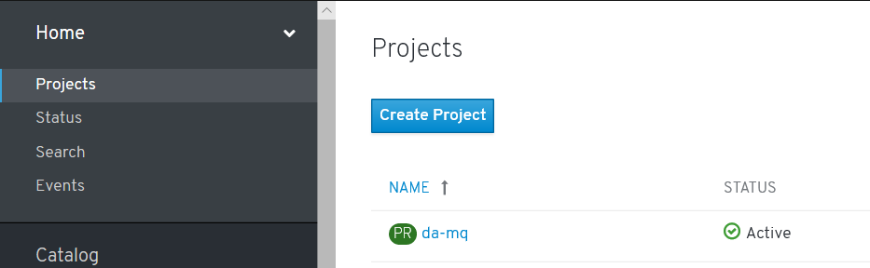

### C:\openshift>oc projects

You have access to the following projects and can switch between them with 'oc project <projectname>':

da-mq - Dave Arnold MQ

default

kube-public

kube-system

* openshift

etc

Using project "openshift" on server "https://api.cluster-4bfc.4bfc.sandbox890.opentlc.com:6443".

### C:\openshift>oc project da-mq

Now using project "da-mq" on server "https://api.cluster-4bfc.4bfc.sandbox890.opentlc.com:6443".

### YAML for create of input image stream

apiVersion: v1

kind: ImageStream

metadata:

name: ibm-mqadvanced-server-integration

spec:

tags:

- name: "9.1.3.0-r4-amd64"

from:

kind: DockerImage

name: davexacom/ibm-mqadvanced-server-integration:9.1.3.0-r4-amd64

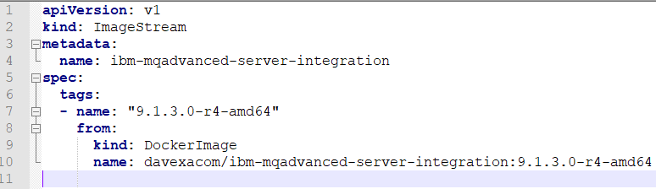

### C:\openshift>oc create -f c:\openshift\data\build-mq-custom.yaml

imagestream.image.openshift.io/ibm-mqadvanced-server-integration created

### Observe the “input” imagestream

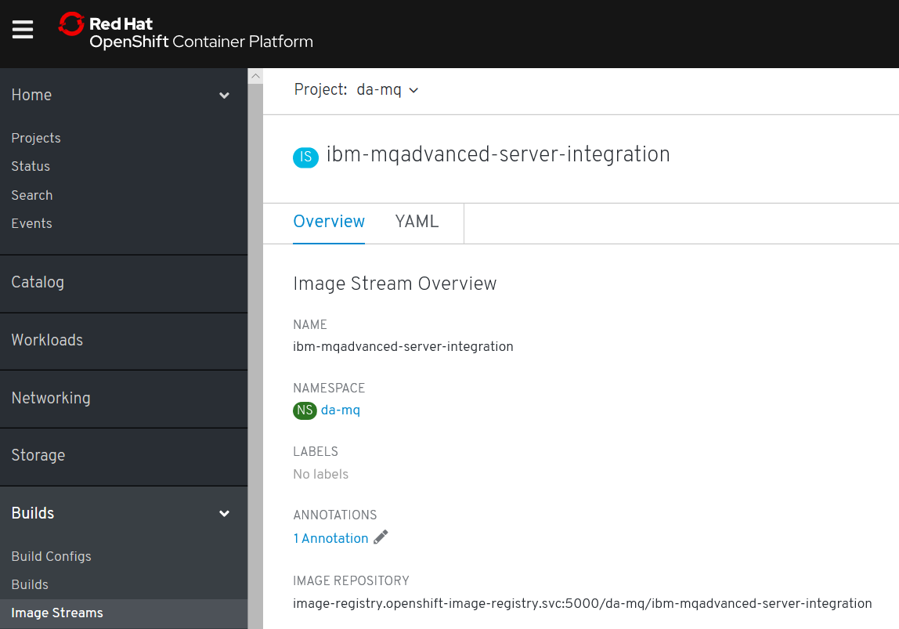

### C:\openshift>oc adm policy add-scc-to-user anyuid -z default

scc "anyuid" added to: ["system:serviceaccount:da-mq:default"]

[note: above allows the MQ container to run as root]

### C:\openshift>oc new-build https://github.com/DAVEXACOM/ibm-mqadvanced-server-tls-build.git

--> Found image ee41039 (3 months old) in image stream "da-mq/ibm-mqadvanced-server-integration" under tag "9.1.3.0-r4-amd64" for "ibm-mqadvanced-server-integration:9.1.3.0-r4-amd64"

IBM MQ Advanced Server

----------------------

Simplify, accelerate and facilitate the reliable exchange of data with a security-rich messaging solution — trusted by the world’s most successful enterprises

Tags: mq messaging

* A Docker build using source code from https://github.com/DAVEXACOM/ibm-mqadvanced-server-tls-build.git will be created

* The resulting image will be pushed to image stream tag "ibm-mqadvanced-server-tls-build:latest"

* Use 'start-build' to trigger a new build

--> Creating resources with label build=ibm-mqadvanced-server-tls-build ...

imagestream.image.openshift.io "ibm-mqadvanced-server-tls-build" created

buildconfig.build.openshift.io "ibm-mqadvanced-server-tls-build" created

--> Success

### Observe the Build config that is created

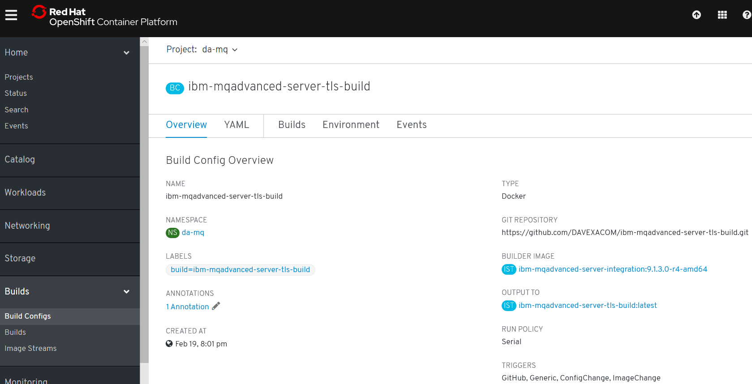

### Observe the build log

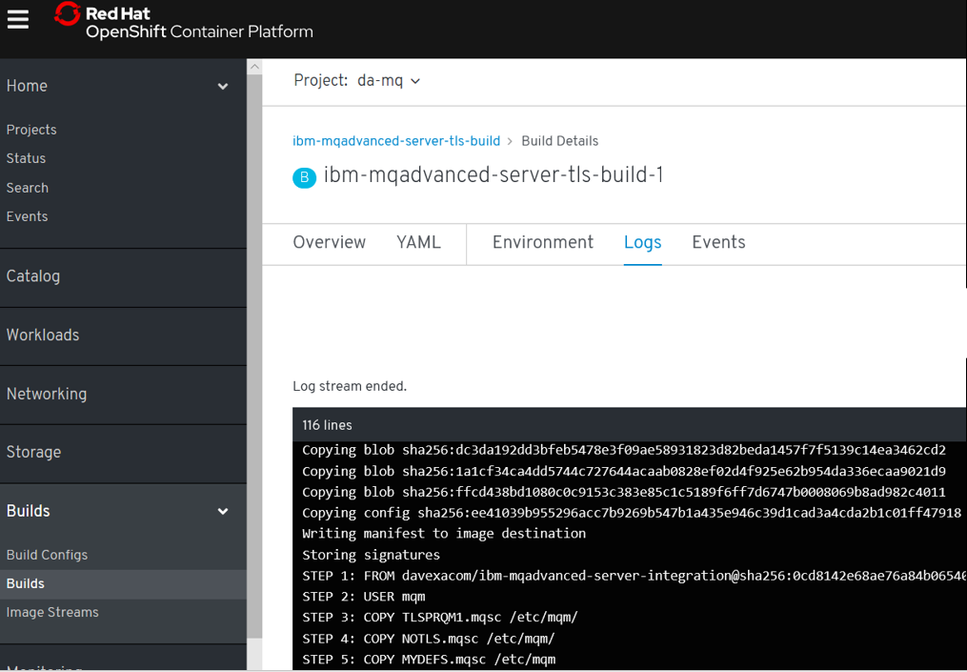

### Observe the “output” image stream

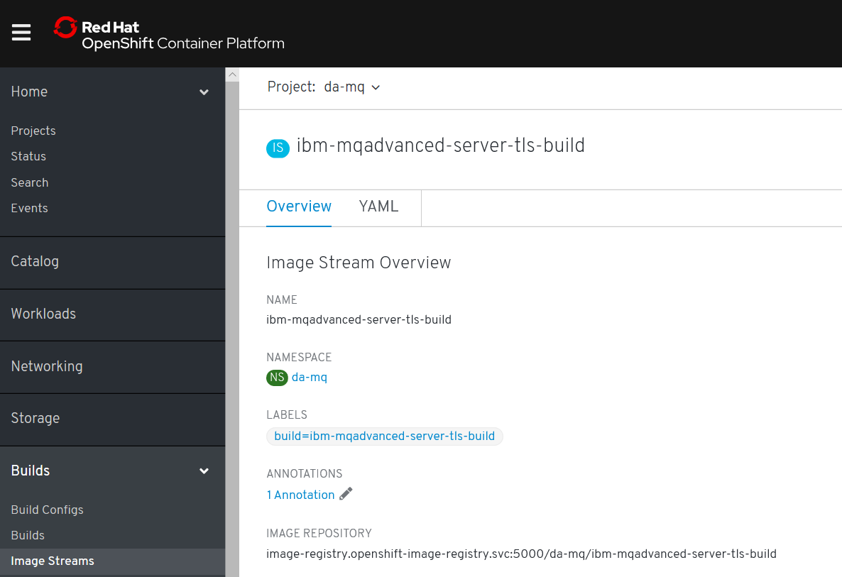

## Creating a “New App” – running up a container From the custom image

### C:\openshift>oc new-app ibm-mqadvanced-server-tls-build --env LICENSE=accept

--> Found image 2306b71 (3 minutes old) in image stream "da-mq/ibm-mqadvanced-server-tls-build" under tag "latest" for "ibm-mqadvanced-server-tls-build"

IBM MQ Advanced Server

----------------------

Simplify, accelerate and facilitate the reliable exchange of data with a security-rich messaging solution — trusted by the world’s most successful enterprises

Tags: mq messaging

* This image will be deployed in deployment config "ibm-mqadvanced-server-tls-build"

* Ports 1414/tcp, 9157/tcp, 9443/tcp will be load balanced by service "ibm-mqadvanced-server-tls-build"

* Other containers can access this service through the hostname "ibm-mqadvanced-server-tls-build"

--> Creating resources ...

deploymentconfig.apps.openshift.io "ibm-mqadvanced-server-tls-build" created

service "ibm-mqadvanced-server-tls-build" created

--> Success

Application is not exposed. You can expose services to the outside world by executing one or more of the commands below:

'oc expose svc/ibm-mqadvanced-server-tls-build'

Run 'oc status' to view your app.

### C:\openshift>oc status

In project Dave Arnold MQ (da-mq) on server https://api.cluster-4bfc.4bfc.sandbox890.opentlc.com:6443

svc/ibm-mqadvanced-server-tls-build - 172.30.48.136 ports 1414, 9157, 9443

dc/ibm-mqadvanced-server-tls-build deploys istag/ibm-mqadvanced-server-tls-build:latest <-

bc/ibm-mqadvanced-server-tls-build docker builds https://github.com/DAVEXACOM/ibm-mqadvanced-server-tls-build.git on istag/ibm-mqadvanced-server-integration:9.1.3.0-r4-amd64

deployment #1 deployed 22 minutes ago - 1 pod

## Testing the custom MQ image

### C:\openshift>oc expose svc/ibm-mqadvanced-server-tls-build

route.route.openshift.io/ibm-mqadvanced-server-tls-build exposed

### C:\openshift>oc get routes

NAME HOST/PORT PATH SERVICES PORT TERMINATION WILDCARD

ibm-mqadvanced-server-tls-build ibm-mqadvanced-server-tls-build-da-mq.apps.cluster-4bfc.4bfc.sandbox890.opentlc.com ibm-mqadvanced-server-tls-build 1414-tcp None

## Connecting to MQ queue manager

### If OCP 4.1 is like 4.2 we need to modify the route for MQ TLS traffic

### C:\openshift\oc get routes

NAME HOST/PORT PATH SERVICES PORT TERMINATION WILDCARD

ibm-mqadvanced-server-tls-build ibm-mqadvanced-server-tls-build-da-mq.apps.cluster-4bfc.4bfc.sandbox890.opentlc.com ibm-mqadvanced-server-tls-build 1414-tcp None

Networking->routes->create route-> then there is a form

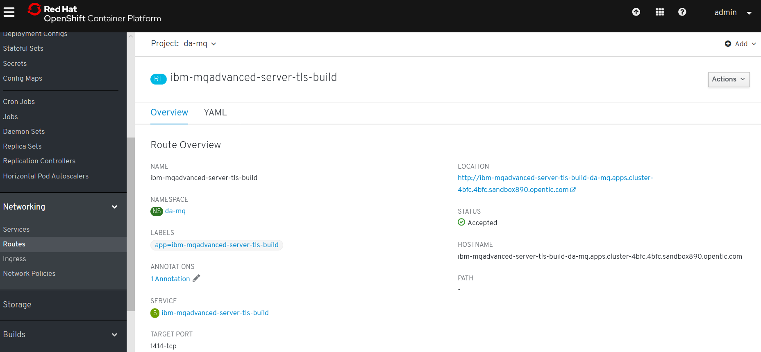

### Create route for TLS

**Tick the TLS secure route and set passthrough. Leave Insecure Traffic unset**

OCP 4.1

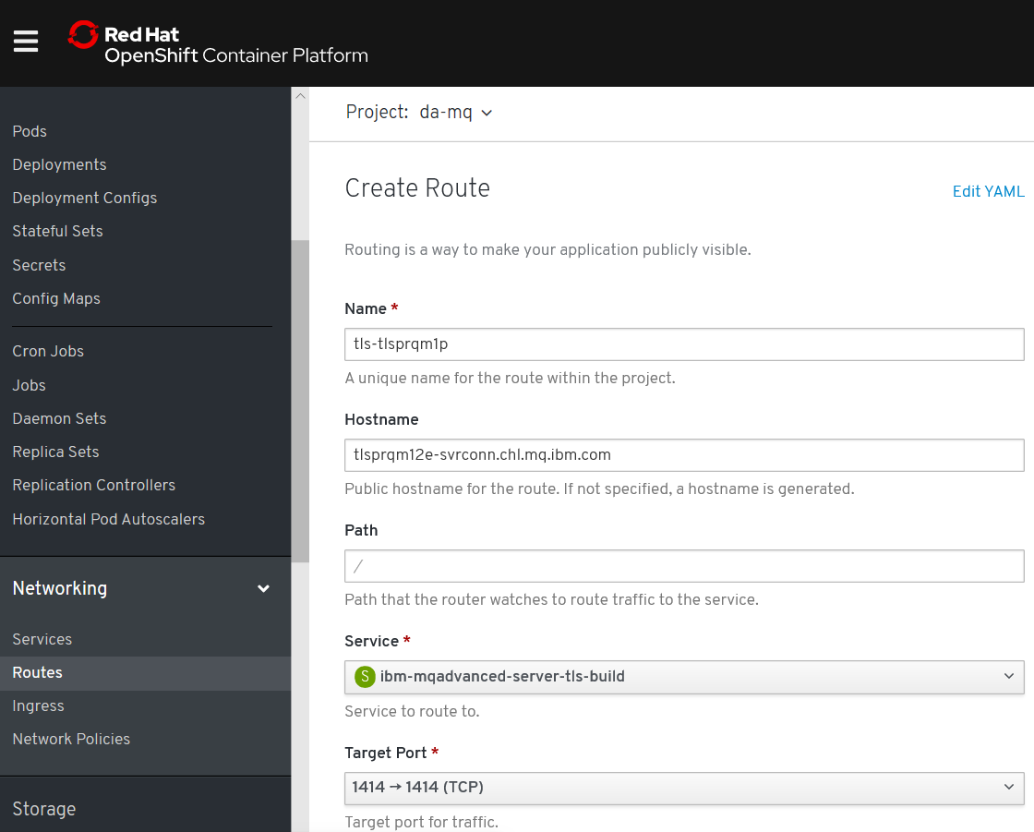

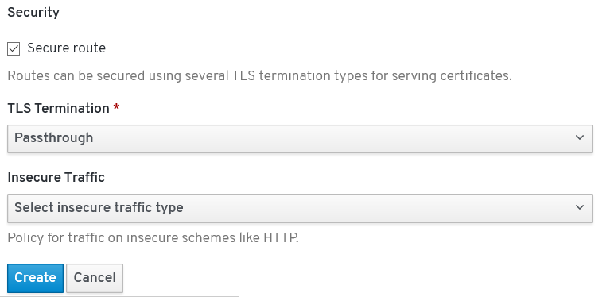

kind: Route

apiVersion: route.openshift.io/v1

metadata:

name: tls-tlsprqm1p

namespace: da-build-project

labels:

app: ibm-mqadvanced-server-tls-build

spec:

host: tlsprqm12e-svrconn.chl.mq.ibm.com

subdomain: ''

to:

kind: Service

name: ibm-mqadvanced-server-tls-build

weight: 100

port:

targetPort: 1414-tcp

tls:

termination: passthrough

wildcardPolicy: None

### C:\openshift>oc get routes

NAME HOST/PORT PATH SERVICES PORT TERMINATION WILDCARD

ibm-mqadvanced-server-tls-build ibm-mqadvanced-server-tls-build-da-mq.apps.cluster-4bfc.4bfc.sandbox890.opentlc.com ibm-mqadvanced-server-tls-build 1414-tcp None

tls-tlsprqm1p tlsprqm12e-svrconn.chl.mq.ibm.com ibm-mqadvanced-server-tls-build 1414-tcp passthrough None

### Get the Queue Manager name

The queue manager name can be obtained from the new application log

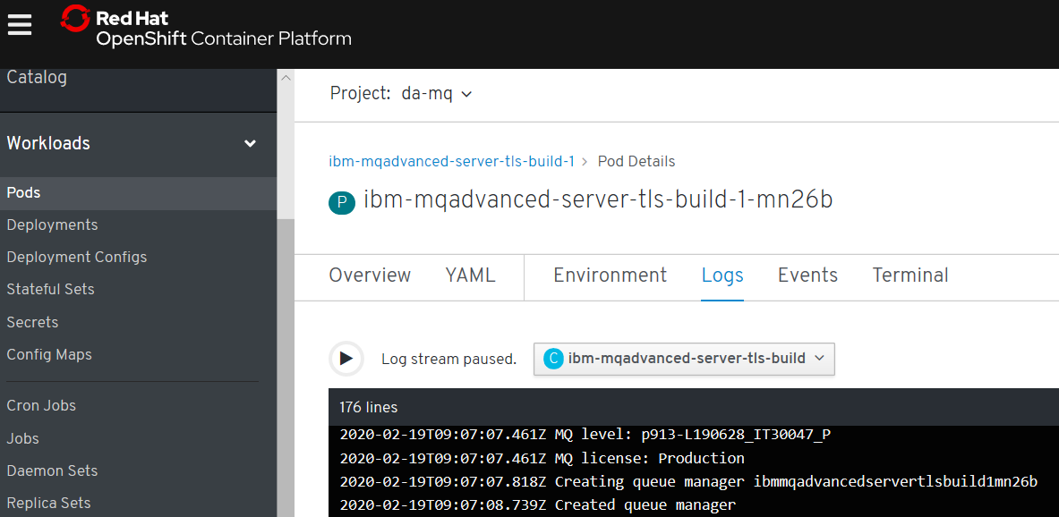

### An MQSC file to create CLNTCONN in CCDT

Depending on the level of OCP will determine the exact CONNAME/PORT (1414 or 443)

DEFINE CHANNEL(TLSPRQM1.SVRCONN) +

CHLTYPE(CLNTCONN) +

TRPTYPE(TCP) +

CONNAME('ibm-mqadvanced-server-tls-build-da-mq.apps.cluster-4bfc.4bfc.sandbox890.opentlc.com(443)') +

CERTLABL('ibmmqarnold') +

QMNAME(' ibmmqadvancedservertlsbuild1mn26b') +

SSLCIPH(ANY_TLS12) +

REPLACE

### runmqsc -n < CUSTOMIMAGE.mqsc

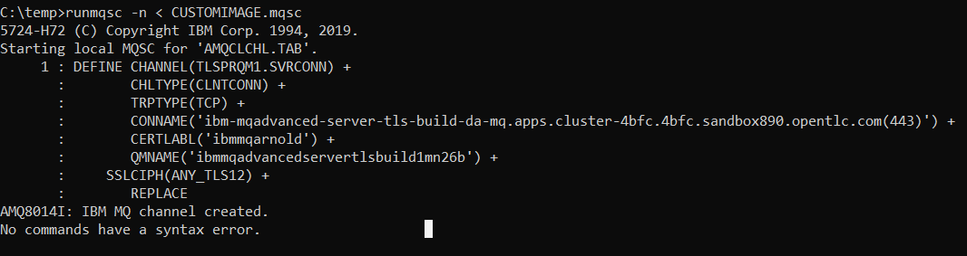

### type c:\programdata\ibm\mq\AMQCLCHL.TAB

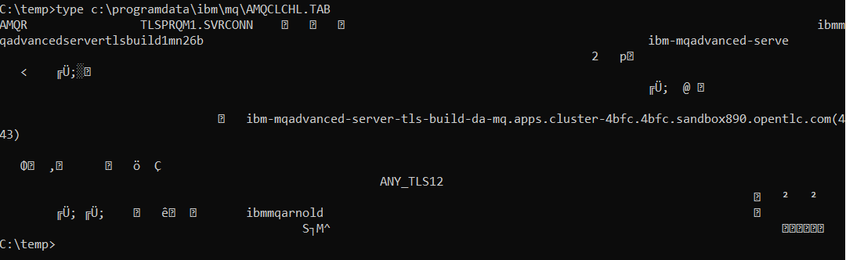

### set MQSSLKEYR=C:\Program Files\IBM\MQ\arnold

[note: connecting over TLS so need to set the keystore location]

You will need the client side (your laptop with MQ on it) keystore files that match those baked into the image. Ge them from Github below.

<https://github.com/DAVEXACOM/Exploring-ICP4i-RHOS/tree/master/MQ%20TLS%20and%20Custom%20Layer%20Image-311and42/clientside%20TLS%20files>

### runmqsc -c ibmmqadvancedservertlsbuild1mn26b

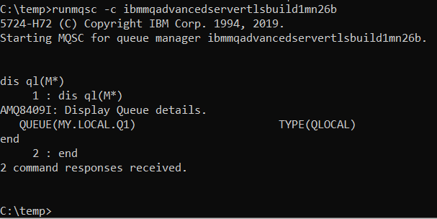

# Build and running MQ custom images on CodeReady on a laptop

<https://access.redhat.com/documentation/en-us/red_hat_codeready_containers/1.6/html/getting_started_guide/index>

## Setup for codeready on windows

### Create directory for codeready

Md c:\codeready

### Set the path to new directory

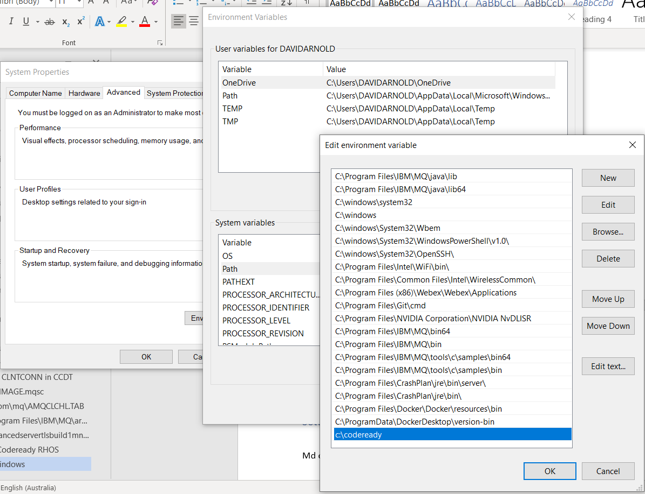

### Create Hyper-V virtual network switch

The networking can be a bit of a pain. The Hyper-V virtual switch can hijack the wifi adapter connection for the rest of the machine and you lose all connectivity off box. So you can get from the host machine to the cluster but to nothing of box. Consider the following post.

<https://www.groovypost.com/howto/share-an-ethernet-or-wireless-network-connection-with-hyper-v-in-windows-10/>

External network switch called crc

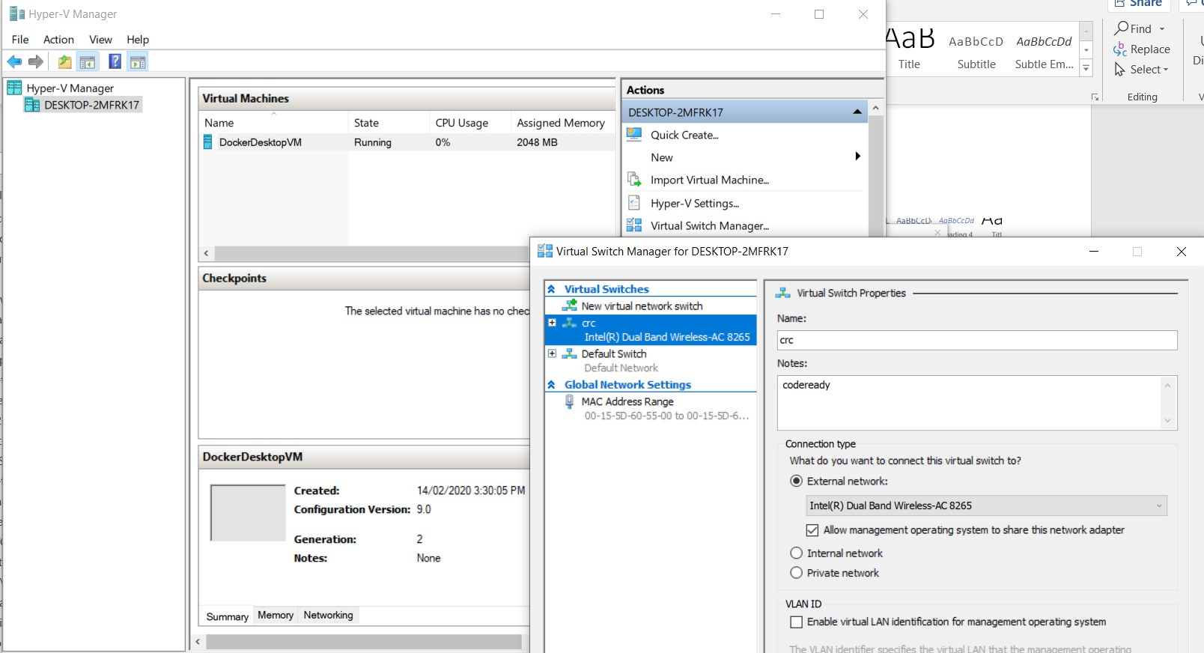

## Download and install code ready

<https://cloud.redhat.com/openshift/install/crc/installer-provisioned>

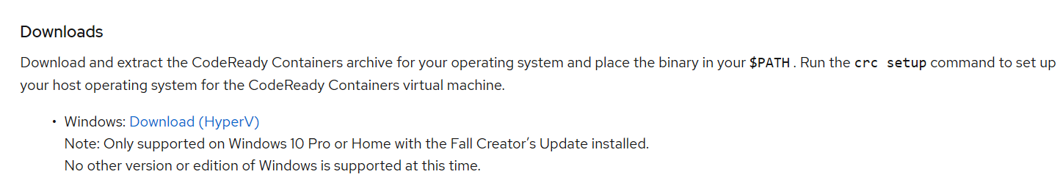



### Extract to c:\codeready

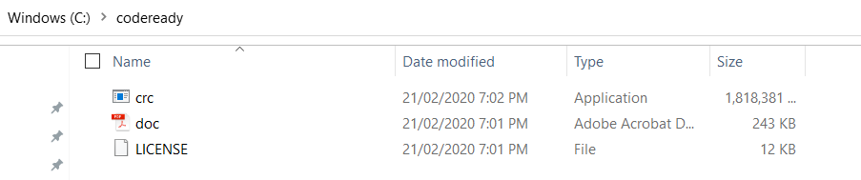

### Install code ready

Crc setup

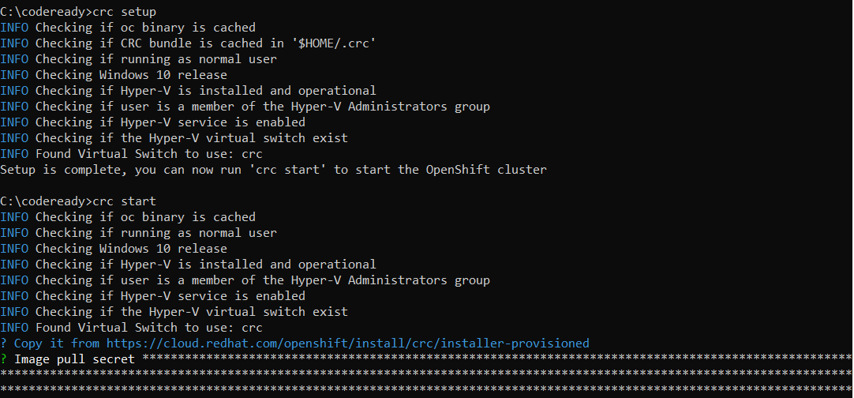

### Start code ready

Crc start or crc start –log-level debug

Get the key from below or you can download is from there and keep it locally

<https://cloud.redhat.com/openshift/install/crc/installer-provisioned>

make sure you say yes at the pop up

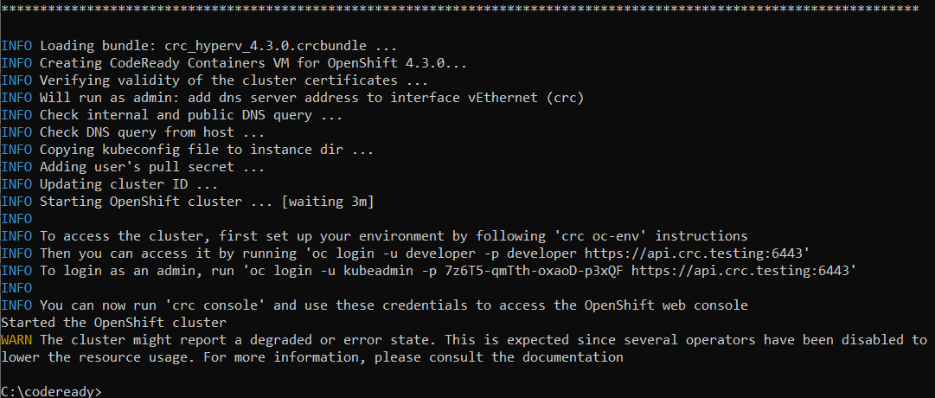

Above is the log for a new cluster starting for the first time

Below is the log for a cluster that already exists being started

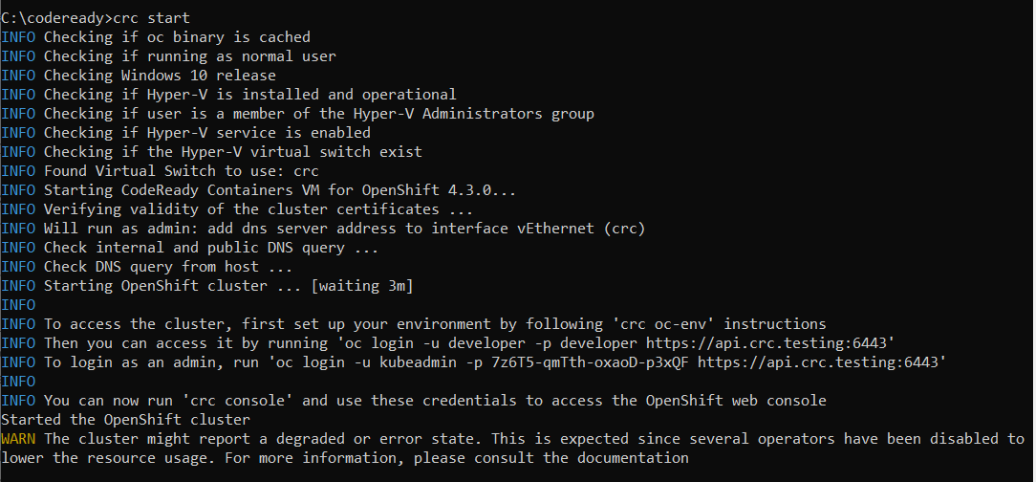

From the crc start output

Then you can access it by running 'oc login -u developer -p developer https://api.crc.testing:6443'

INFO To login as an admin, run 'oc login -u kubeadmin -p 7z6T5-qmTth-oxaoD-p3xQF https://api.crc.testing:6443'

## Using code ready

<https://access.redhat.com/documentation/en-us/red_hat_codeready_containers/1.6/html/getting_started_guide/using-codeready-containers_gsg>

### Logging into codeready

Get the credentials for the codeready instance

C:\codeready\crc console –credentials

C:\codeready>crc console --credentials

To login as a regular user, run 'oc login -u developer -p developer https://api.crc.testing:6443'.

To login as an admin, run 'oc login -u kubeadmin -p 7z6T5-qmTth-oxaoD-p3xQF https://api.crc.testing:6443'



Start the Web UI console

C:\codeready>crc console

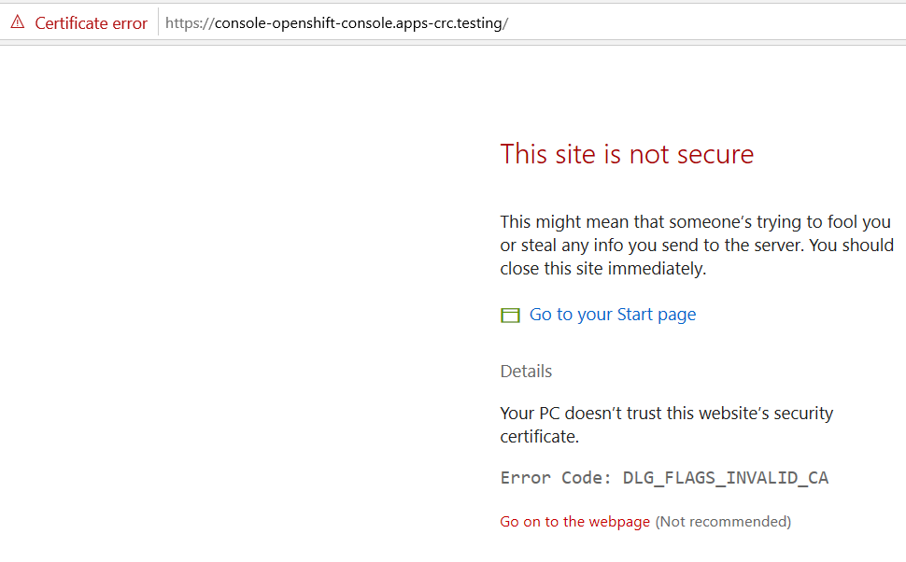

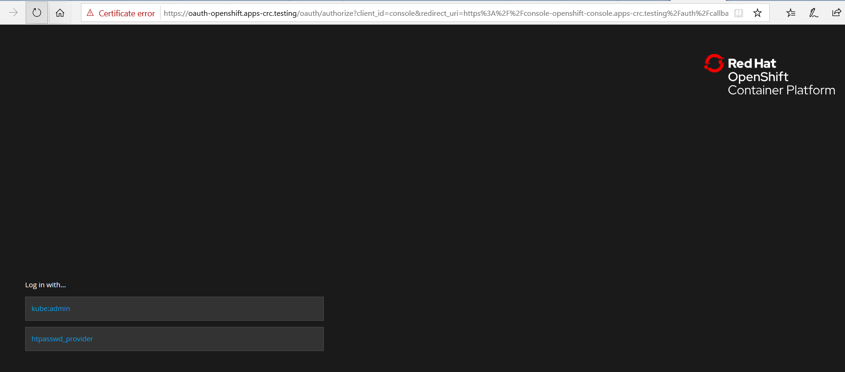

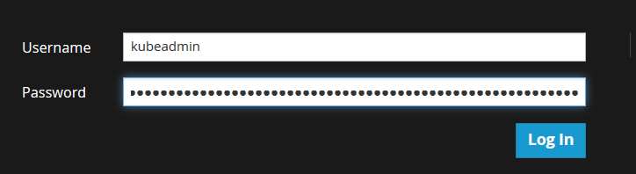

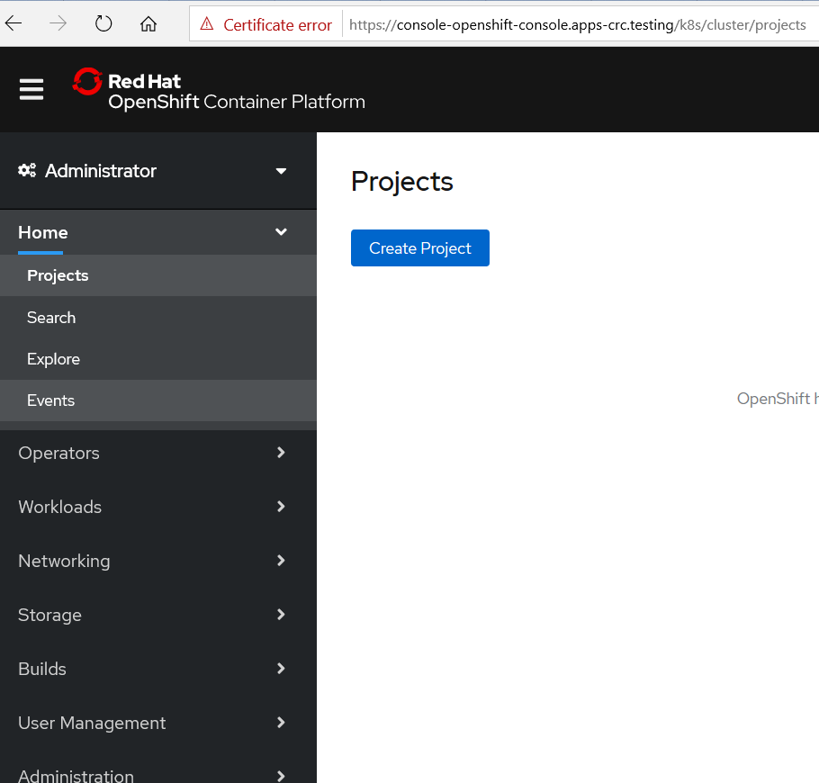

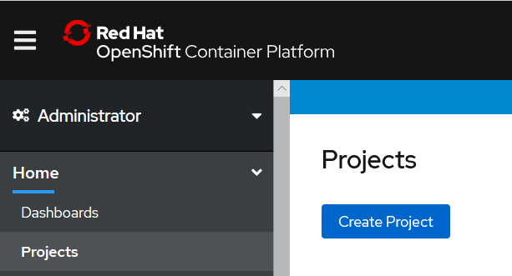

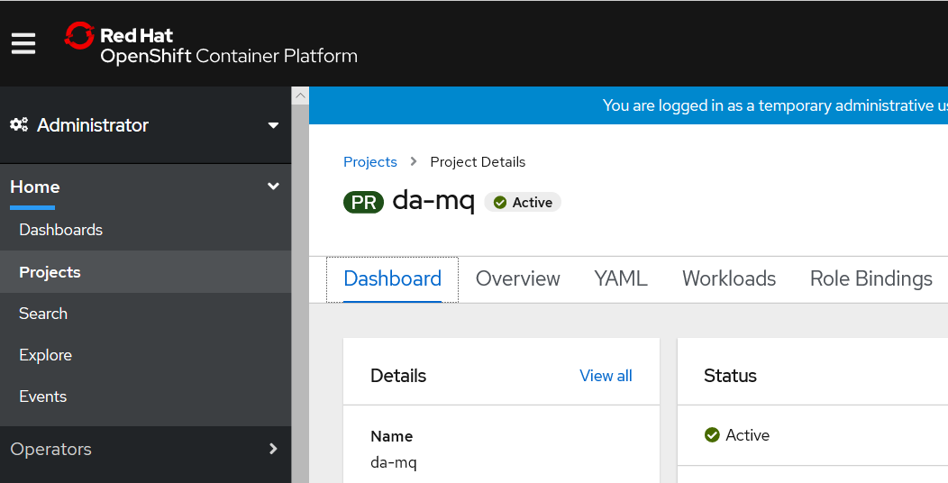

### access the OpenShift cluster via the oc command

Run the crc oc-env command to print the command needed to add the cached oc binary to your PATH:

### crc oc-env to set up the command line path

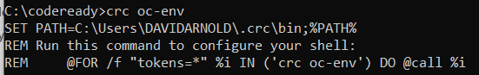

Run the printed command.

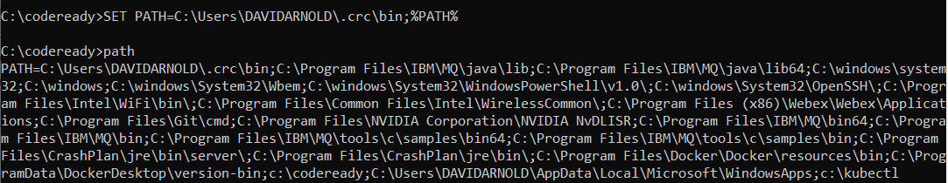

Log in as the developer user:

To login as a regular user, run 'oc login -u developer -p developer https://api.crc.testing:6443'.

To login as an admin, run 'oc login -u kubeadmin -p 7z6T5-qmTth-oxaoD-p3xQF https://api.crc.testing:6443'

oc login -u kubeadmin -p 7z6T5-qmTth-oxaoD-p3xQF <https://api.crc.testing:6443>

**oc login -u developer -p developer** [**https://api.crc.testing:6443**](https://api.crc.testing:6443)

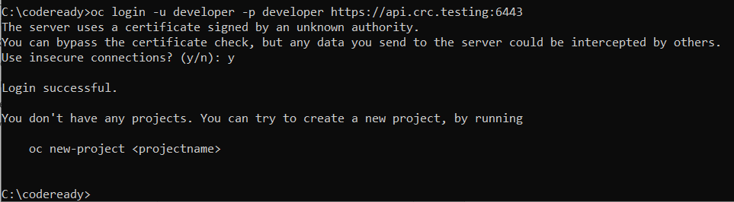

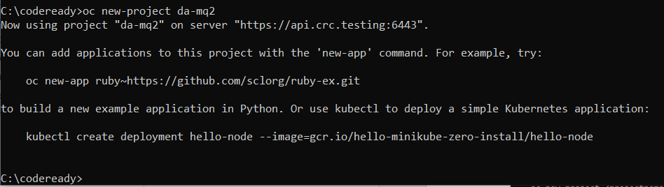

Observe new project in Web console

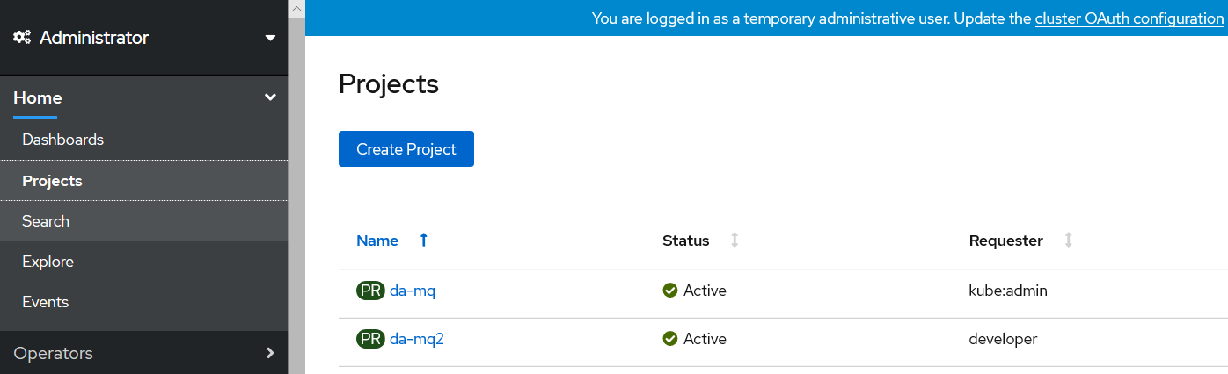

## Build, run and test IBM Middleware on code ready

### C:\codeready>oc projects

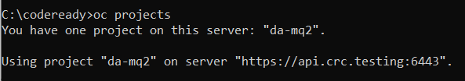

### C:\codeready>oc project da-mq2

(note oc new-project da-mq2 will create and change you to this project if you did not create one in the web ui console)



### YAML for create of input image stream

apiVersion: v1

kind: ImageStream

metadata:

name: ibm-mqadvanced-server-integration

spec:

tags:

- name: "9.1.3.0-r4-amd64"

from:

kind: DockerImage

name: davexacom/ibm-mqadvanced-server-integration:9.1.3.0-r4-amd64



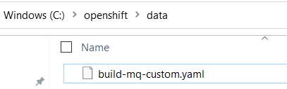

### C:\codeready>oc create -f c:\openshift\data\build-mq-custom.yaml

imagestream.image.openshift.io/ibm-mqadvanced-server-integration created



### Observe the “input” imagestream

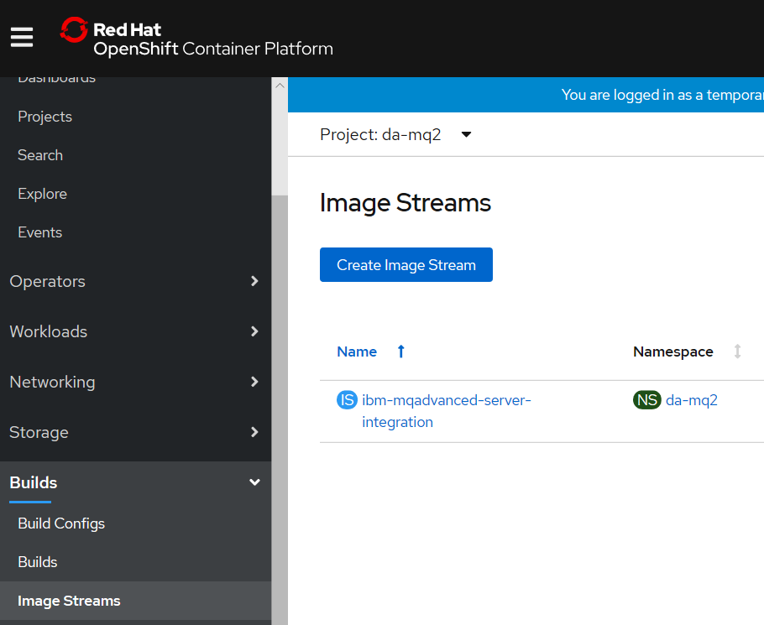

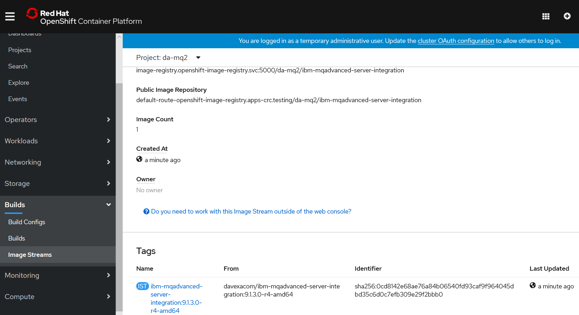

### C:\codeready>oc adm policy add-scc-to-user anyuid -z default



Need to execute as administrator

Open second command prompt and change to c:\codeready directory

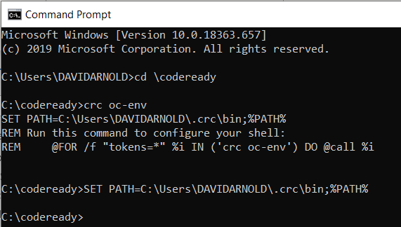

oc login -u kubeadmin -p 7z6T5-qmTth-oxaoD-p3xQF <https://api.crc.testing:6443>

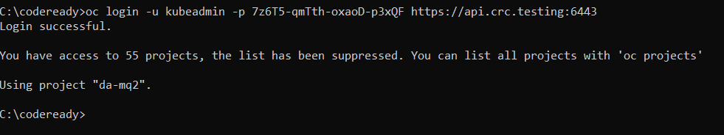

### C:\codeready>oc adm policy add-scc-to-user anyuid -z default

Run

scc "anyuid" added to: ["system:serviceaccount:da-mq:default"]

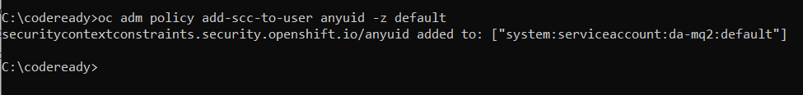

[note: above allows the MQ container to run as root]

Switch back to the developer command prompt

### C:\codeready>oc new-build <https://github.com/DAVEXACOM/ibm-mqadvanced-server-tls-build.git>

### Observe build in the Web console

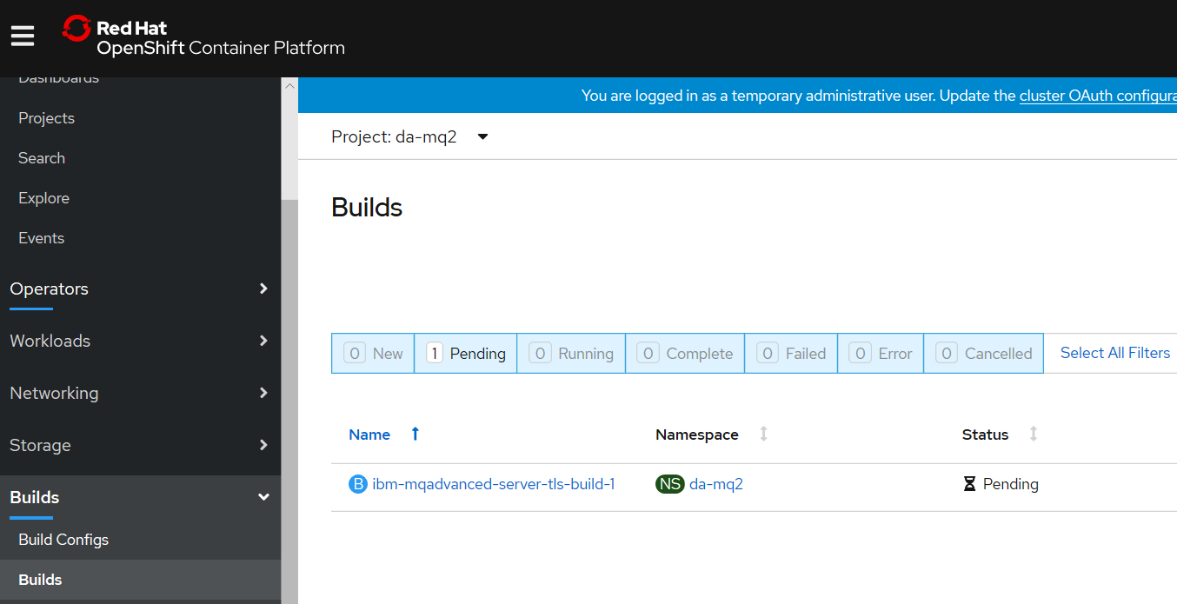

--> Found image ee41039 (3 months old) in image stream "da-mq/ibm-mqadvanced-server-integration" under tag "9.1.3.0-r4-amd64" for "ibm-mqadvanced-server-integration:9.1.3.0-r4-amd64"

IBM MQ Advanced Server

----------------------

Simplify, accelerate and facilitate the reliable exchange of data with a security-rich messaging solution — trusted by the world’s most successful enterprises

Tags: mq messaging

* A Docker build using source code from https://github.com/DAVEXACOM/ibm-mqadvanced-server-tls-build.git will be created

* The resulting image will be pushed to image stream tag "ibm-mqadvanced-server-tls-build:latest"

* Use 'start-build' to trigger a new build

--> Creating resources with label build=ibm-mqadvanced-server-tls-build ...

imagestream.image.openshift.io "ibm-mqadvanced-server-tls-build" created

buildconfig.build.openshift.io "ibm-mqadvanced-server-tls-build" created

--> Success

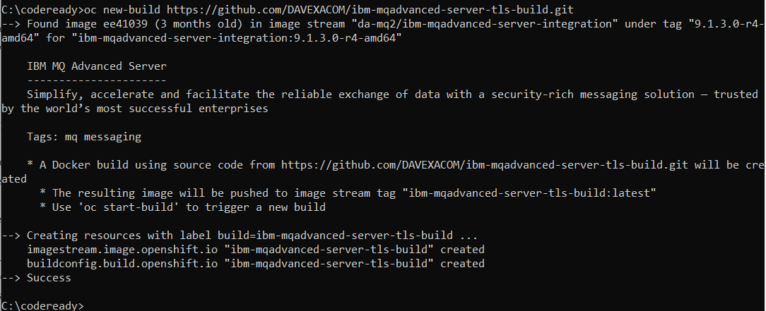

### Observe the Build config that is created

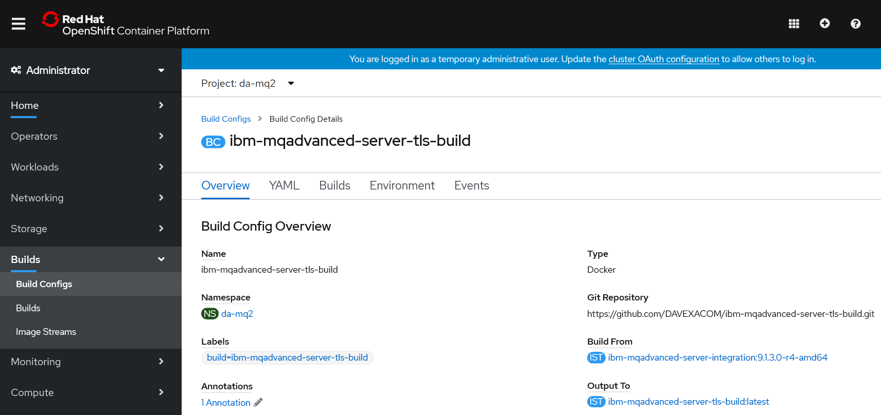

### Observe the build log

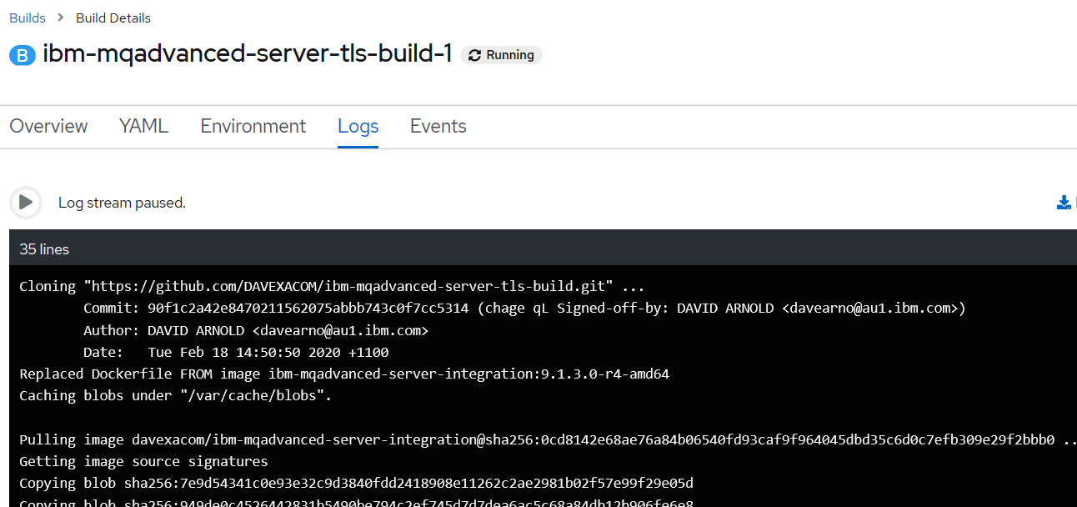

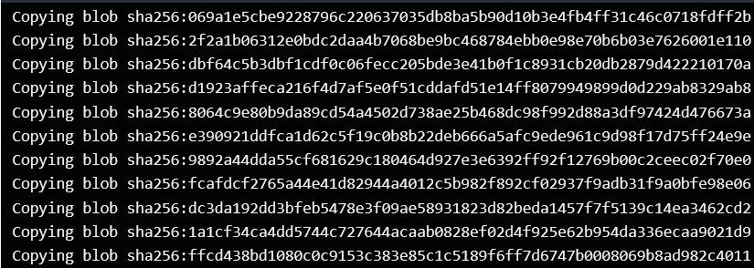

### Observe the “output” image stream



## Creating a “New App” – running up a container From the custom image

### C:\openshift>oc new-app ibm-mqadvanced-server-tls-build --env LICENSE=accept

--> Found image 2306b71 (3 minutes old) in image stream "da-mq/ibm-mqadvanced-server-tls-build" under tag "latest" for "ibm-mqadvanced-server-tls-build"

IBM MQ Advanced Server

----------------------

Simplify, accelerate and facilitate the reliable exchange of data with a security-rich messaging solution — trusted by the world’s most successful enterprises

Tags: mq messaging

* This image will be deployed in deployment config "ibm-mqadvanced-server-tls-build"

* Ports 1414/tcp, 9157/tcp, 9443/tcp will be load balanced by service "ibm-mqadvanced-server-tls-build"

* Other containers can access this service through the hostname "ibm-mqadvanced-server-tls-build"

--> Creating resources ...

deploymentconfig.apps.openshift.io "ibm-mqadvanced-server-tls-build" created

service "ibm-mqadvanced-server-tls-build" created

--> Success

Application is not exposed. You can expose services to the outside world by executing one or more of the commands below:

'oc expose svc/ibm-mqadvanced-server-tls-build'

Run 'oc status' to view your app.

### C:\openshift>oc status

In project Dave Arnold MQ (da-mq) on server https://api.cluster-4bfc.4bfc.sandbox890.opentlc.com:6443

svc/ibm-mqadvanced-server-tls-build - 172.30.48.136 ports 1414, 9157, 9443

dc/ibm-mqadvanced-server-tls-build deploys istag/ibm-mqadvanced-server-tls-build:latest <-

bc/ibm-mqadvanced-server-tls-build docker builds https://github.com/DAVEXACOM/ibm-mqadvanced-server-tls-build.git on istag/ibm-mqadvanced-server-integration:9.1.3.0-r4-amd64

deployment #1 deployed 22 minutes ago - 1 pod

## Testing the custom image

### C:\openshift>oc expose svc/ibm-mqadvanced-server-tls-build

route.route.openshift.io/ibm-mqadvanced-server-tls-build exposed

### C:\openshift>oc get routes

NAME HOST/PORT PATH SERVICES PORT TERMINATION WILDCARD

ibm-mqadvanced-server-tls-build ibm-mqadvanced-server-tls-build-da-mq.apps.cluster-4bfc.4bfc.sandbox890.opentlc.com ibm-mqadvanced-server-tls-build 1414-tcp None

## Connecting to MQ queue manager

### OCP 4.1 is like 4.2 so we need to modify the route for MQ TLS traffic

### C:\openshift\oc get routes

NAME HOST/PORT PATH SERVICES PORT TERMINATION WILDCARD

ibm-mqadvanced-server-tls-build ibm-mqadvanced-server-tls-build-da-mq.apps.cluster-4bfc.4bfc.sandbox890.opentlc.com ibm-mqadvanced-server-tls-build 1414-tcp None

Networking->routes->create route-> then there is a form



### Create route for TLS

**Tick the TLS secure route and set passthrough. Leave Insecure Traffic unset**

OCP 4.1





kind: Route

apiVersion: route.openshift.io/v1

metadata:

name: tls-tlsprqm1p

namespace: da-mq

selfLink: /apis/route.openshift.io/v1/namespaces/da-mq/routes/tls-tlsprqm1p

uid: 1cb7e145-536b-11ea-8e06-0a580a800077

resourceVersion: '148718'

creationTimestamp: '2020-02-19T22:56:49Z'

labels:

app: ibm-mqadvanced-server-tls-build

spec:

host: tlsprqm12e-svrconn.chl.mq.ibm.com

subdomain: ''

to:

kind: Service

name: ibm-mqadvanced-server-tls-build

weight: 100

port:

targetPort: 1414-tcp

tls:

termination: passthrough

wildcardPolicy: None

status:

ingress:

- host: tlsprqm12e-svrconn.chl.mq.ibm.com

routerName: default

conditions:

- type: Admitted

status: 'True'

lastTransitionTime: '2020-02-19T22:56:49Z'

wildcardPolicy: None

routerCanonicalHostname: apps.cluster-4bfc.4bfc.sandbox890.opentlc.com

### C:\openshift>oc get routes

NAME HOST/PORT PATH SERVICES PORT TERMINATION WILDCARD

ibm-mqadvanced-server-tls-build ibm-mqadvanced-server-tls-build-da-mq.apps.cluster-4bfc.4bfc.sandbox890.opentlc.com ibm-mqadvanced-server-tls-build 1414-tcp None

tls-tlsprqm1p tlsprqm12e-svrconn.chl.mq.ibm.com ibm-mqadvanced-server-tls-build 1414-tcp passthrough None

### Get the Queue Manager name

The queue manager name can be obtained from the new application log



### An MQSC file to create CLNTCONN in CCDT

Depending on the level of OCP will determine the exact CONNAME/PORT (1414 or 443)

DEFINE CHANNEL(TLSPRQM1.SVRCONN) +

CHLTYPE(CLNTCONN) +

TRPTYPE(TCP) +

CONNAME('ibm-mqadvanced-server-tls-build-da-mq.apps.cluster-4bfc.4bfc.sandbox890.opentlc.com(443)') +

CERTLABL('ibmmqarnold') +

QMNAME(' ibmmqadvancedservertlsbuild1mn26b') +

SSLCIPH(ANY_TLS12) +

REPLACE

### runmqsc -n < CUSTOMIMAGE.mqsc



### type c:\programdata\ibm\mq\AMQCLCHL.TAB



### set MQSSLKEYR=C:\Program Files\IBM\MQ\arnold

[note: connecting over TLS so need to set the keystore location]

You will need the client side (your laptop with MQ on it) keystore files that match those baked into the image. Ge them from Github below.

<https://github.com/DAVEXACOM/Exploring-ICP4i-RHOS/tree/master/MQ%20TLS%20and%20Custom%20Layer%20Image-311and42/clientside%20TLS%20files>

### runmqsc -c ibmmqadvancedservertlsbuild1mn26b



## Stopping codeready (virtual machine)

The crc stop command stops the running CodeReady Containers virtual machine and OpenShift cluster. The stopping process will take a few minutes while the cluster shuts down.

**Procedure**

* Stop the CodeReady Containers virtual machine and OpenShift cluster:

$ crc stop

# Building and running MQ and ACE Custom images on RHOS (ICP4i)

## Build and run MQ custom from certified base image on RHOS

### oc login --token=WM4a6Lj9Vj67U626gJ8Z897Cijr-OnjG-KcVxPhPk1Q --server=https://api.cloudpak.ocp4.cloudnativekube.com:6443

### oc project da-build-project

### oc create -f c:\openshift\data\build-mq-custom.yaml

apiVersion: v1

kind: ImageStream

metadata:

name: ibm-mqadvanced-server-integration

spec:

tags:

- name: "9.1.3.0-r4-amd64"

from:

kind: DockerImage

name: davexacom/ibm-mqadvanced-server-integration:9.1.3.0-r4-amd64

### oc adm policy add-scc-to-user anyuid -z default

### oc new-build https://github.com/DAVEXACOM/ibm-mqadvanced-server-tls-build.git

### oc new-app ibm-mqadvanced-server-tls-build --env LICENSE=accept

### oc expose svc/ibm-mqadvanced-server-tls-build

### oc status

### oc create -f c:\openshift\data\create-mq-route.yaml

kind: Route

apiVersion: route.openshift.io/v1

metadata:

name: tls-tlsprqm1p

namespace: da-build-project

labels:

app: ibm-mqadvanced-server-tls-build

spec:

host: tlsprqm12e-svrconn.chl.mq.ibm.com

subdomain: ''

to:

kind: Service

name: ibm-mqadvanced-server-tls-build

weight: 100

port:

targetPort: 1414-tcp

tls:

termination: passthrough

wildcardPolicy: None

### oc get routes

NAME HOST/PORT PATH SERVICES PORT TERMINATION WILDCARD

ibm-mqadvanced-server-tls-build ibm-mqadvanced-server-tls-build-da-build-project.apps.cloudpak.ocp4.cloudnativekube.com ibm-mqadvanced-server-tls-build 1414-tcp None

get the CONNANE from the host/port of the route above

get the queue manager name from the logs workload->pods

### CLNTCONN Channel definition

DEFINE CHANNEL(TLSPRQM1.SVRCONN) +

CHLTYPE(CLNTCONN) +

TRPTYPE(TCP) +

CONNAME('ibm-mqadvanced-server-tls-build-da-build-project.apps.cloudpak.ocp4.cloudnativekube.com(443)') +

CERTLABL('ibmmqarnold') +

QMNAME('ibmmqadvancedservertlsbuild147zgm') +

SSLCIPH(ANY_TLS12) +

REPLACE

### runmqsc -n < CUSTOMIMAGE.mqsc

### Observe the AMQCLCHL.TAB

type c:\programdata\ibm\mq\AMQCLCHL.TAB

### set MQSSLKEYR=C:\Program Files\IBM\MQ\arnold

### runmqsc -c ibmmqadvancedservertlsbuild147zgm

5724-H72 (C) Copyright IBM Corp. 1994, 2019.

Starting MQSC for queue manager ibmmqadvancedservertlsbuild147zgm.

DIS QL(M*)

AMQ8409I: Display Queue details.

QUEUE(MY.LOCAL.Q1) TYPE(QLOCAL)

end

### Adding a webhook for the MQ custom image build

Goto the build configs

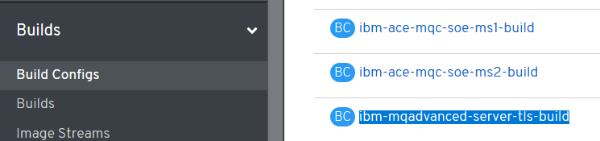

Select ibm-mqserver-server-tls-build and page down to webhooks – copy the url with secret

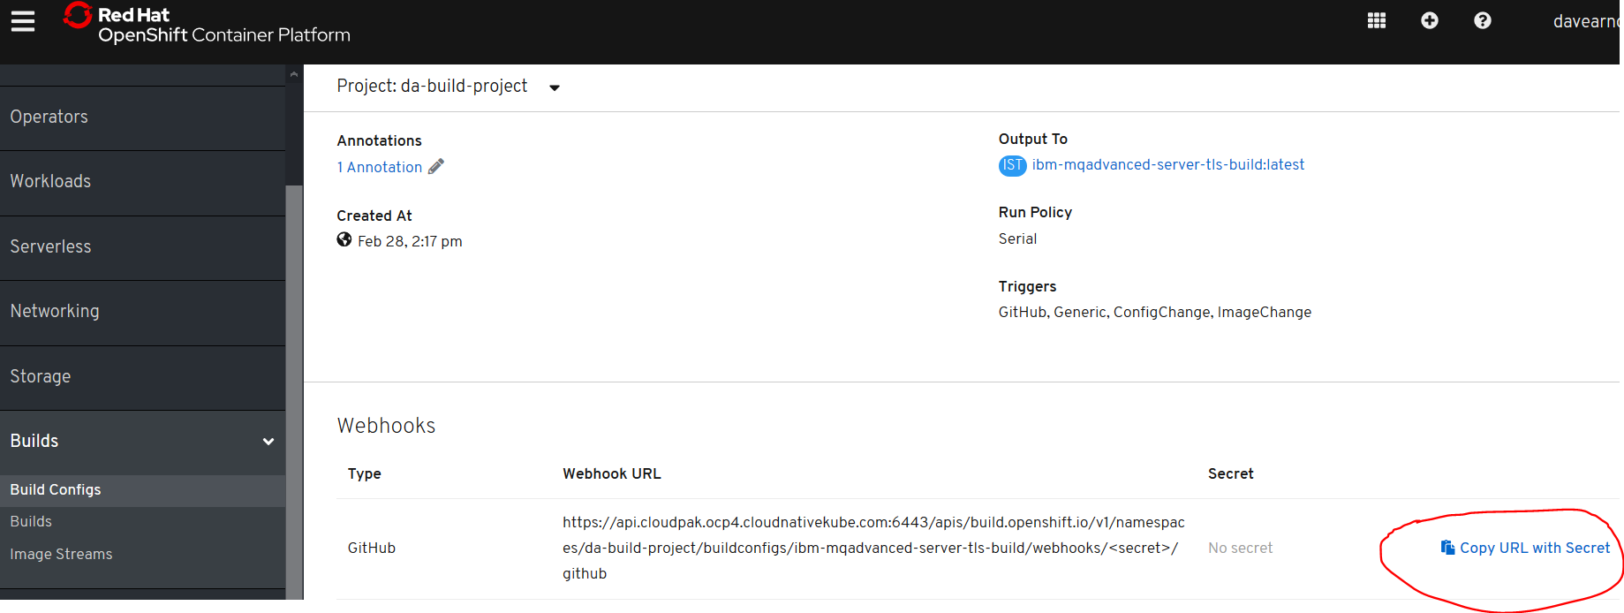

Goto github (your clone of the repos below)

<https://github.com/DAVEXACOM/ibm-mqadvanced-server-tls-build>

select settings->webhooks and paste into the Payload URL

The set the content type and disable SSL

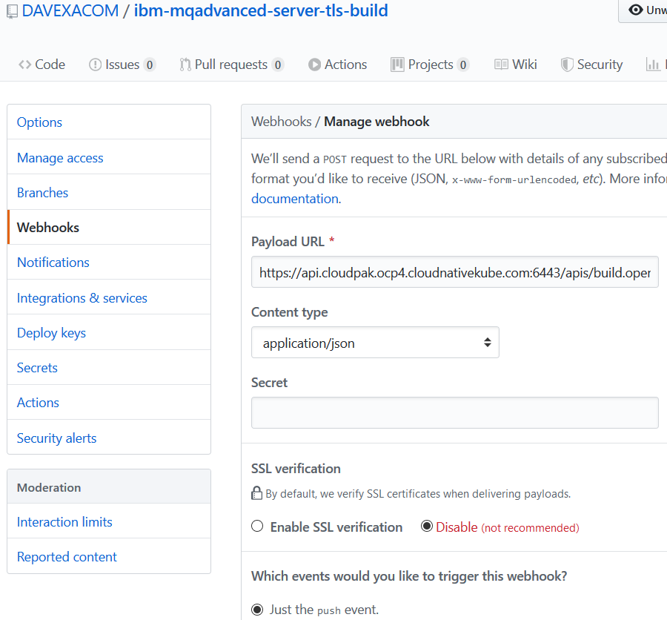

Hit the add webhook button at the bottom and then check for the tick below

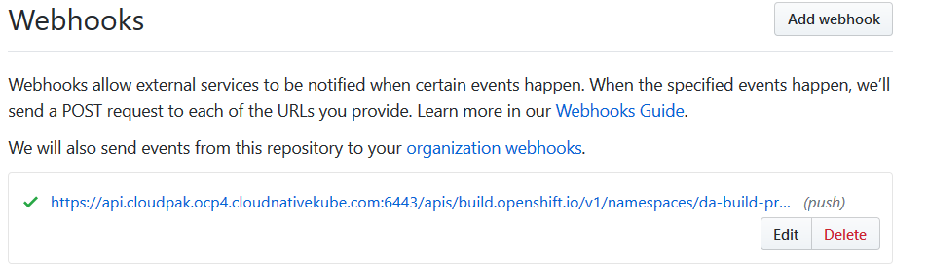

### Push MQSC file change to Github

Add some user queues

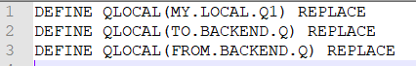

Push to Git

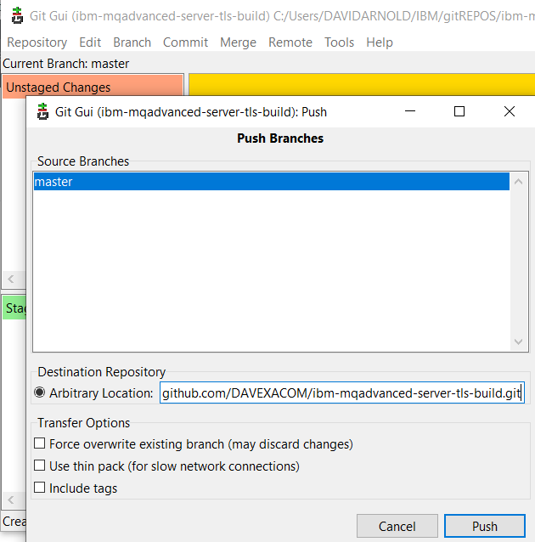

### Observer triggered build in RHOS

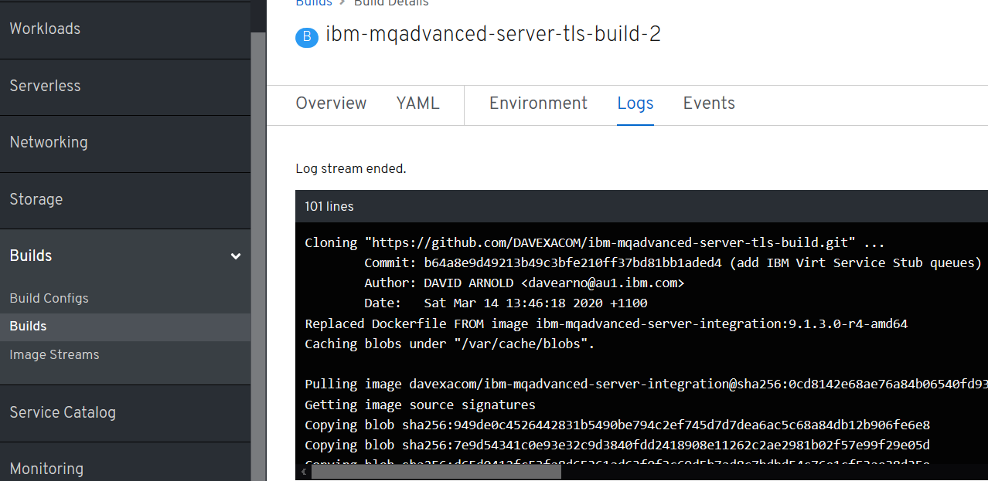

Check the deployment config for Rolling and trigger on image change

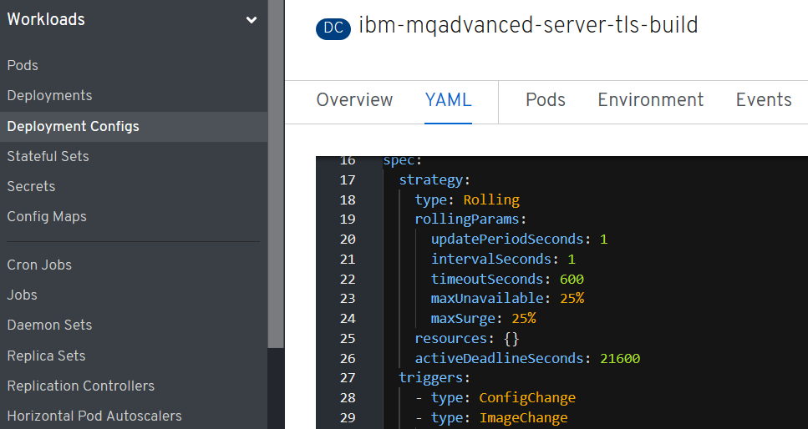

### Observer Pod has updated based on the new build

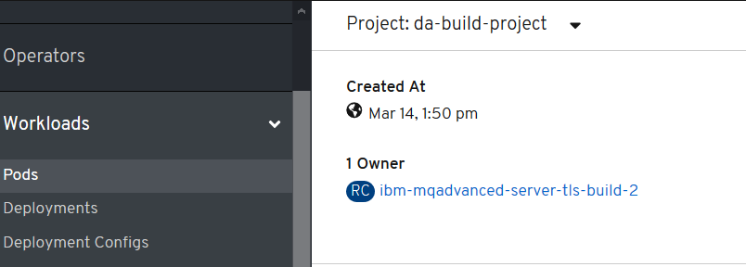

## Test the new MQ deployment for new queues

### Obtain the queue manager name in latest build

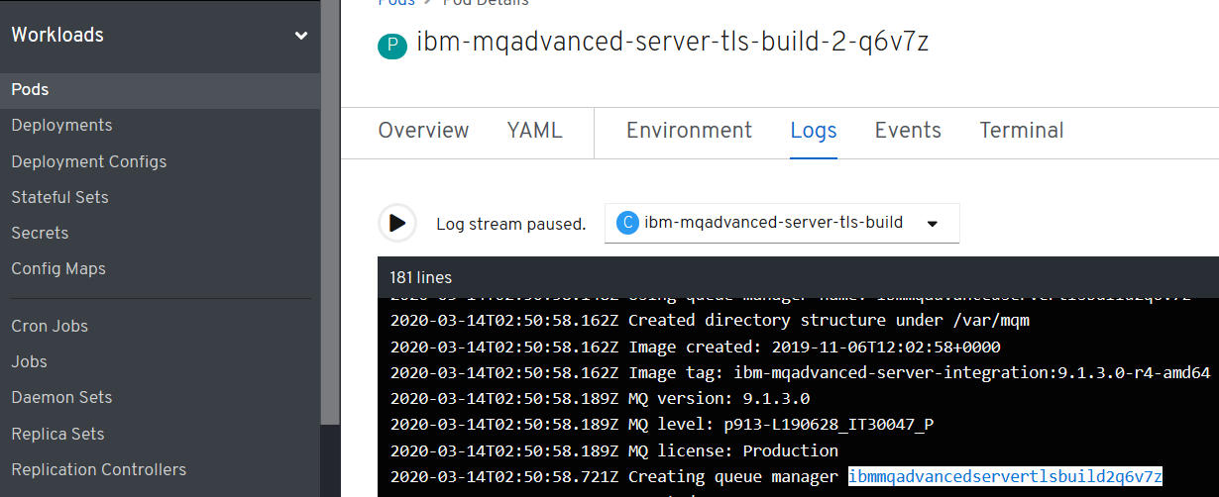

In this example ibmmqadvancedservertlsbuild2q6v7z

### Open command prompt as administrator

get the queue manager name from the logs workload->pods

### CLNTCONN Channel definition

DEFINE CHANNEL(TLSPRQM1.SVRCONN) +

CHLTYPE(CLNTCONN) +

TRPTYPE(TCP) +

CONNAME('ibm-mqadvanced-server-tls-build-da-build-project.apps.cloudpak.ocp4.cloudnativekube.com(443)') +

CERTLABL('ibmmqarnold') +

QMNAME('ibmmqadvancedservertlsbuild2q6v7z') +

SSLCIPH(ANY_TLS12) +

REPLACE

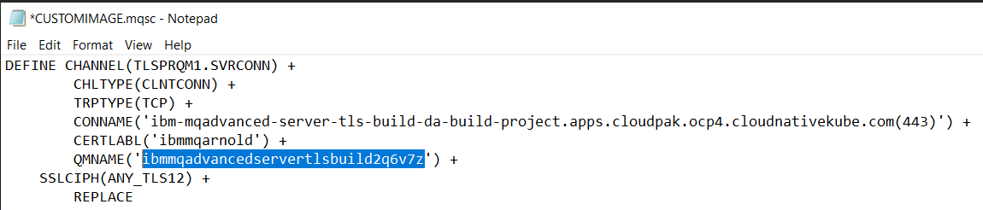

runmqsc -n < CUSTOMIMAGE.mqsc

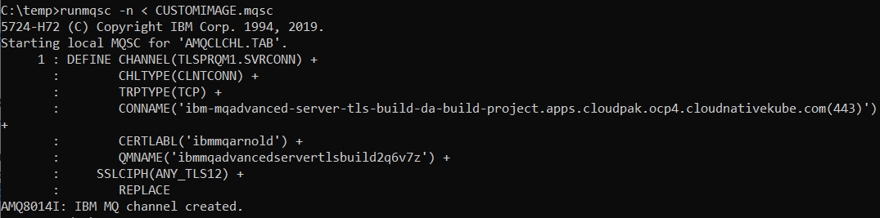

### Check the AMQCLCHL.TAB

type c:\programdata\ibm\mq\AMQCLCHL.TAB

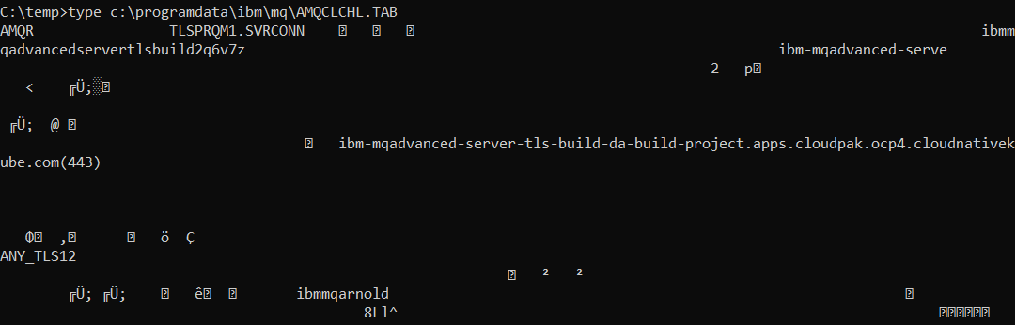

set MQSSLKEYR=C:\Program Files\IBM\MQ\arnold

runmqsc -c ibmmqadvancedservertlsbuild2q6v7z

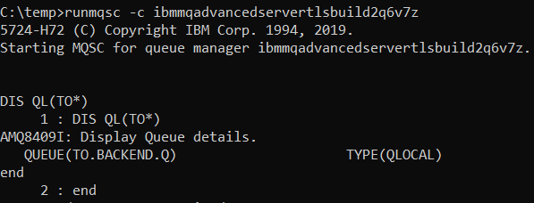

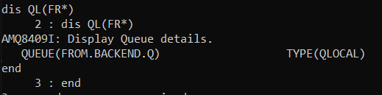

## Build and Run ACE Microservice 1 from SoE on RHOS

### Creds for ICP4i

RHOCP console:

<https://console-openshift-console.apps.cloudpak.ocp4.cloudnativekube.com/dashboard>

davearno

passw0rd1234

Kubeadmin

UqJrM-aKo2y-VYnYi-QiuBV

### Github/dockerhub

<https://github.com/DAVEXACOM/ibm-ace-mqc-soe-ms1-build>

<https://hub.docker.com/repository/docker/davexacom/ace11002mqc91soe>

<https://hub.docker.com/repository/docker/davexacom/ibm-mqadvanced-server-integration>

Build from <https://hub.docker.com/repository/docker/davexacom/ace11002mqc91soe>

Using a version of <https://github.com/DAVEXACOM/ACEonICPIntMicSrv1Img>

Which is at https://github.com/DAVEXACOM/ibm-ace-mqc-soe-ms1-build

Should be able to test using curl against liveliness probe , ace ms1 won’t work without ms2 or a stub behind it.

### Code for ACE Microservice1

<https://github.com/DAVEXACOM/ACEonICPIntMicSrv1>

### Code for ACE Liveliness probe

<https://github.com/DAVEXACOM/ACEonICPIntMicSoE>

### Building the ACE MS1 image

#### oc login --token=WM4a6Lj9Vj67U626gJ8Z897Cijr-OnjG-KcVxPhPk1Q --server=https://api.cloudpak.ocp4.cloudnativekube.com:6443

#### oc project da-build-project

create the image stream to the base SoE image of ACE if you do not already have it

#### oc create -f c:\openshift\data\build-ace-custom.yaml

### Observe the image stream

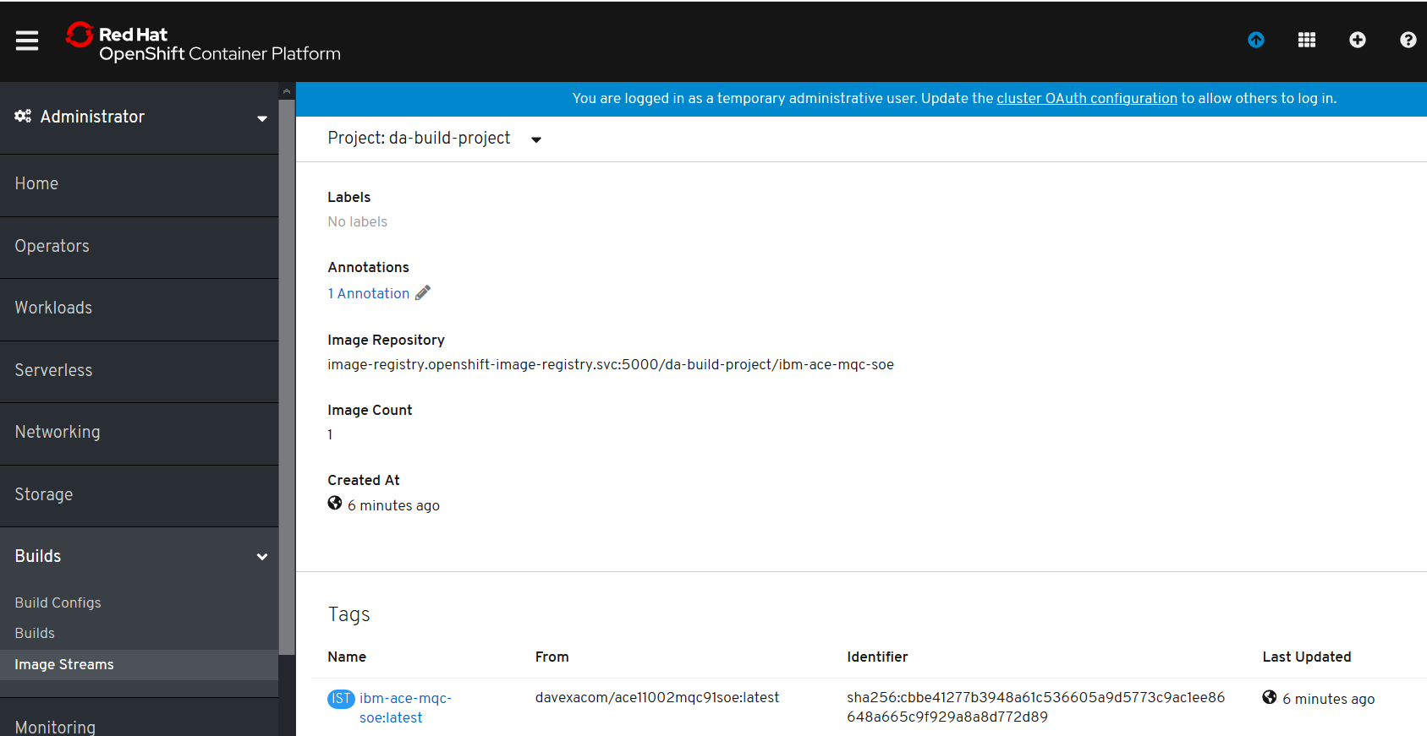

#### oc new-build <https://github.com/DAVEXACOM/ibm-ace-mqc-soe-ms1-build.git>

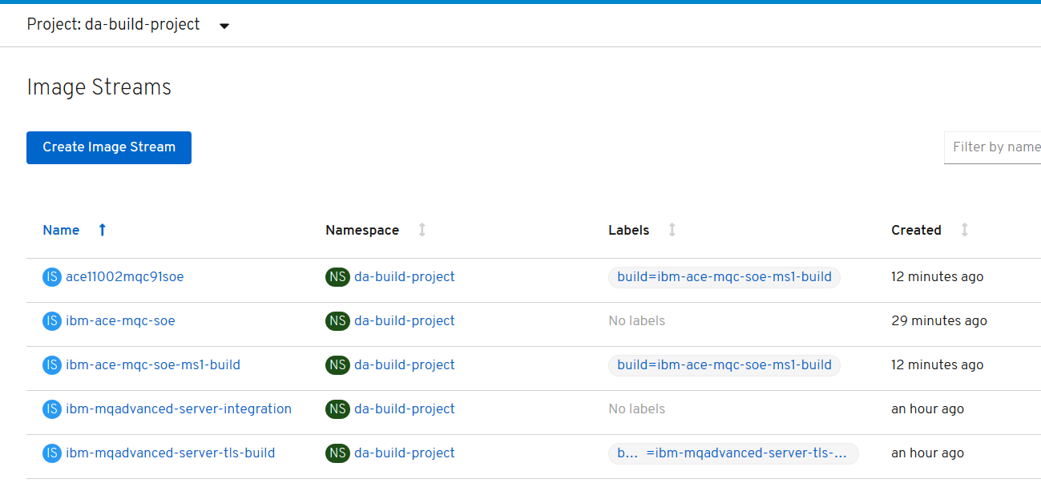

### Observe the build

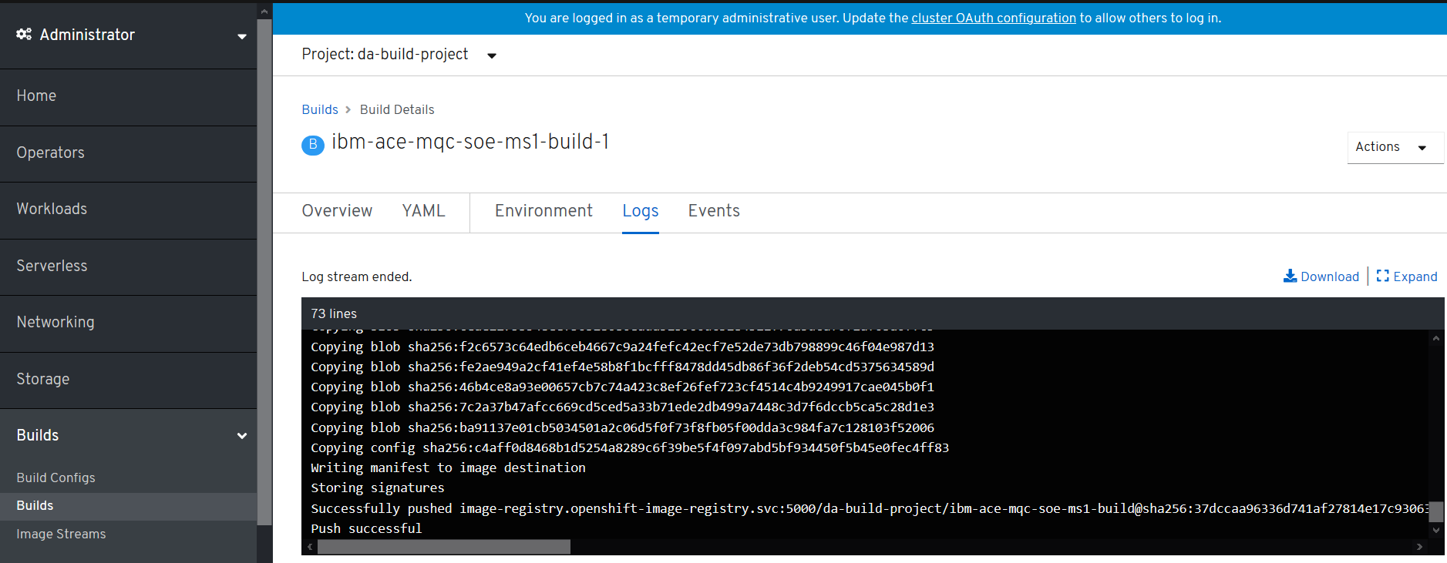

#### oc new-app ibm-ace-mqc-soe-ms1-build --env LICENSE=accept

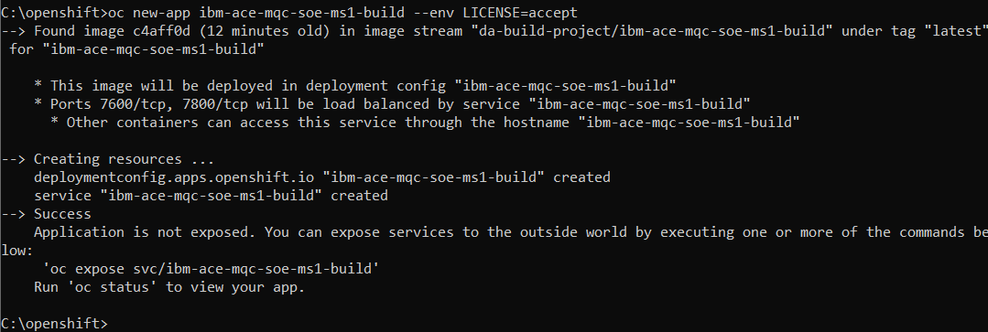

NOTE: If you use oc expose you will get a route (URL) that exposes 7600 the WebUI and not the 7800 for HTTP connection to the deployed services. So recommend using the oc create route, jump to @DA1@ below

#### oc expose svc/ibm-ace-mqc-soe-ms1-build – note better to use oc create



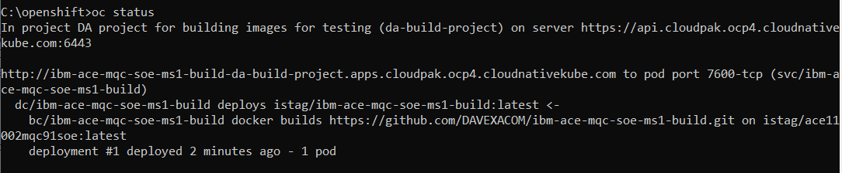

#### oc get routes



NAME HOST/PORT PATH SERVICES PORT TERMINATION WILDCARD

ibm-ace-mqc-soe-ms1-build ibm-ace-mqc-soe-ms1-build-da-build-project.apps.cloudpak.ocp4.cloudnativekube.com ibm-ace-mqc-soe-ms1-build 7600-tcp

### Testing the running application

#### Test the webUI

http://ibm-ace-mqc-soe-ms1-build-da-build-project.apps.cloudpak.ocp4.cloudnativekube.com/

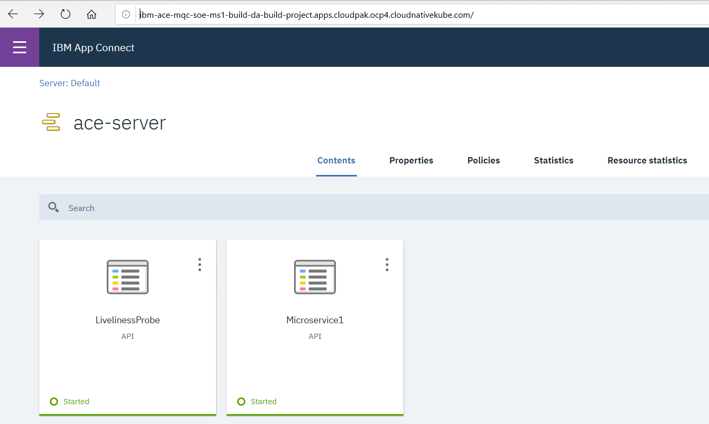

Below is the route. Note it is leveraging port 7600 – hence the WebUI works

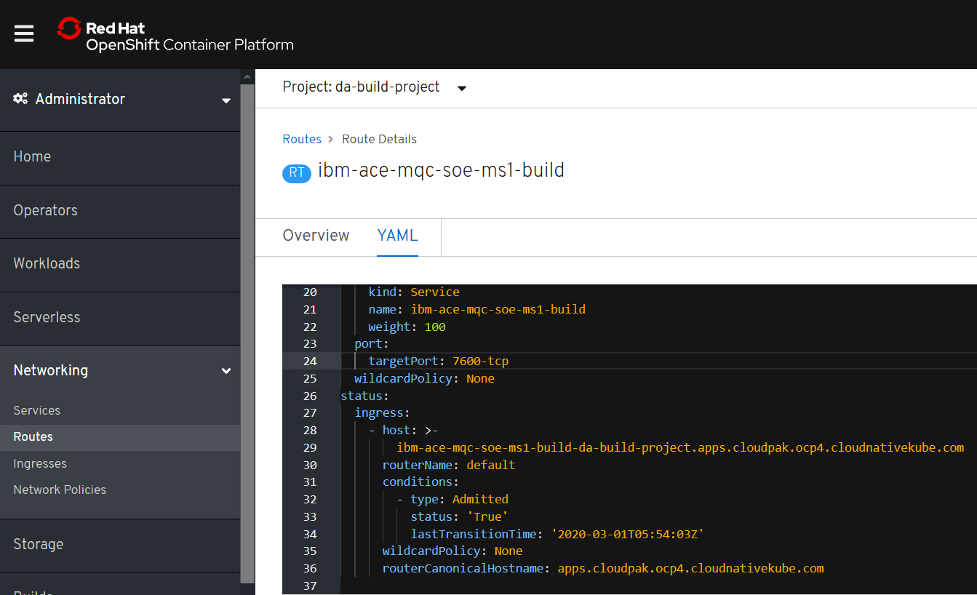

@DA1@ below

### Changing the route 7600 to 7800 for target port

save and reload

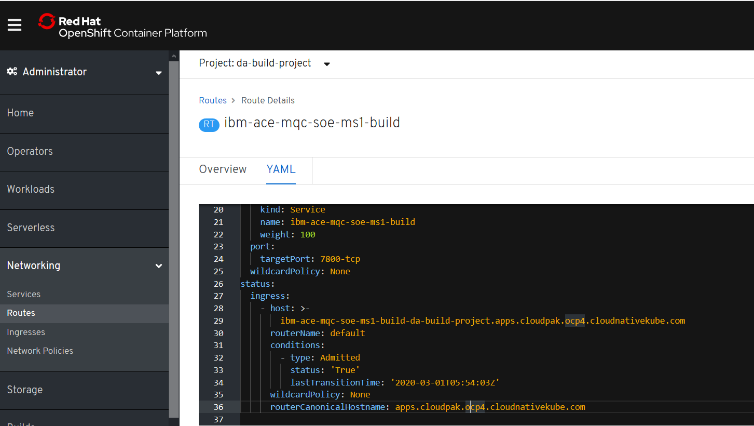

### Test the deployed Liveliness probe service

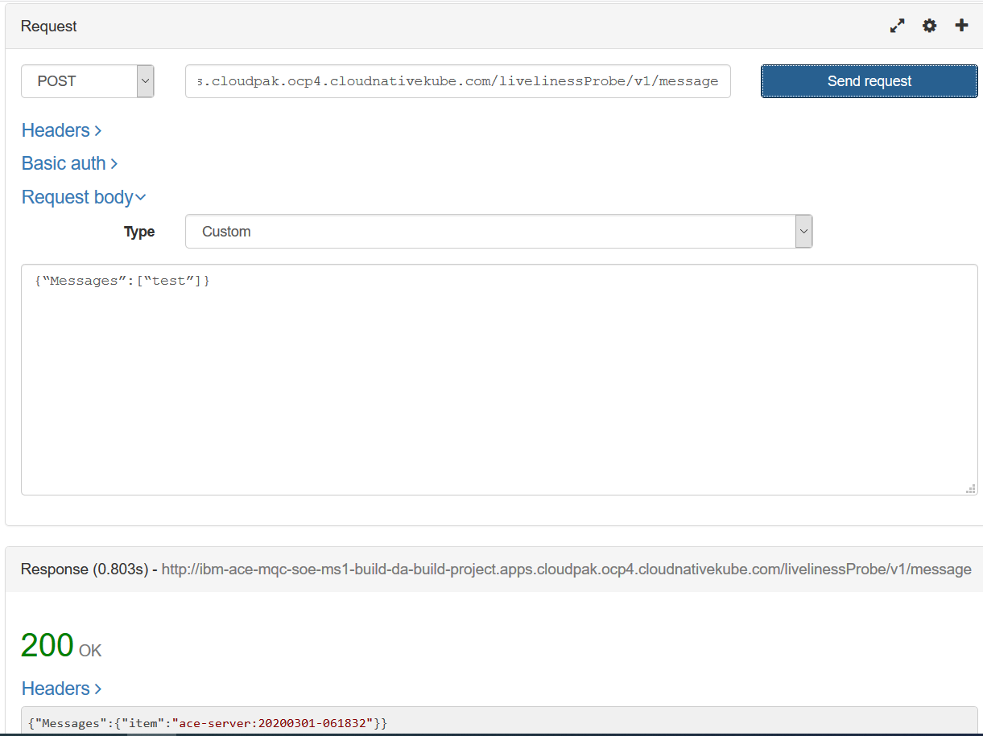

### Alternative – using oc create to create the route instead of expose

#### oc create -f c:\openshift\data\create-ace-route.yaml

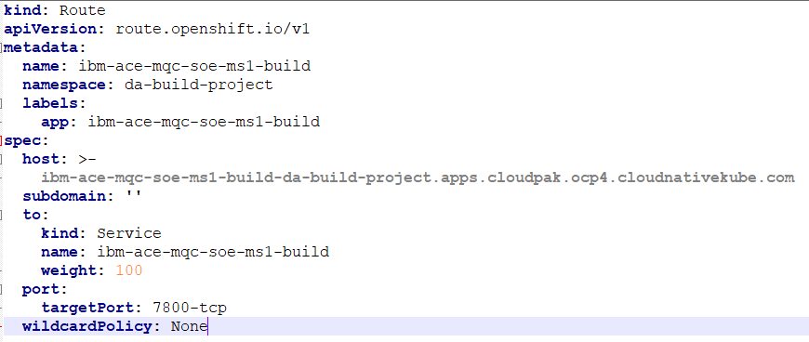

kind: Route

apiVersion: route.openshift.io/v1

metadata:

name: ibm-ace-mqc-soe-ms1-build

namespace: da-build-project

labels:

app: ibm-ace-mqc-soe-ms1-build

spec:

host: >-

ibm-ace-mqc-soe-ms1-build-da-build-project.apps.cloudpak.ocp4.cloudnativekube.com

subdomain: ''

to:

kind: Service

name: ibm-ace-mqc-soe-ms1-build

weight: 100

port:

targetPort: 7800-tcp

wildcardPolicy: None

#### oc get routes



### Test the liveliness probe service again

<http://ibm-ace-mqc-soe-ms1-build-da-build-project.apps.cloudpak.ocp4.cloudnativekube.com/livelinessProbe/v1/message>

{“Messages”:[“test”]}

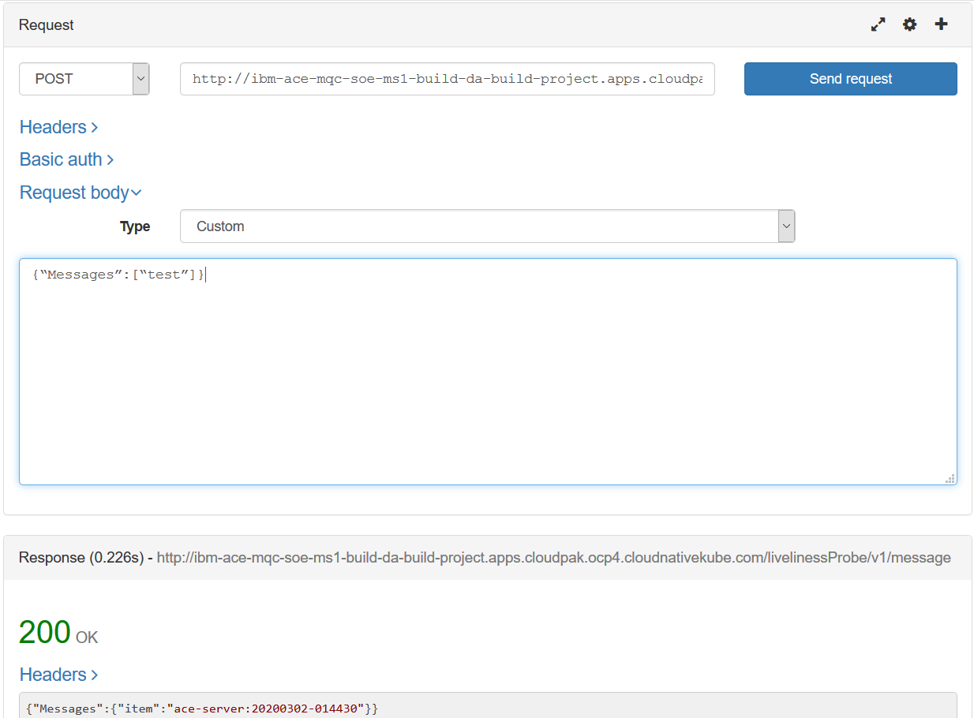

### Create a webhook to trigger builds

#### Obtain the web hook URL from the build config

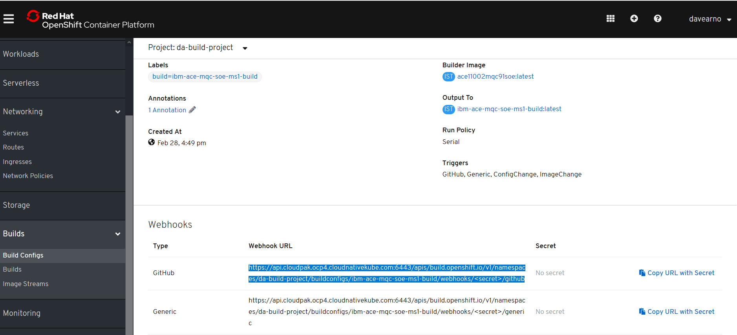

https://api.cloudpak.ocp4.cloudnativekube.com:6443/apis/build.openshift.io/v1/namespaces/da-build-project/buildconfigs/ibm-ace-mqc-soe-ms1-build/webhooks/<secret>/github

<https://api.cloudpak.ocp4.cloudnativekube.com:6443/apis/build.openshift.io/v1/namespaces/da-build-project/buildconfigs/ibm-ace-mqc-soe-ms1-build/webhooks/nuDTe2L6Wv_XpQB4Jd1v/github>

### Create webhook in github

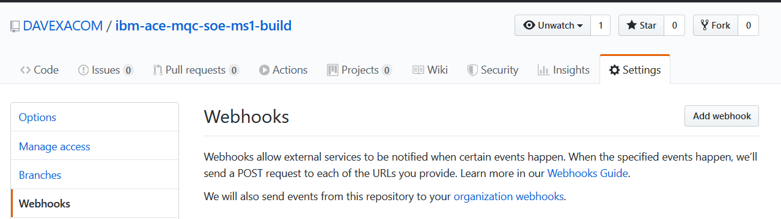

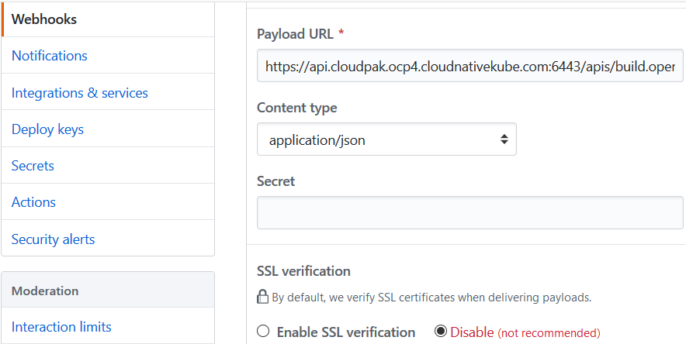

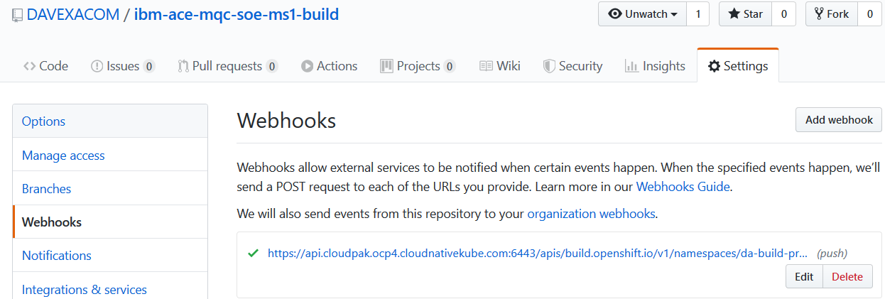

### Push a README.MD update to Test trigger fires

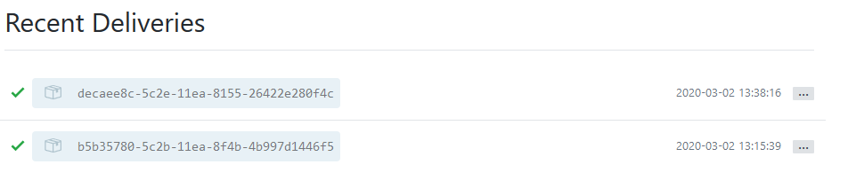

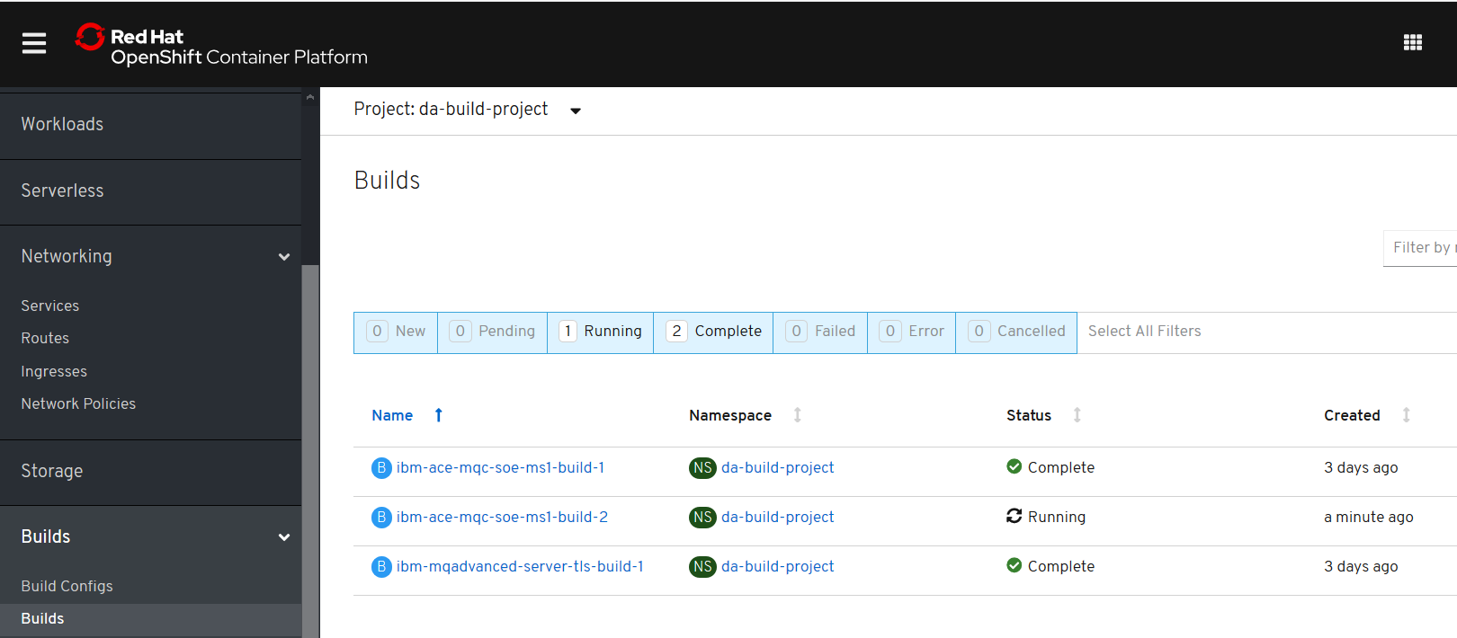

## Build and run ACE Microservice 2 from ACE SoE on RHOS

### Creds for ICP4i

RHOCP console:

<https://console-openshift-console.apps.cloudpak.ocp4.cloudnativekube.com/dashboard>

davearno

passw0rd1234

Kubeadmin

UqJrM-aKo2y-VYnYi-QiuBV

### Github/dockerhub

<https://github.com/DAVEXACOM/ibm-ace-mqc-soe-ms2-build>

<https://hub.docker.com/repository/docker/davexacom/ace11002mqc91soe>

Build from <https://hub.docker.com/repository/docker/davexacom/ace11002mqc91soe>

Using a version of <https://github.com/DAVEXACOM/ACEonICPIntMicSrv2Img>

Which is at <https://github.com/DAVEXACOM/ibm-ace-mqc-soe-ms2-build>

### Code for ACE Microservice2

[https://github.com/DAVEXACOM/ACEonICPIntMicSrv2](https://github.com/DAVEXACOM/ACEonICPIntMicSrv21)

### Code for ACE Liveliness probe

<https://github.com/DAVEXACOM/ACEonICPIntMicSoE>

## Deploying ACE microservice to RHOS

#### oc login --token=WM4a6Lj9Vj67U626gJ8Z897Cijr-OnjG-KcVxPhPk1Q --server=https://api.cloudpak.ocp4.cloudnativekube.com:6443

#### oc project da-build-project

@DA2@ I don’t think you need the oc create of the image stream for the input. The oc new-build seem to take care of that via the FROM

~~oc create -f c:\openshift\data\build-ace-custom.yaml~~

#### oc new-build <https://github.com/DAVEXACOM/ibm-ace-mqc-soe-ms2-build.git>

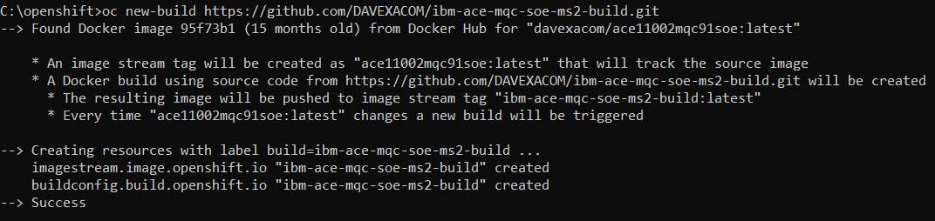

### Review image streams

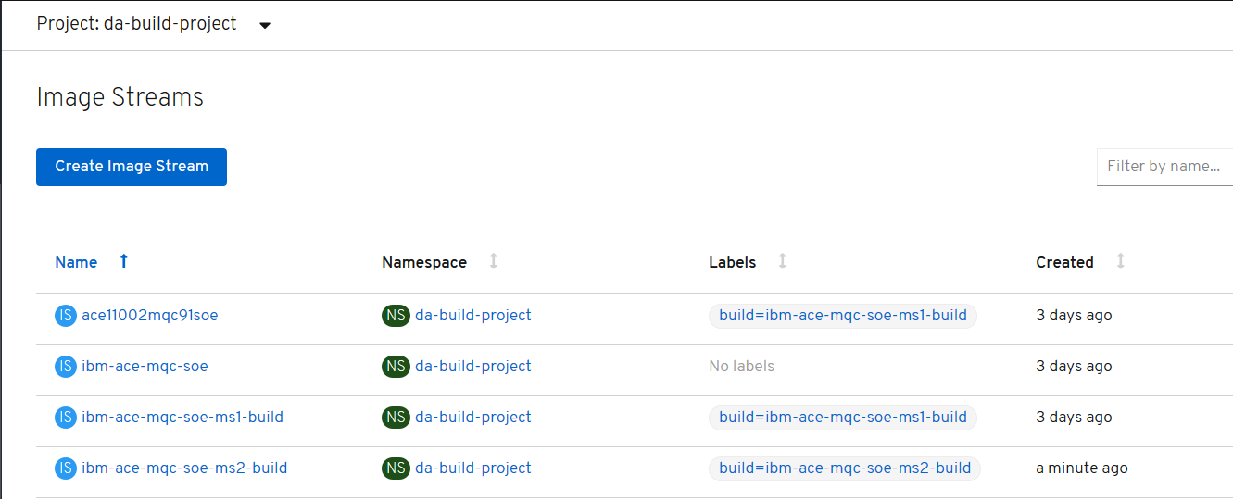

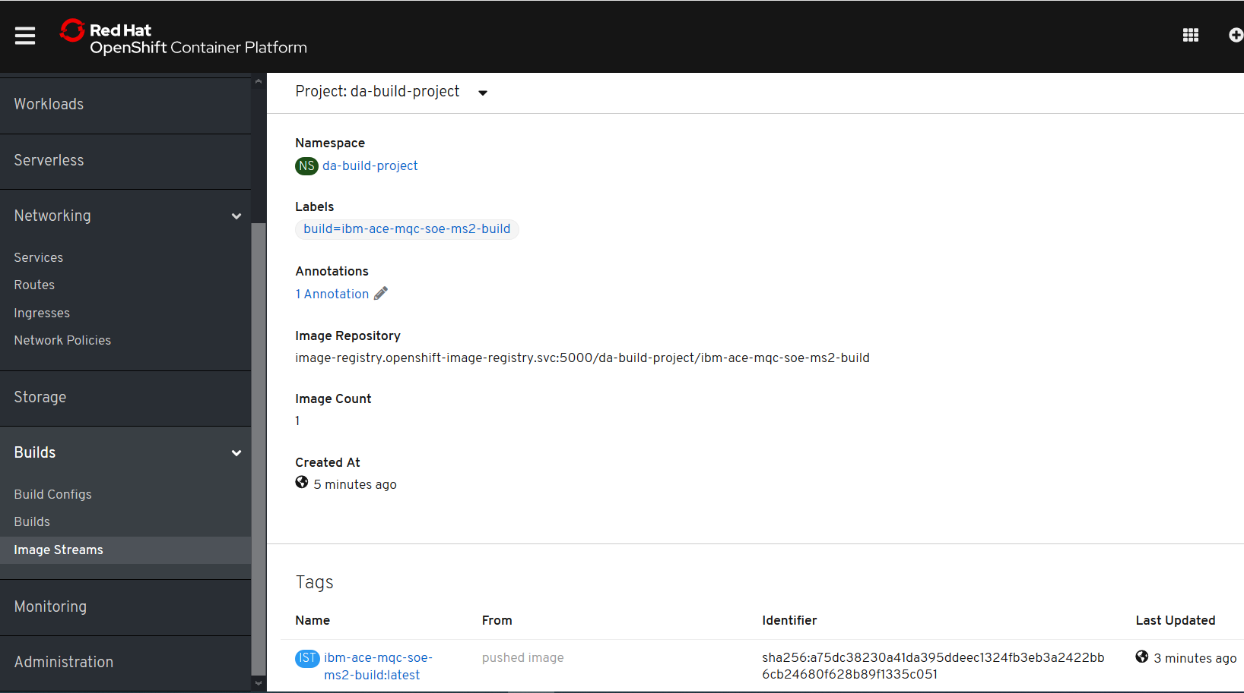

### Review builds

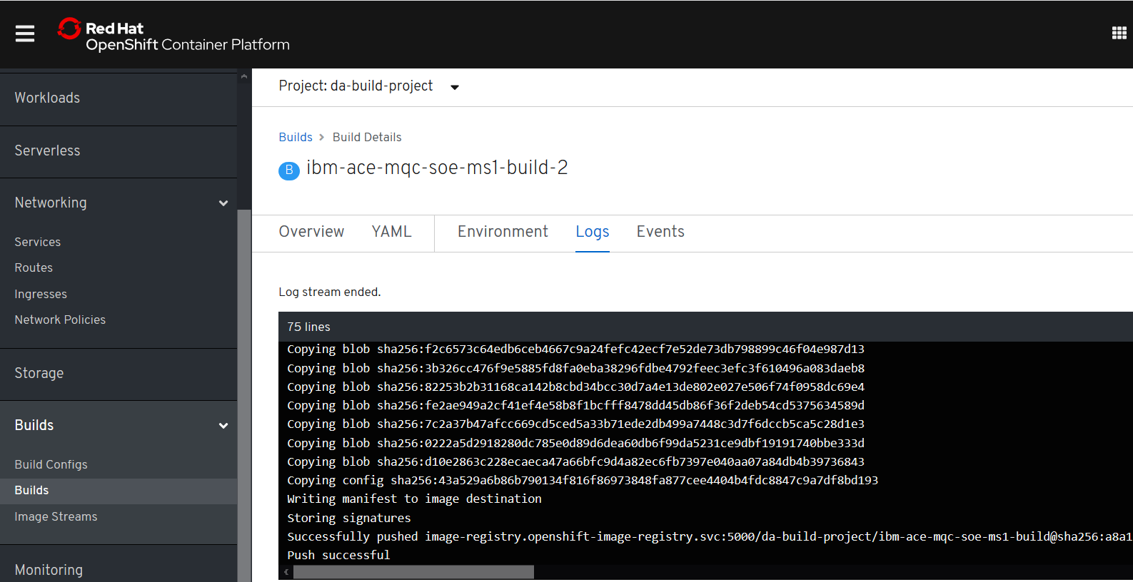

#### oc new-app ibm-ace-mqc-soe-ms2-build --env LICENSE=accept

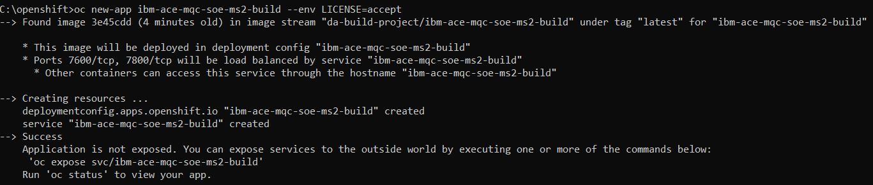

### Review service

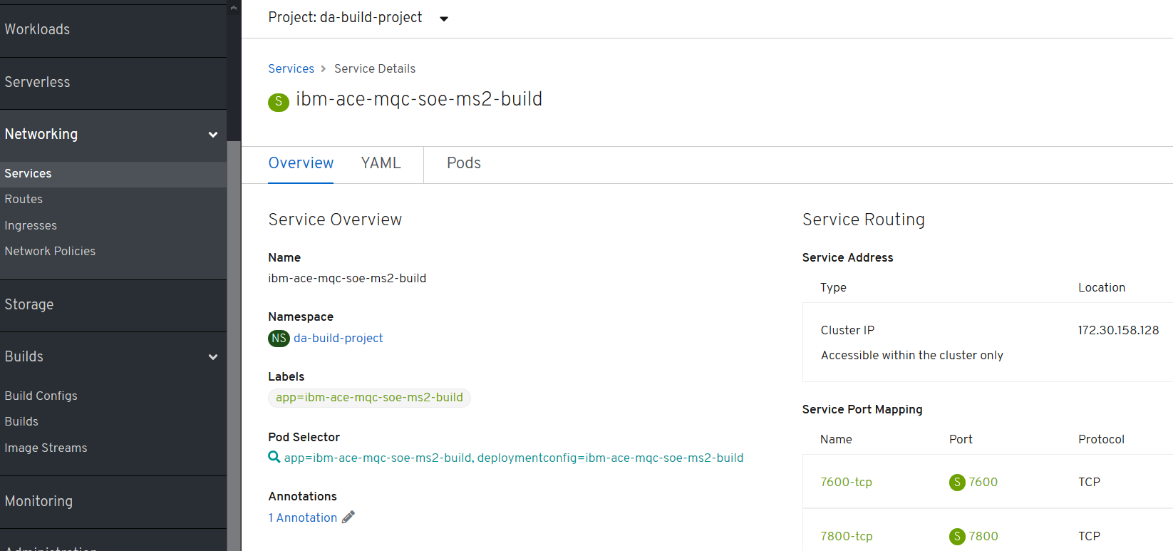

### Review deployment config

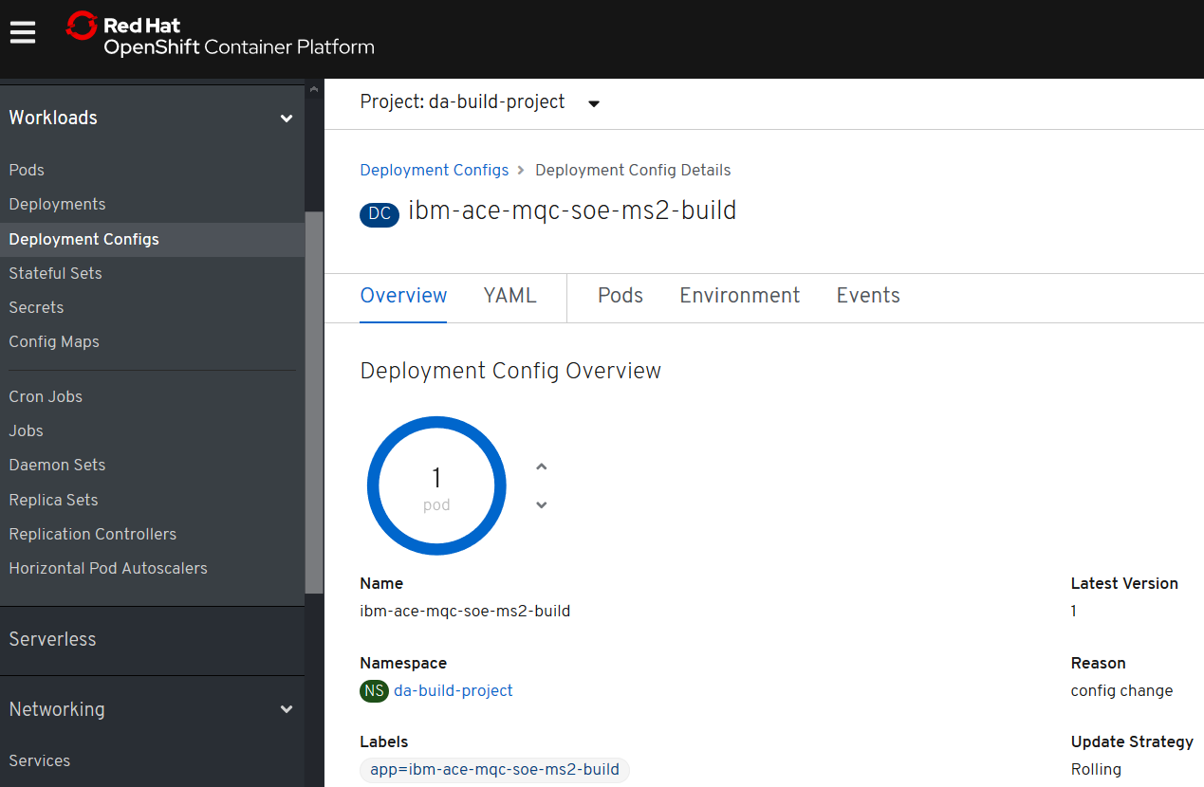

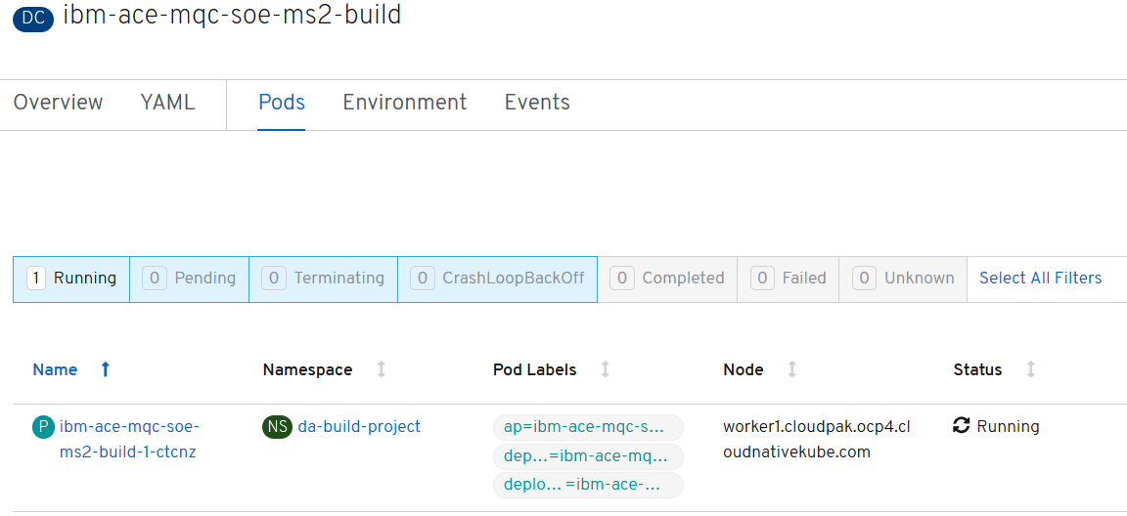

#### oc create -f c:\openshift\data\create-acems2-route.yaml



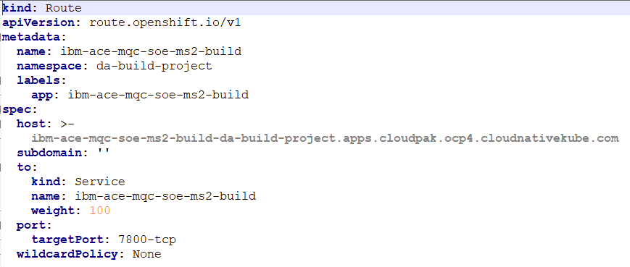

kind: Route

apiVersion: route.openshift.io/v1

metadata:

name: ibm-ace-mqc-soe-ms2-build

namespace: da-build-project

labels:

app: ibm-ace-mqc-soe-ms2-build

spec:

host: >-

ibm-ace-mqc-soe-ms2-build-da-build-project.apps.cloudpak.ocp4.cloudnativekube.com

subdomain: ''

to:

kind: Service

name: ibm-ace-mqc-soe-ms2-build

weight: 100

port:

targetPort: 7800-tcp

wildcardPolicy: None

#### oc get routes



## Test the ACE microservices on RHOS

### Test the liveliness probe in the MS2 container

<http://ibm-ace-mqc-soe-ms2-build-da-build-project.apps.cloudpak.ocp4.cloudnativekube.com/livelinessProbe/v1/message>

{“Messages”:[“test”]}

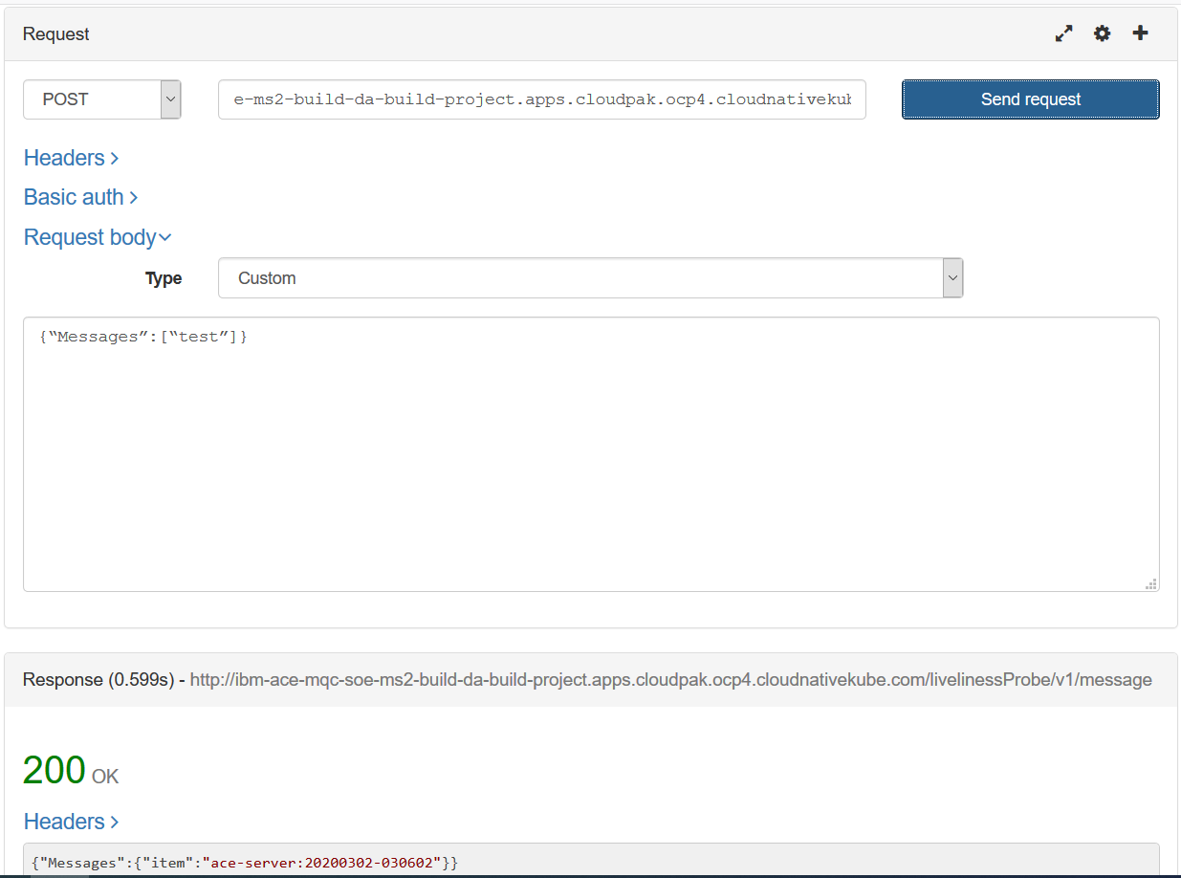

### Test microservice 2 in the MS2 container

### <http://ibm-ace-mqc-soe-ms2-build-da-build-project.apps.cloudpak.ocp4.cloudnativekube.com/microservice2/v1/message>

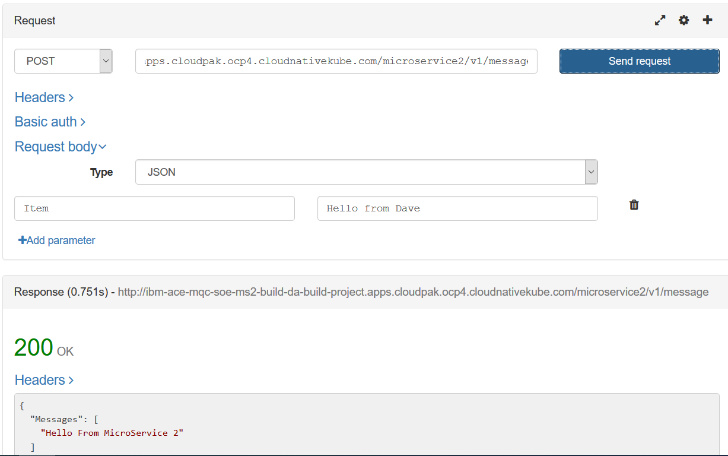

### Create the webhook trigger in Github

### Get Webhook details from the build config

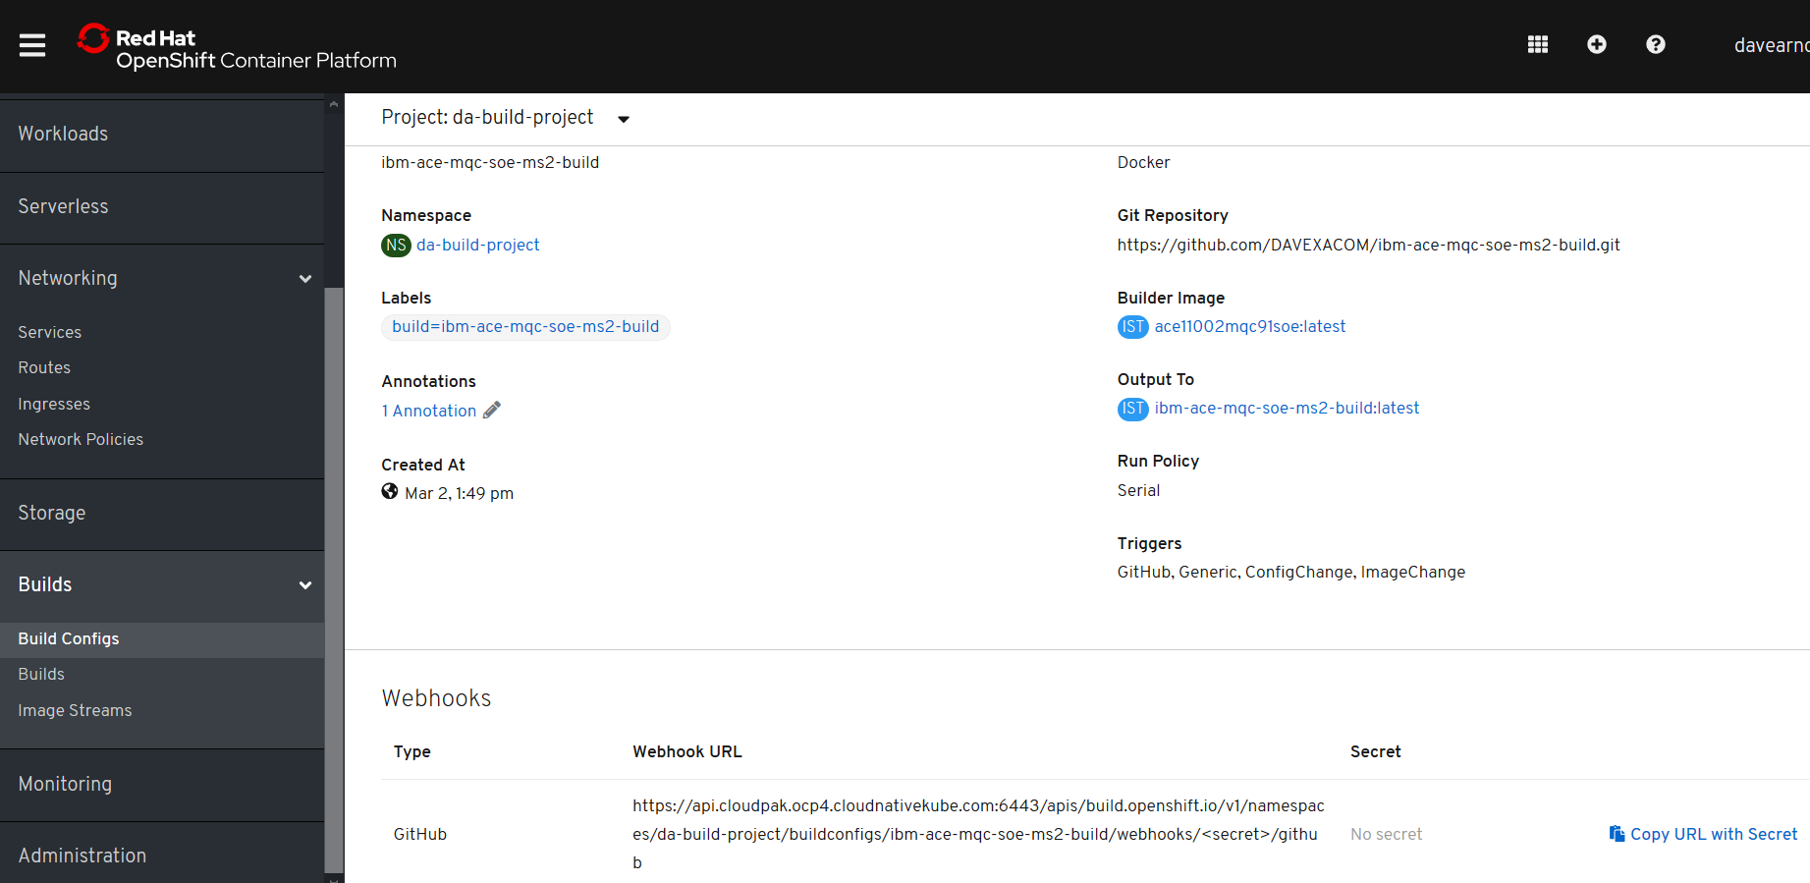

[https://api.cloudpak.ocp4.cloudnativekube.com:6443/apis/build.openshift.io/v1/namespaces/da-build-project/buildconfigs/ibm-ace-mqc-soe-ms2-build/webhooks/<secret>/github](https://api.cloudpak.ocp4.cloudnativekube.com:6443/apis/build.openshift.io/v1/namespaces/da-build-project/buildconfigs/ibm-ace-mqc-soe-ms2-build/webhooks/%3csecret%3e/github)

<https://api.cloudpak.ocp4.cloudnativekube.com:6443/apis/build.openshift.io/v1/namespaces/da-build-project/buildconfigs/ibm-ace-mqc-soe-ms2-build/webhooks/PJyT27d09q73G2hl71JB/github>

### Create webhook in github

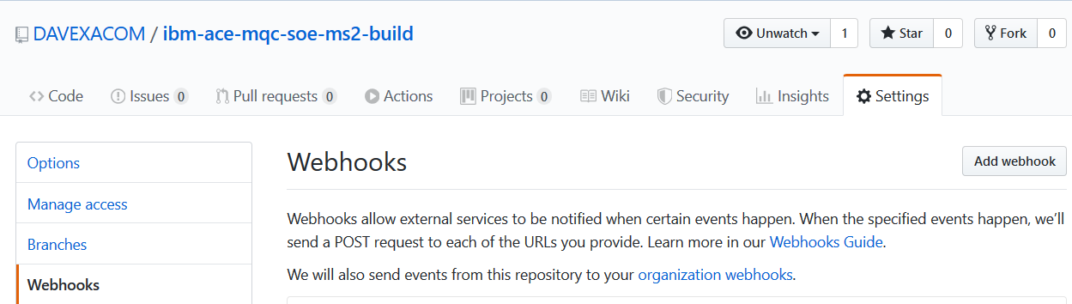

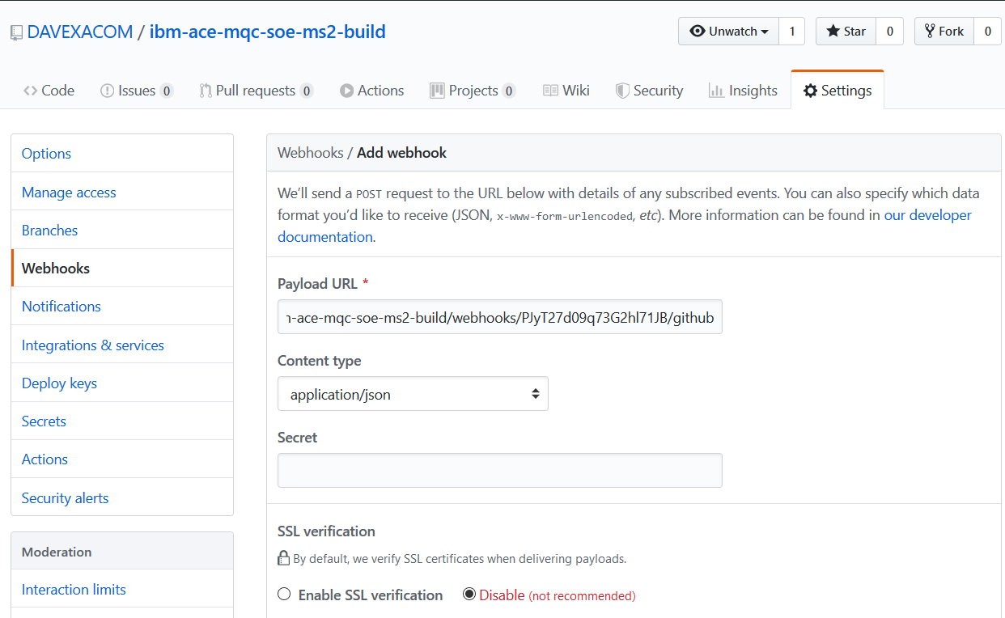



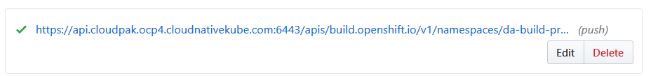

### Update Microservice2 and trigger a new build

#### Change ACE MS2 service in ACE Toolkit

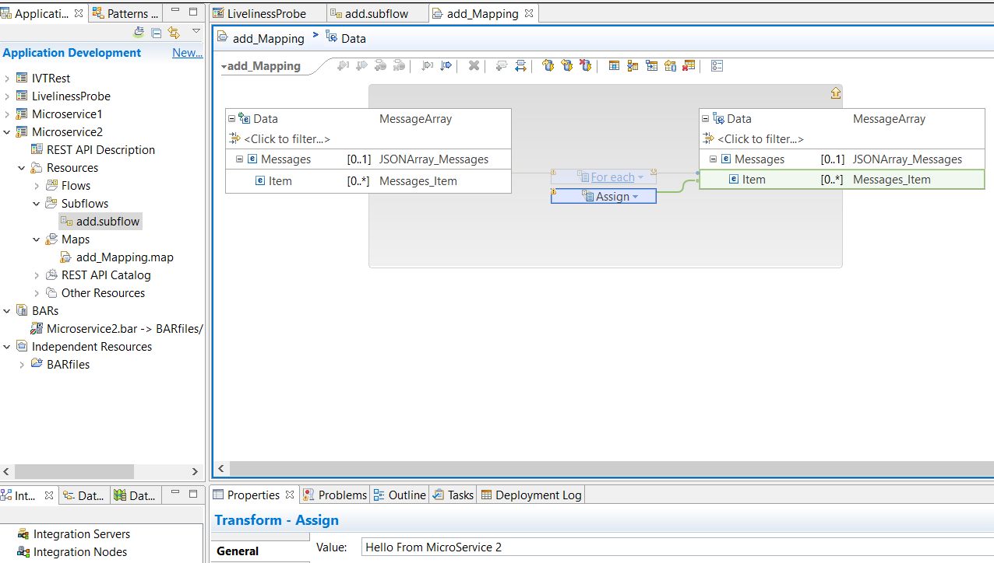

Change the test in the value property for the assign

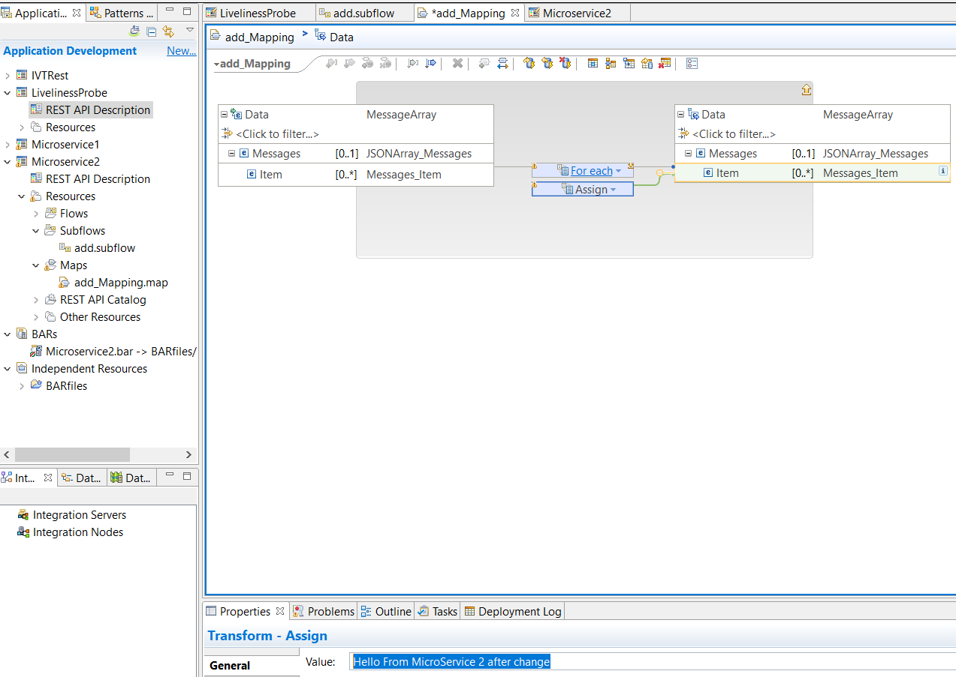

#### Save and update BAR

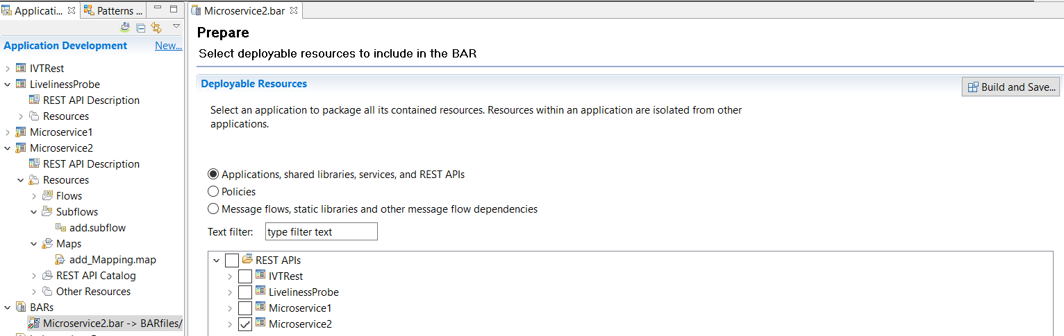

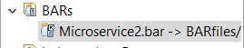note its updated

#### Export the BAR to the local Git repos

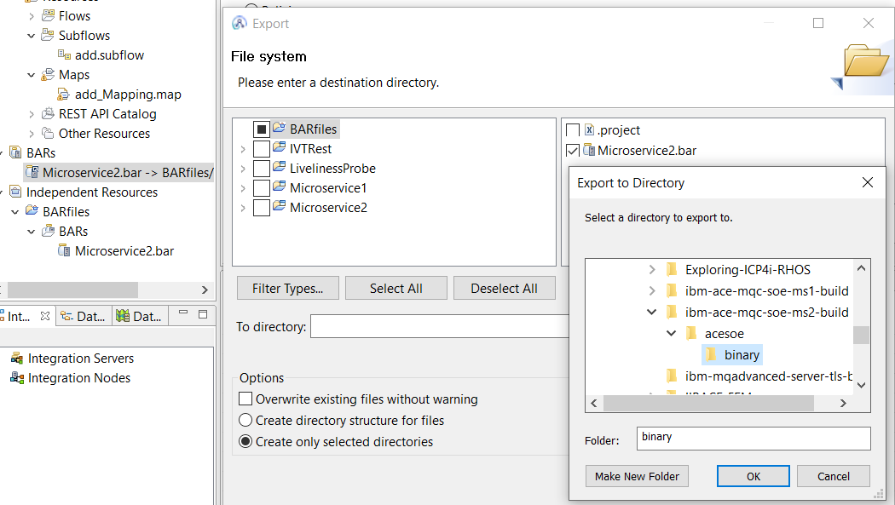

### Git client rescan – pick up the change

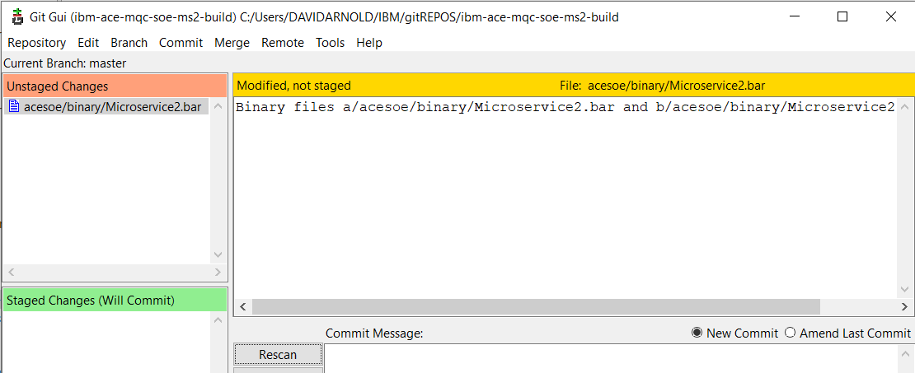

### Push to github

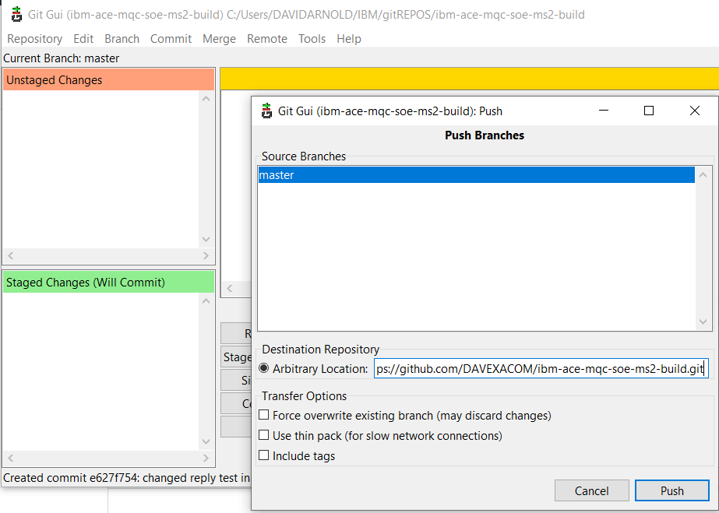

### Observe webhook fire in github

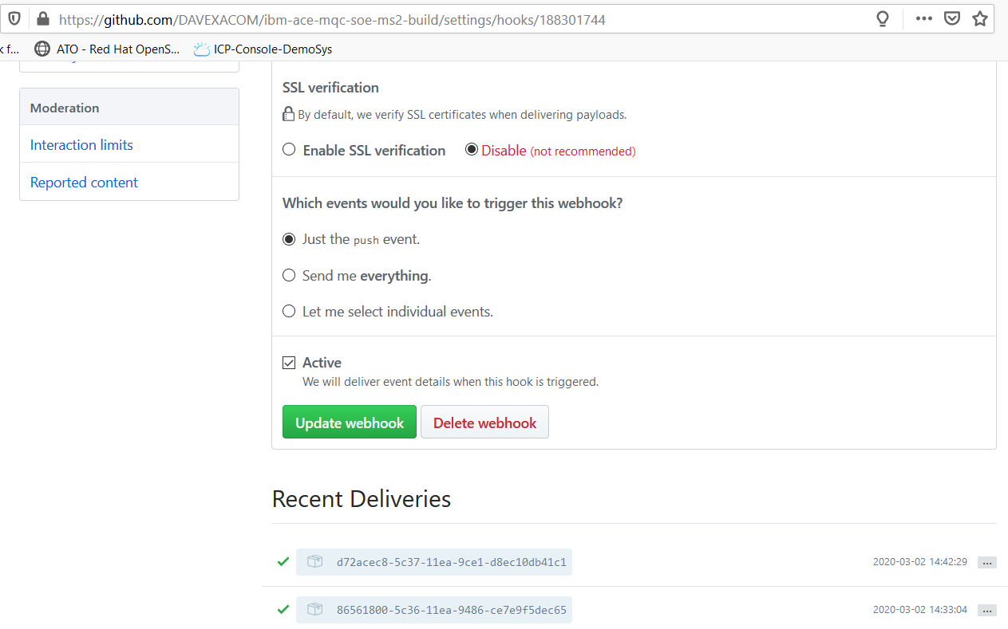

### Observe new build in RHOS

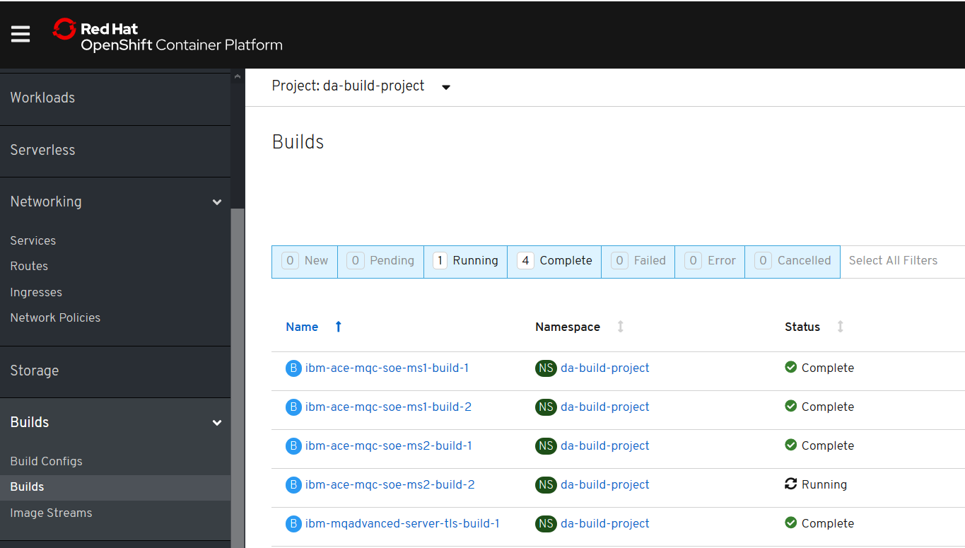

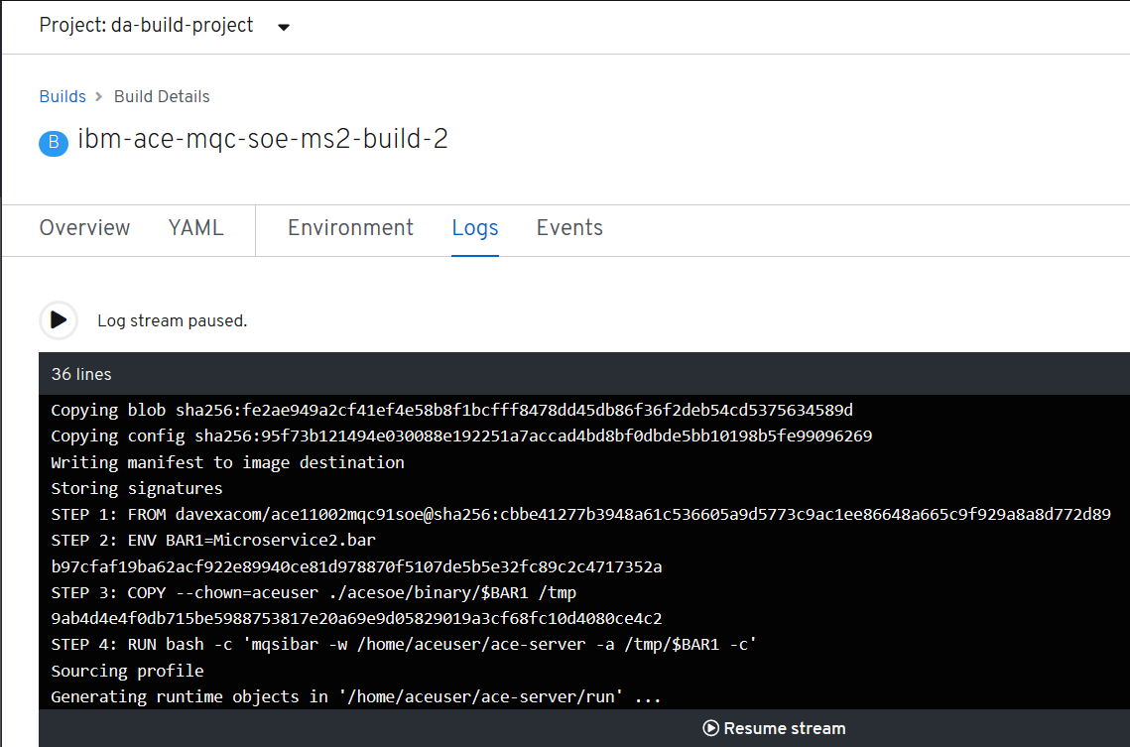



### Retest the ACE MS2 service

#### Navigate to the running pod for ace MS2

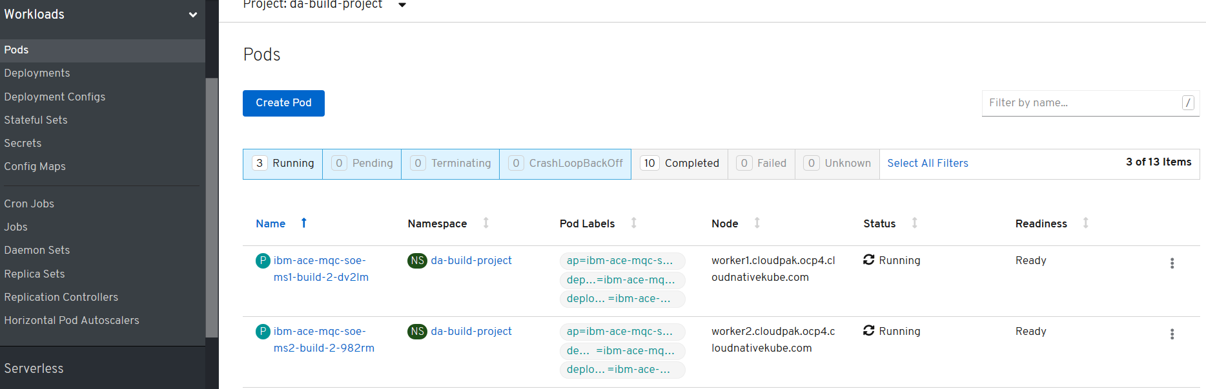

### New Version of Container via Deployment Configuration – Rolling trigger on image change

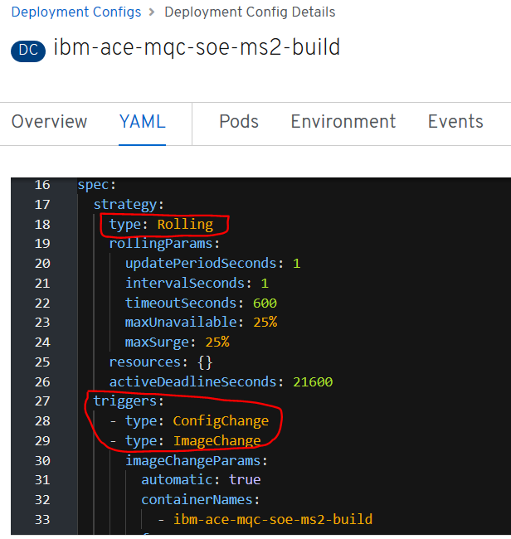

#### New version of the container via manual pod restart

Delete the pod for [ibm-ace-mqc-soe-ms2-build-2-m7b68](https://console-openshift-console.apps.cloudpak.ocp4.cloudnativekube.com/k8s/ns/da-build-project/pods/ibm-ace-mqc-soe-ms2-build-2-m7b68)

Can be done through the UI or oc get pods, oc delete pod

### Test the rest service

<http://ibm-ace-mqc-soe-ms2-build-da-build-project.apps.cloudpak.ocp4.cloudnativekube.com/microservice2/v1/message>

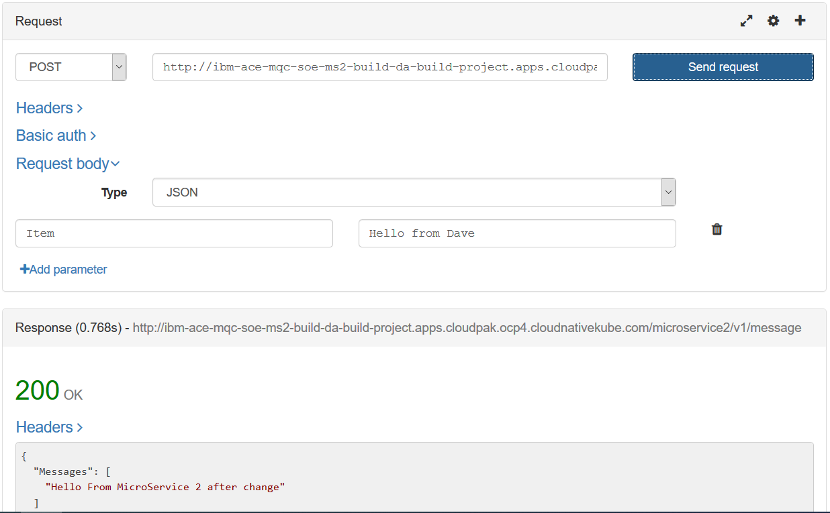

## Connecting ACE MS1 to ACE MS2 in the RHOS cluster

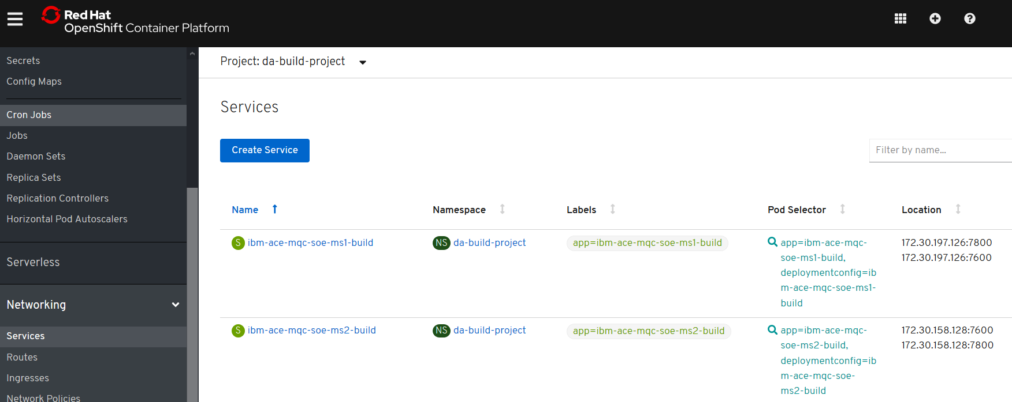

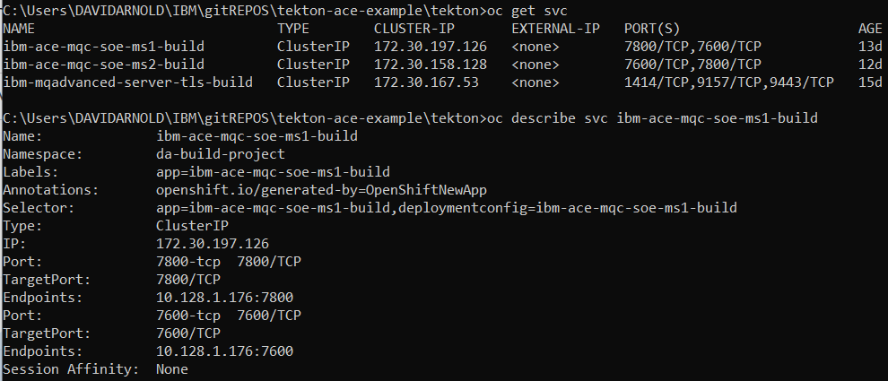

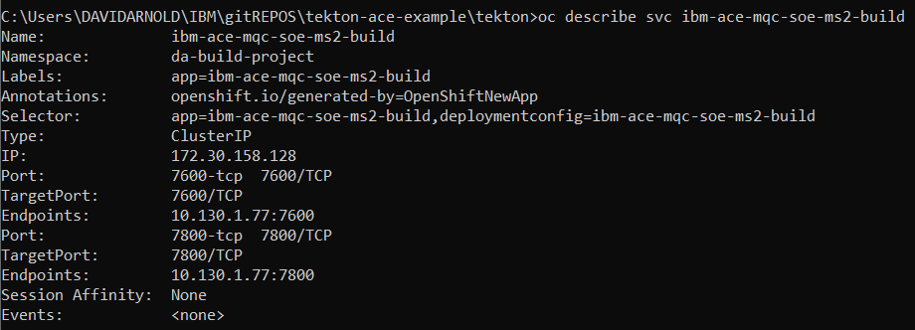

### Cluster IPs for ACE microservices

Cluster IP for ibm-ace-mqc-soe-ms1-build = 172.30.197.126:7800

Cluster IP for ibm-ace-mqc-soe-ms2-build = 172.30.158.128:7800

### K8s DNS names for ACE microservices

Intra cluster use the service name.

DNS = ibm-ace-mqc-soe-ms1-build

DNS = ibm-ace-mqc-soe-ms2-build

### Public IP for ACE microservice 1 – rest requesst

**POST to:**

<http://ibm-ace-mqc-soe-ms1-build-da-build-project.apps.cloudpak.ocp4.cloudnativekube.com/microservice1/v1/message>

**with data:**

{"Messages":["Hello From Test Client"]}

### Calling ms2 from ms1

<http://ibm-ace-mqc-soe-ms2-build:7800/microservice2/v1>

Source code change

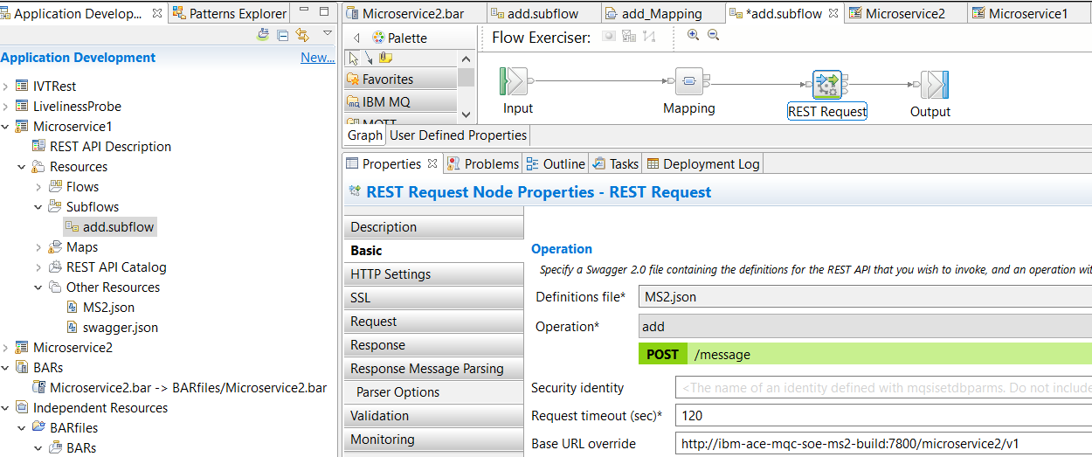

OR BAR deployment descriptor override

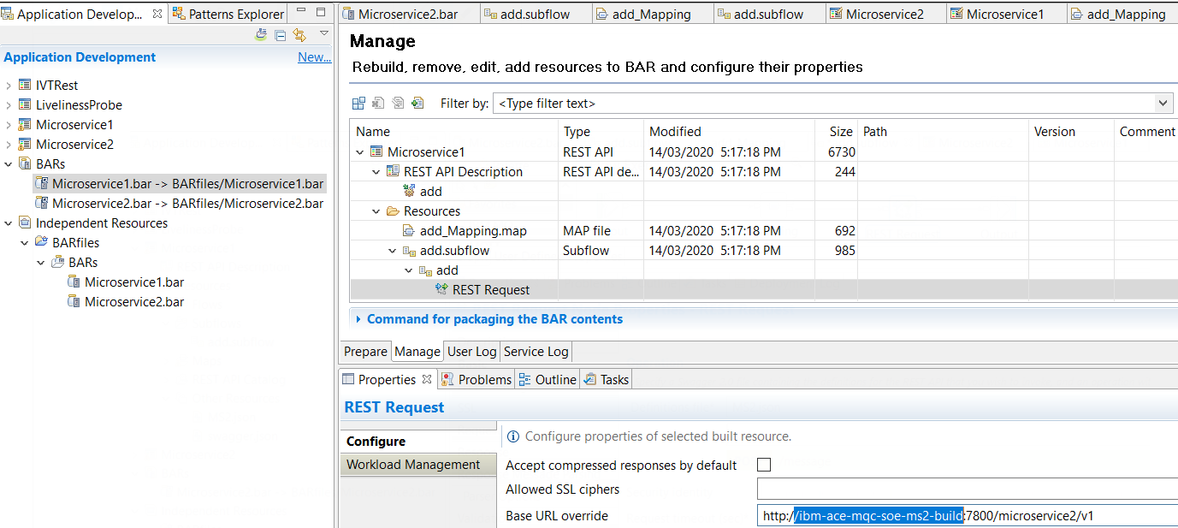

Export to local GitRepo

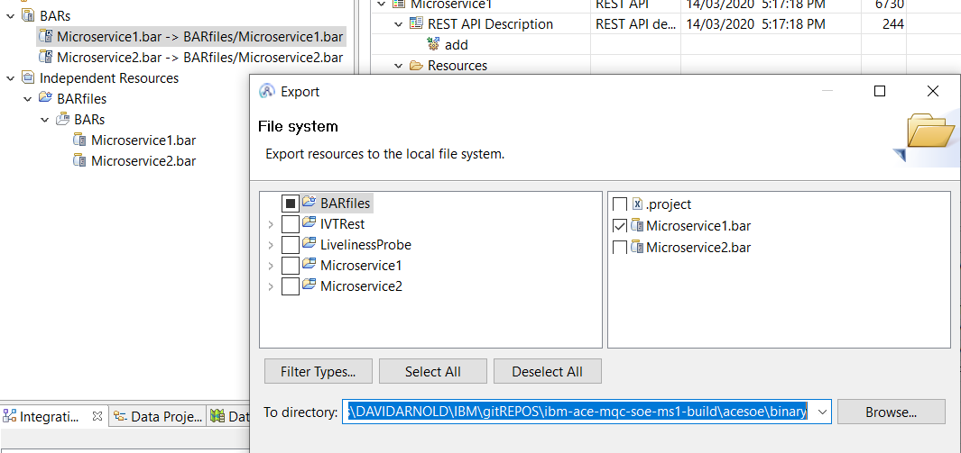

Git push

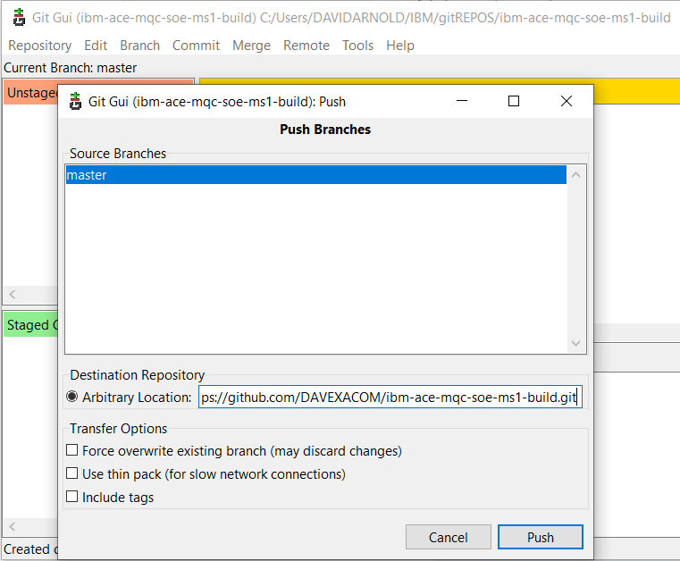

Check the build

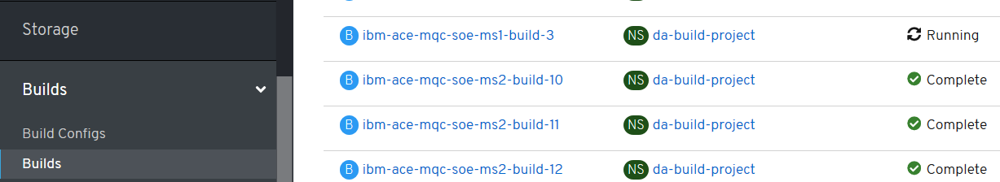

### Test ACE MS2 calling ACE MS2

POST

### <http://ibm-ace-mqc-soe-ms1-build-da-build-project.apps.cloudpak.ocp4.cloudnativekube.com/microservice1/v1/message>

Data

### {"Messages":["Hello From Test Client"]}

Using REST Client

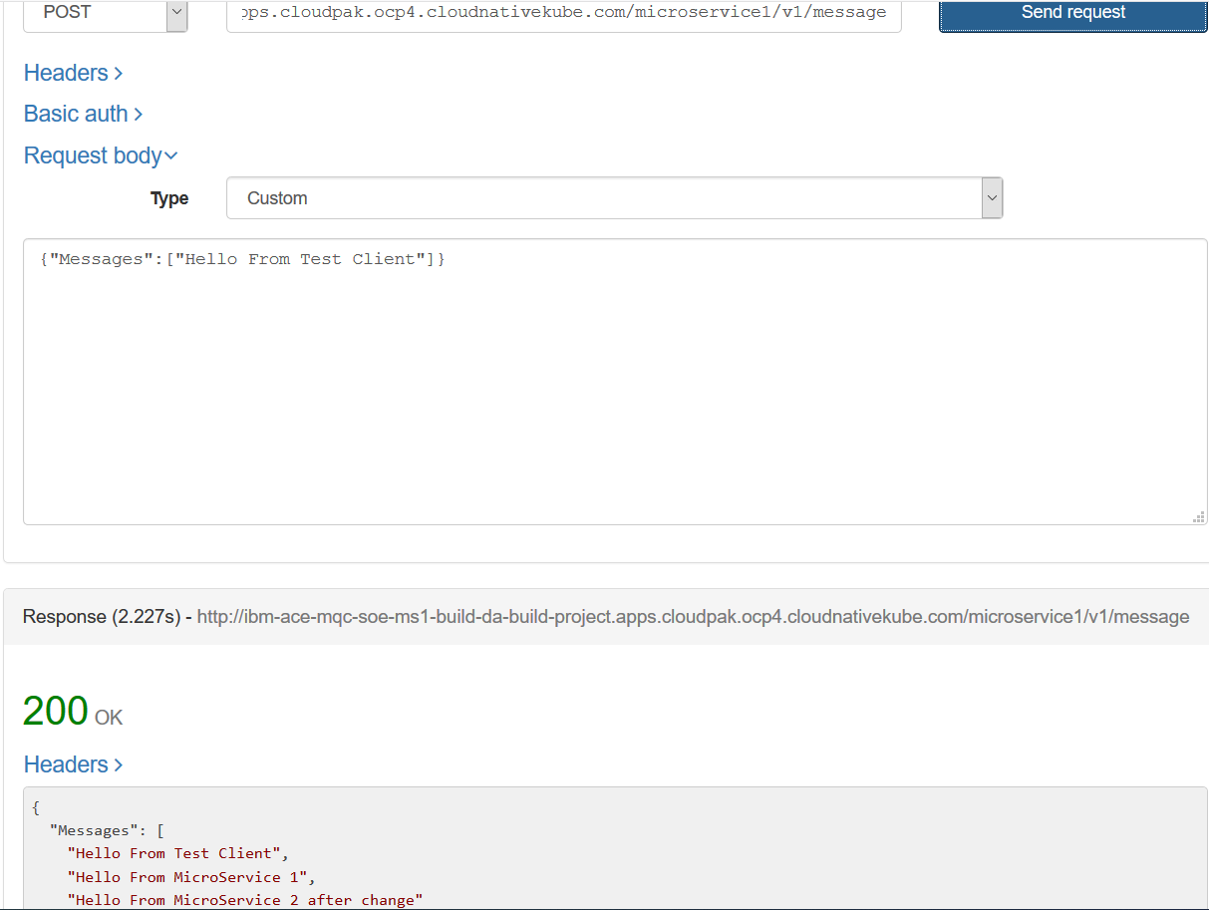

# ACE MS 3 – REST Service exposing off RHOS cluster MQ QMGR

## ACE Microservice 3 Project and Code

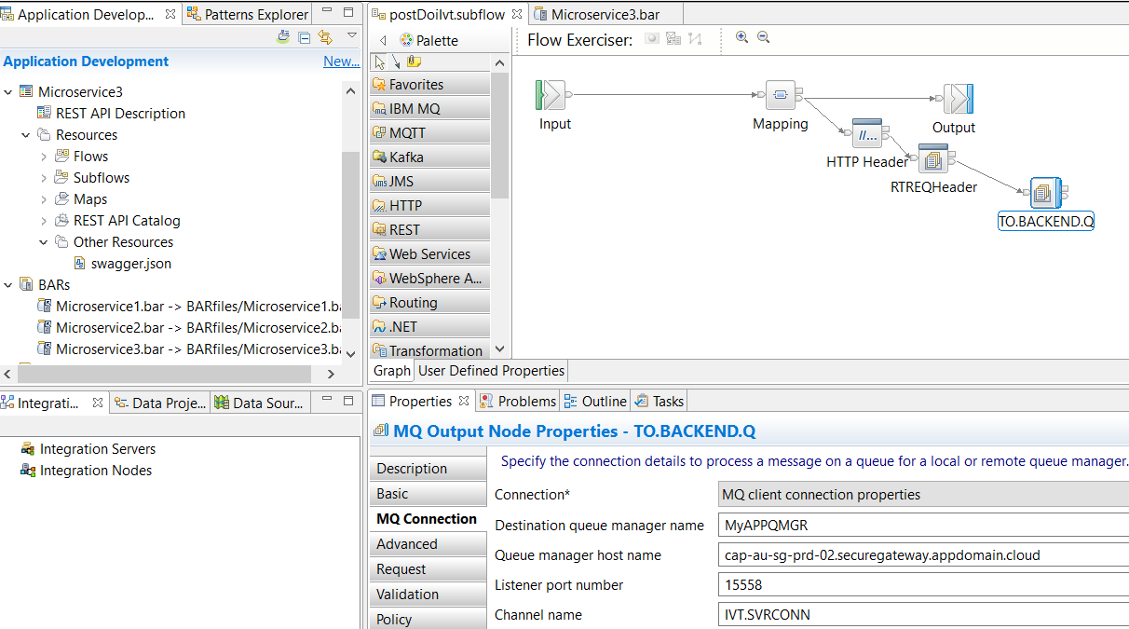

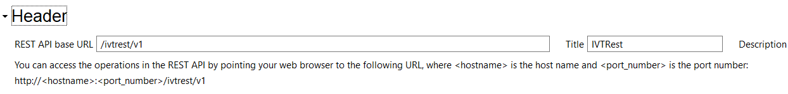

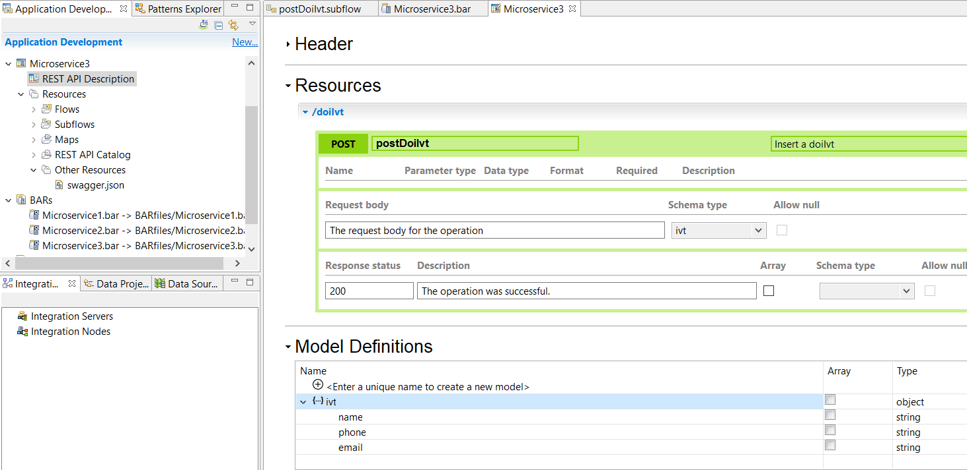

## ACE Microservice 3 GitHub repos

<https://github.com/DAVEXACOM/ibm-ace-mqc-soe-ms3-build>

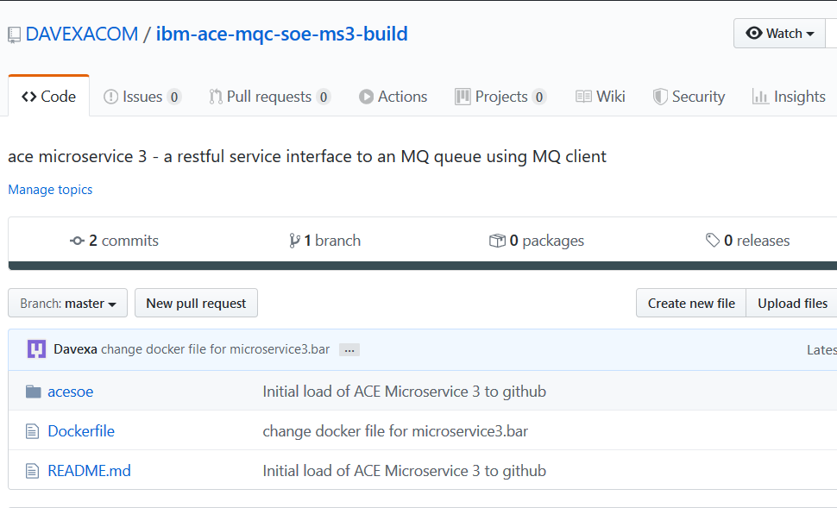

## ACE Microservice 3 RHOS set up

oc login --token=icMK5QdKiseLa0-kREUcCvYHoK0hCrZr0W9QB6rUs_Y --server=https://api.cloudpak.ocp4.cloudnativekube.com:6443

oc new-build https://github.com/DAVEXACOM/ibm-ace-mqc-soe-ms3-build.git

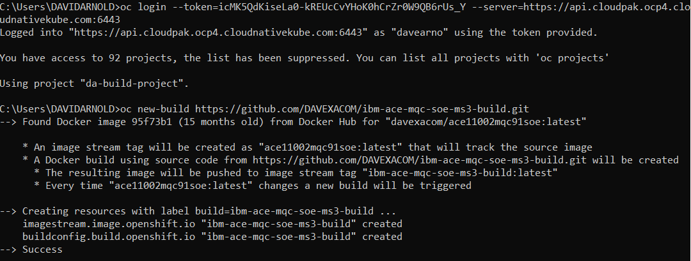

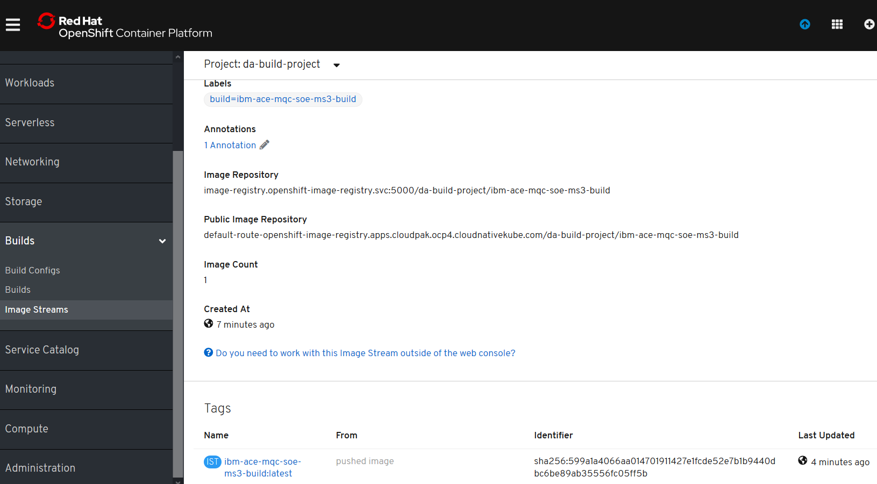

oc new-app ibm-ace-mqc-soe-ms3-build --env LICENSE=accept

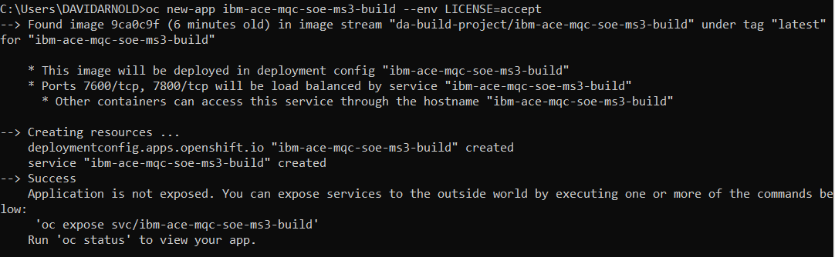

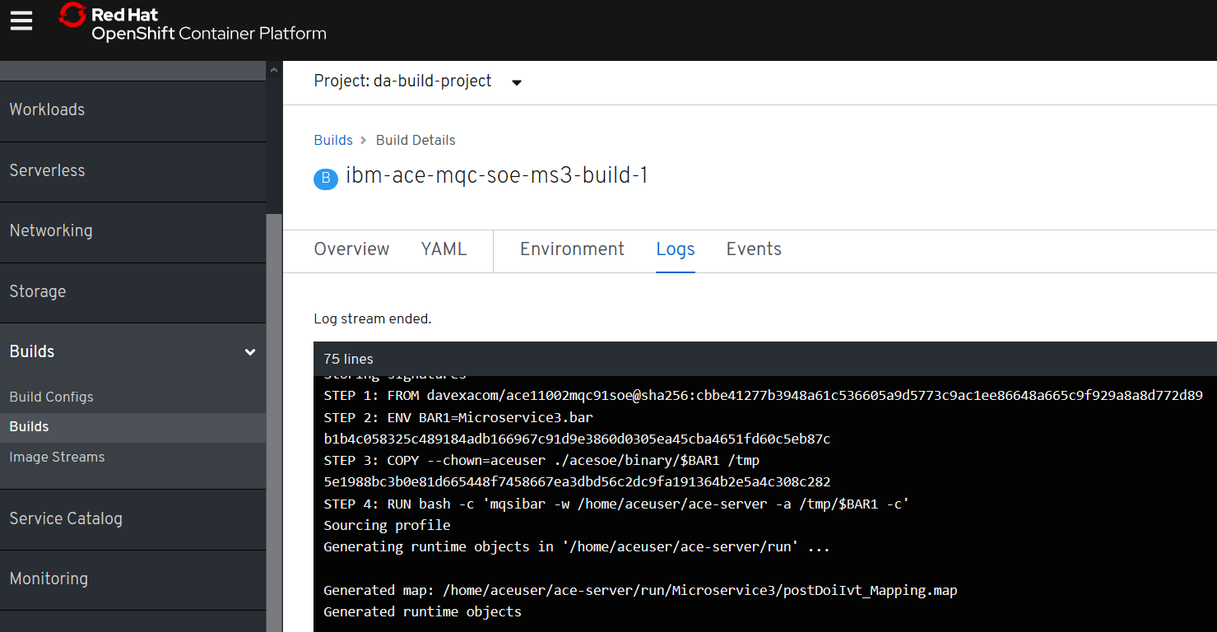

oc create -f c:\openshift\data\create-ace-route.yaml

kind: Route

apiVersion: route.openshift.io/v1

metadata:

name: ibm-ace-mqc-soe-ms3-build

namespace: da-build-project

labels:

app: ibm-ace-mqc-soe-ms3-build

spec:

host: >-

ibm-ace-mqc-soe-ms3-build-da-build-project.apps.cloudpak.ocp4.cloudnativekube.com

subdomain: ''

to:

kind: Service

name: ibm-ace-mqc-soe-ms3-build

weight: 100

port:

targetPort: 7800-tcp

wildcardPolicy: None



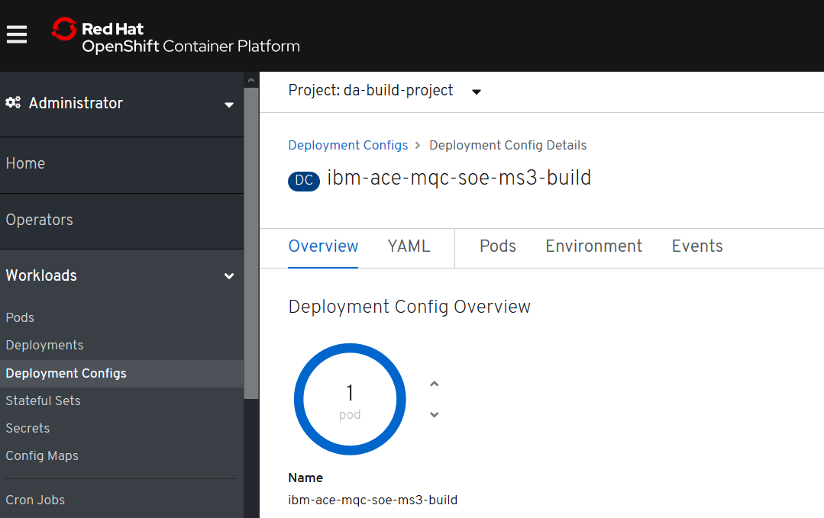

## IBM MQ Queue Manager

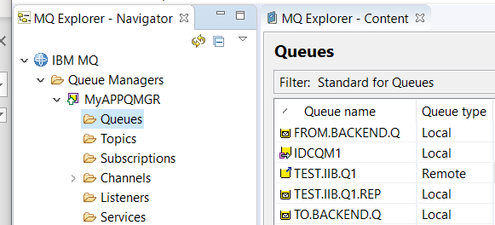

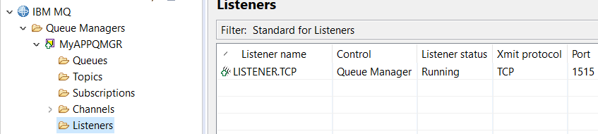

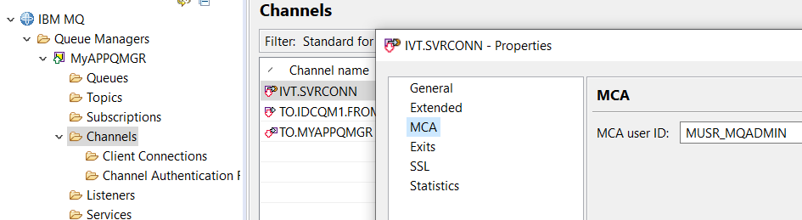

### Channel creation for Linux based queue manager

DEFINE CHANNEL(IVT.SVRCONN) CHLTYPE(SVRCONN) REPLACE

SET CHLAUTH(IVT.SVRCONN) TYPE(BLOCKUSER) USERLIST(nobody)

ALTER AUTHINFO(SYSTEM.DEFAULT.AUTHINFO.IDPWOS) AUTHTYPE(IDPWOS) CHCKCLNT(NONE) ADOPTCTX(YES)

SET CHLAUTH(IVT.SVRCONN) TYPE (ADDRESSMAP) ADDRESS(*) MCAUSER('mqm')

REFRESH SECURITY TYPE(CONNAUTH)

### Channel creation for windows based queue manager

DEFINE CHANNEL(IVT.SVRCONN) CHLTYPE(SVRCONN) REPLACE

SET CHLAUTH(IVT.SVRCONN) TYPE(BLOCKUSER) USERLIST(nobody)

ALTER AUTHINFO(SYSTEM.DEFAULT.AUTHINFO.IDPWOS) AUTHTYPE(IDPWOS) CHCKCLNT(NONE) ADOPTCTX(YES)

SET CHLAUTH(IVT.SVRCONN) TYPE (ADDRESSMAP) ADDRESS(*) MCAUSER('MUSR_MQADMIN')

REFRESH SECURITY TYPE(CONNAUTH)

## IBM Secure Gateway Service – IBM Cloud

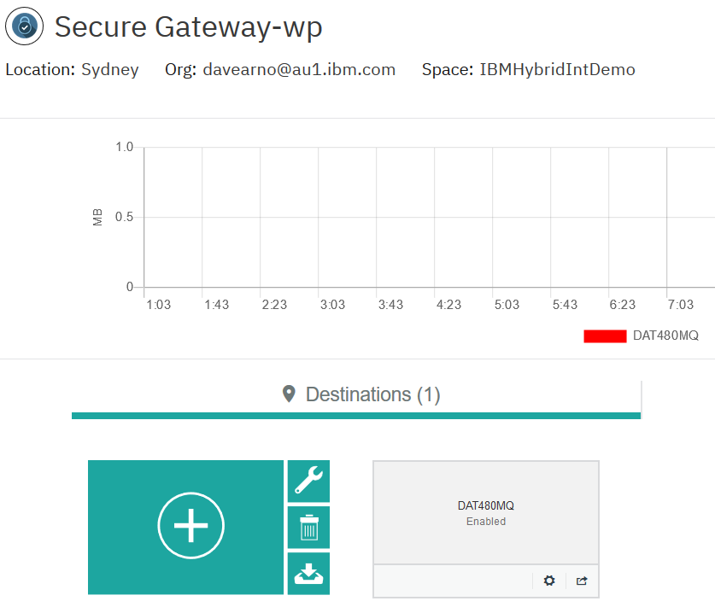

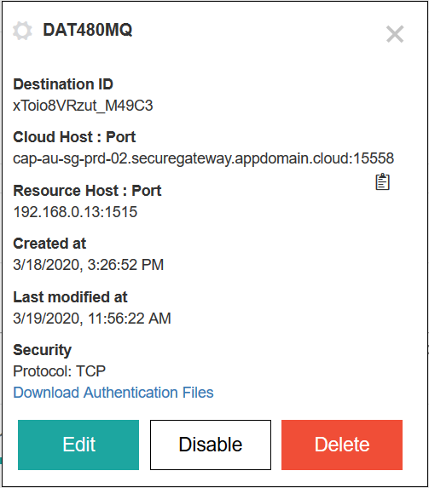

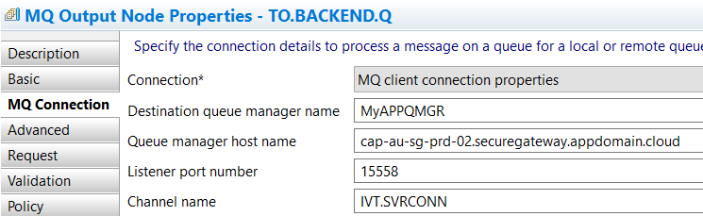

## IBM Secure Gateway Service – Client (Laptop end)

### Windows firewall

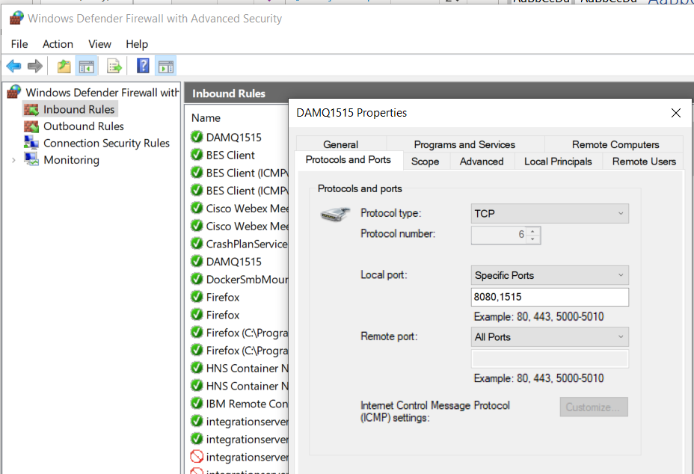

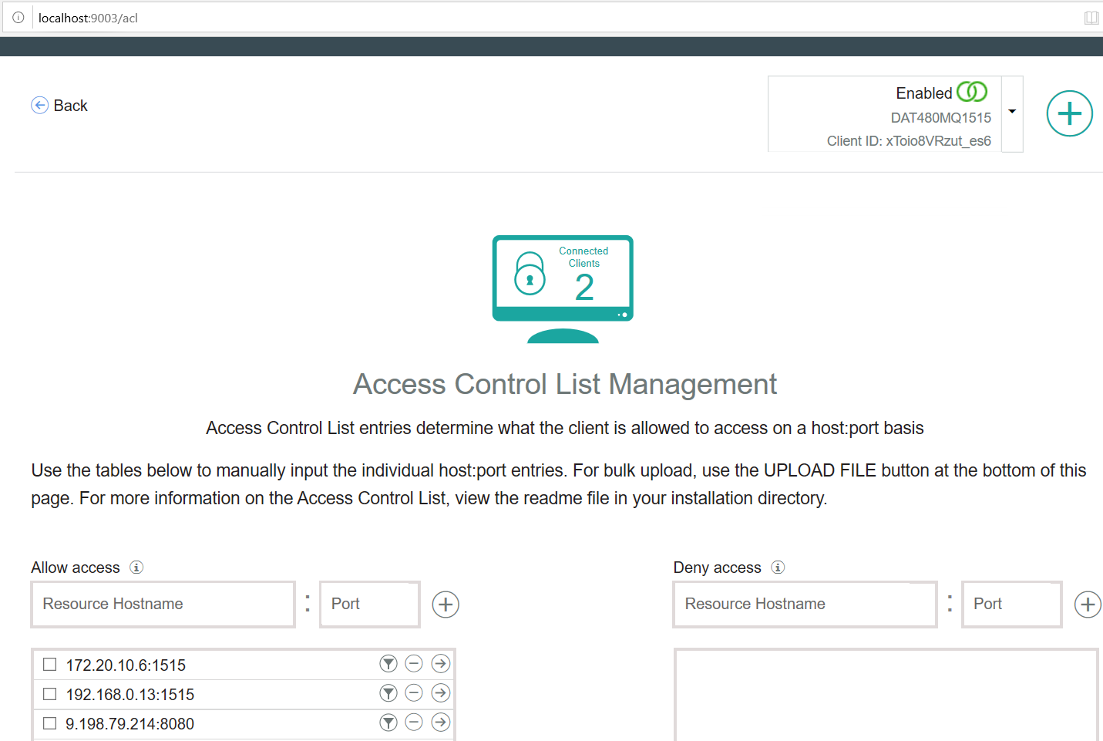

## Testing MQ via IBM Public IP – using RFHUTILC

IVT.SVRCONN/TCP/cap-au-sg-prd-02.securegateway.appdomain.cloud(15558)

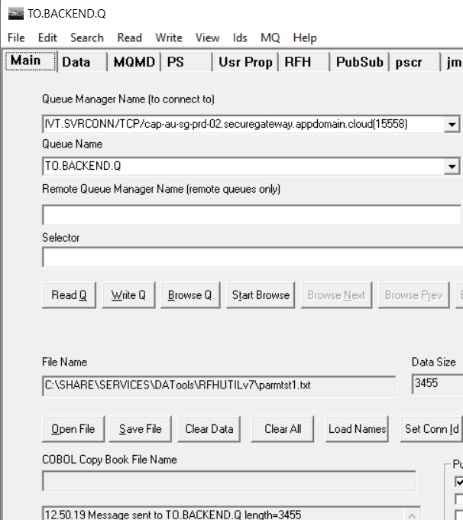

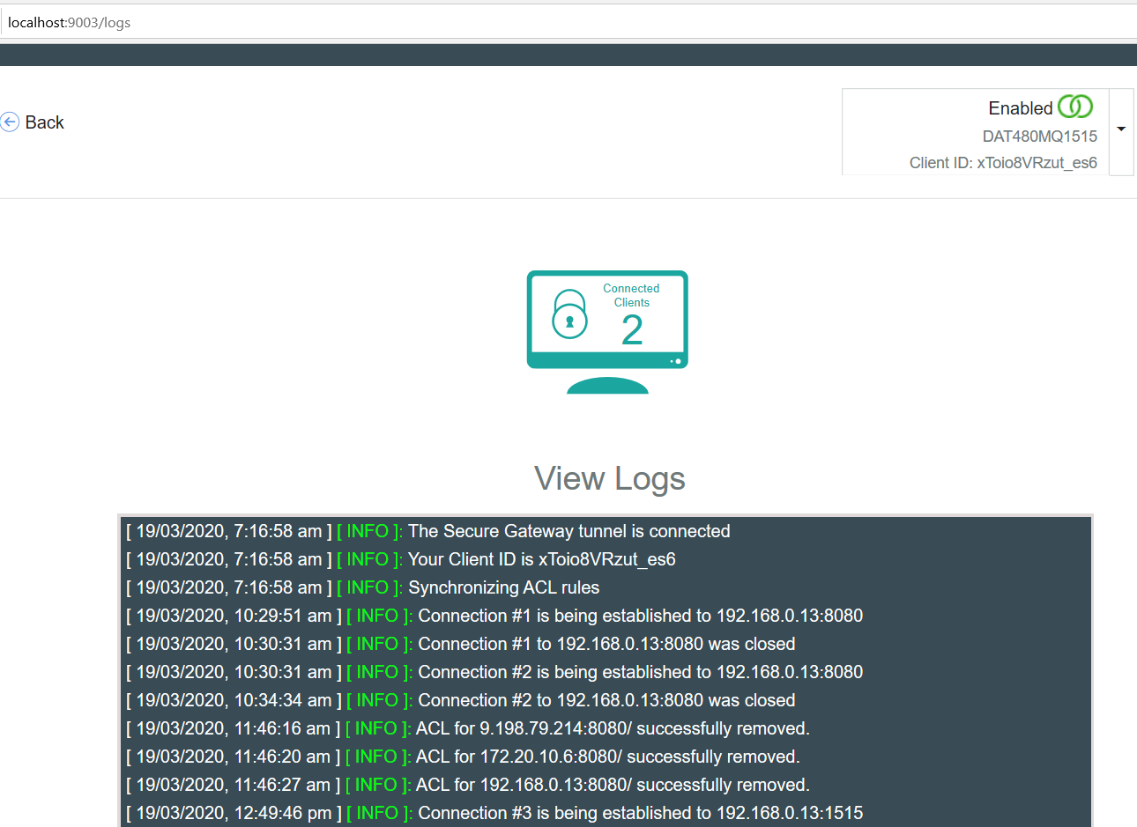

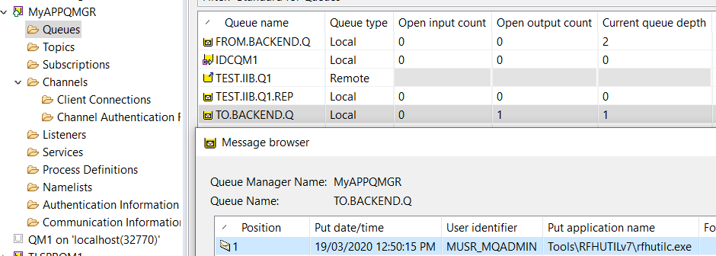

## Testing ACE Microservice 3 to Put to MQ via IBM Public IP

### Route for ACE MS3

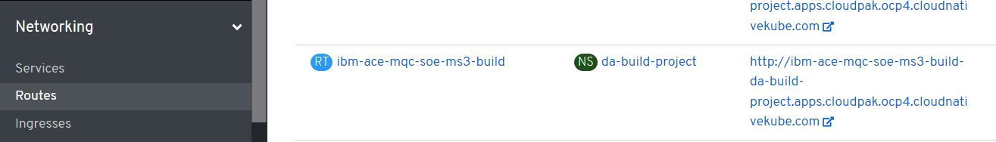

### URL for ACE MS3 service

<http://ibm-ace-mqc-soe-ms3-build-da-build-project.apps.cloudpak.ocp4.cloudnativekube.com/ivtrest/v1/doiIvt>

### Data to test ACE MS3 service

{

"name":"anyname",

"phone":"123545454",

"email": "anyname@host.com"

}

### Test with REST Client

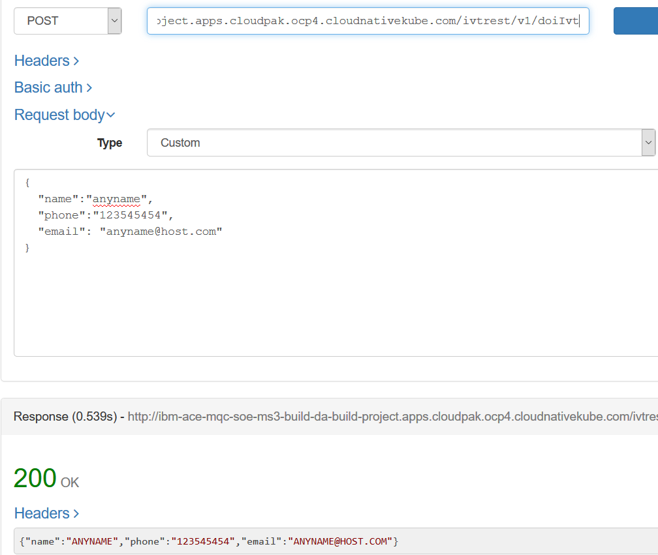

### Test Results

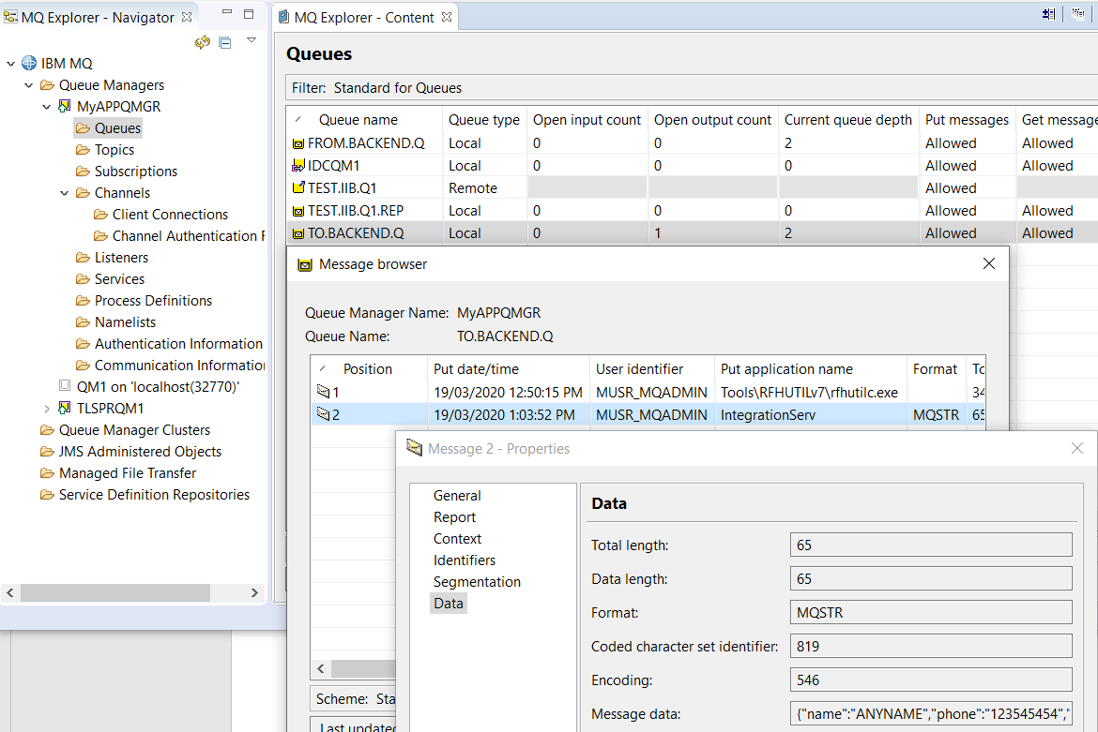

# OpenShift Pipelines - Tekton

## Catalog

Add the pipelines operator – it installs and manages the upgrade etc of pipelines

## Pipeline operator

Installs pipelines

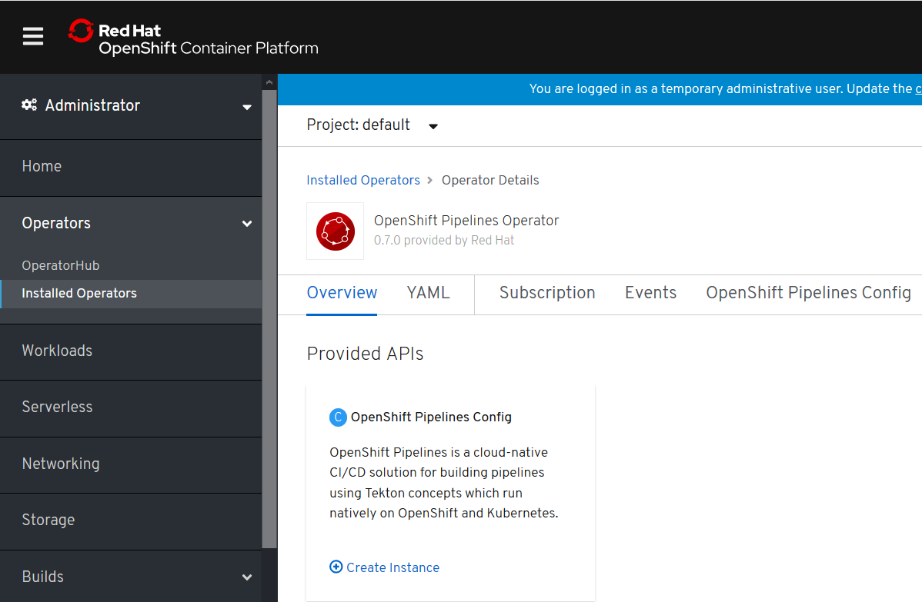

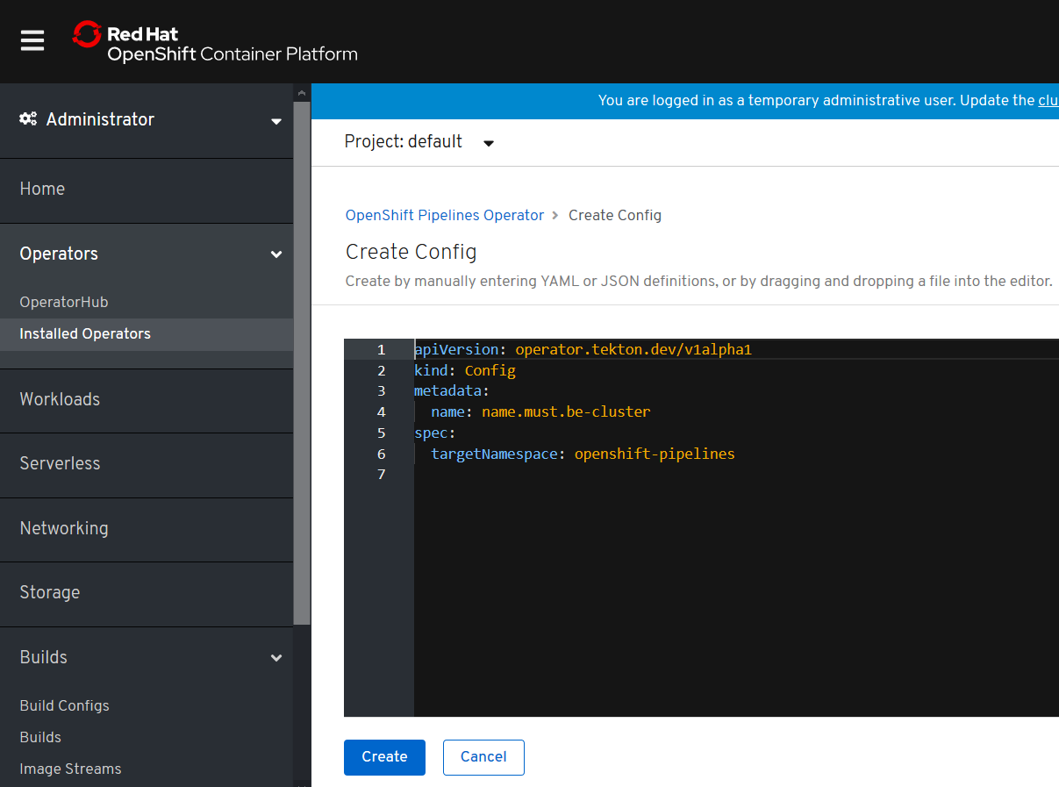

# Tekton ACE Example

## Example Environment

RHOS 4.2 on IBM Cloud – ICP4i is installed.

Namespace: da-build-project

### RHOS console

## <https://console-openshift-console.apps.cloudpak.ocp4.cloudnativekube.com/dashboards>

### Tekton dashboard

<https://tekton-dashboard-tekton-pipelines.apps.cloudpak.ocp4.cloudnativekube.com/#/namespaces/da-build-project/pipelines>

## GIT Repos for Tekton ACE Artifacts

<https://github.com/DAVEXACOM/tekton-ace-example>

## GIT Repos for ACE microservice (ACE MS2) to be tested

<https://github.com/DAVEXACOM/ibm-ace-mqc-soe-ms2-build>

## Tekton YAML files to be used

### Resources

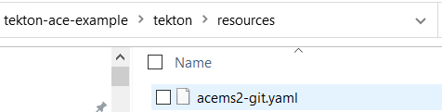

### Tasks

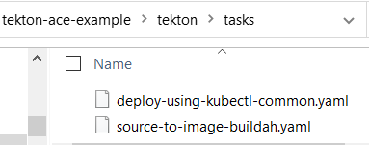

### Pipeline

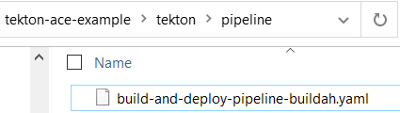

### PipelineRun

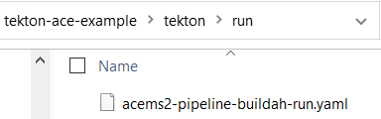

### Deployment Config YAML for the ACE MS2 service

This file is edited by the tekton deploy task so also exists (has a copy in) in the ace ms 2 respository

During the deploy step of the pipeline this file is edited to added the image name created in the build step. This then creates the deployment config with “rolling” strategy and trigger on image update.

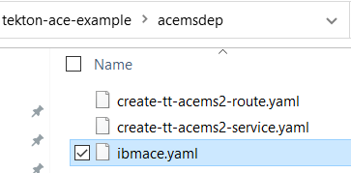

## Commands to create/replace(update)/delete artifacts in Tekton on RHOS

Use OC CREATE commands to load the tekton artifacts into your RHOS environment

resources.yaml

source-to-image-buildah.yaml

deploy-using-kubectl-common.yaml

build-and-deploy-pipeline-buildah.yaml

acems2-pipeline-buildah-run.yaml

oc create -f c:\users\DAVIDARNOLD\IBM\gitREPOS\tekton-ace-example\tekton\run\acems2-pipeline-buildah-run.yaml - this is the last command - it creates the "run" which starts the pipeline

USE OC REPLACE if you change and files

oc replace -f c:\users\DAVIDARNOLD\IBM\gitREPOS\tekton-ace-example\tekton\tasks\source-to-image-buildah.yaml

USE OC DELETE -f c:\temp\tempyaml.yaml to remove any artifacts from RHOS - use a yaml snippet in a file to identify kind: , name: and namespace: see example tempyaml.yaml below

apiVersion: tekton.dev/v1alpha1

kind: Task

metadata:

creationTimestamp: '2020-03-03T00:27:03Z'

generation: 3

name: source-to-image

namespace: da-build-project

## Creating the Service and Routes

### tt ace ms2 service

created manually at this point and not automated in the pipeline (but it could be in the same manner as the ibmace.yaml deployment config in the pipeline)

**oc create -f C:\openshift\data\create-tt-acems2-service.yaml**

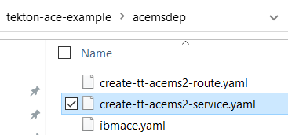

### Tekton tt ACE ms2 route

created manually at this point and not automated in the pipeline (but it could be in the same manner as the ibmace.yaml deployment config in the pipeline)

**oc create -f C:\openshift\data\create-tt-acems2-route.yaml**

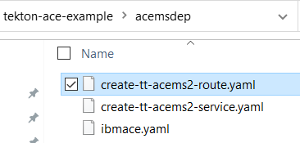

## Exploring the RHOS Tekton environment

### Tekton dashboard -resources

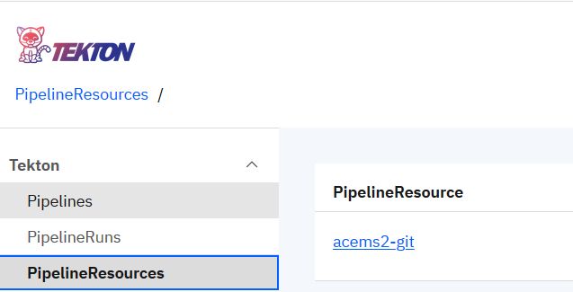

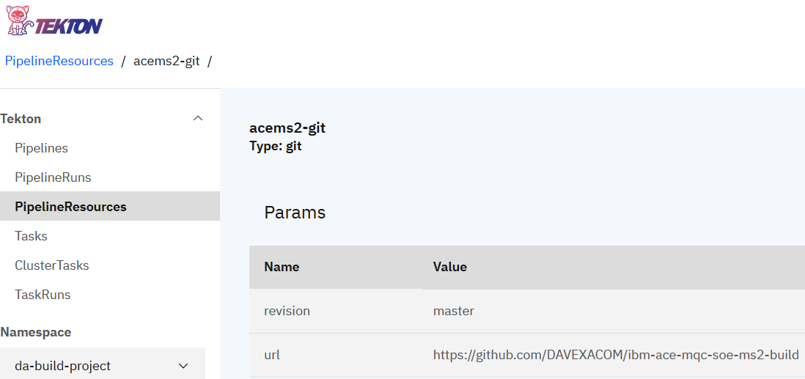

### Tekton dashboard -tasks

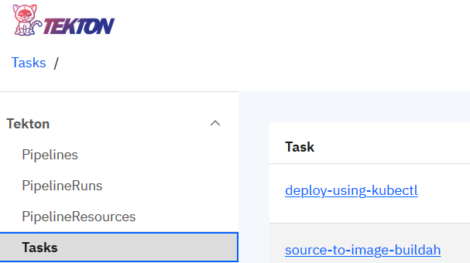

### Tekton dashboard -pipeline

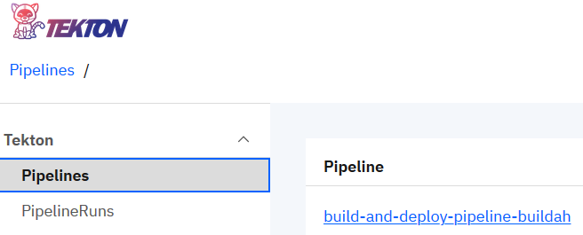

### Tekton dashboard -pipeline-run

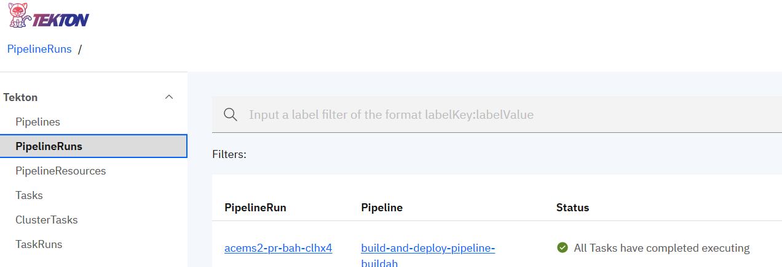

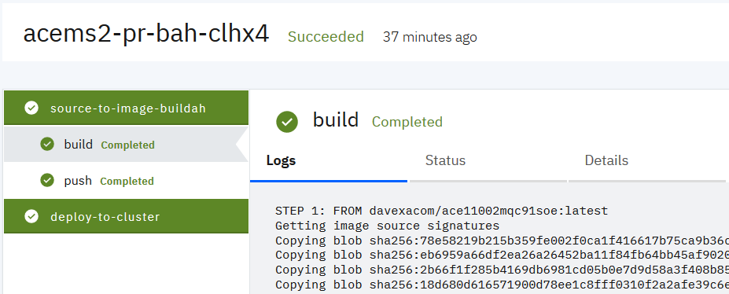

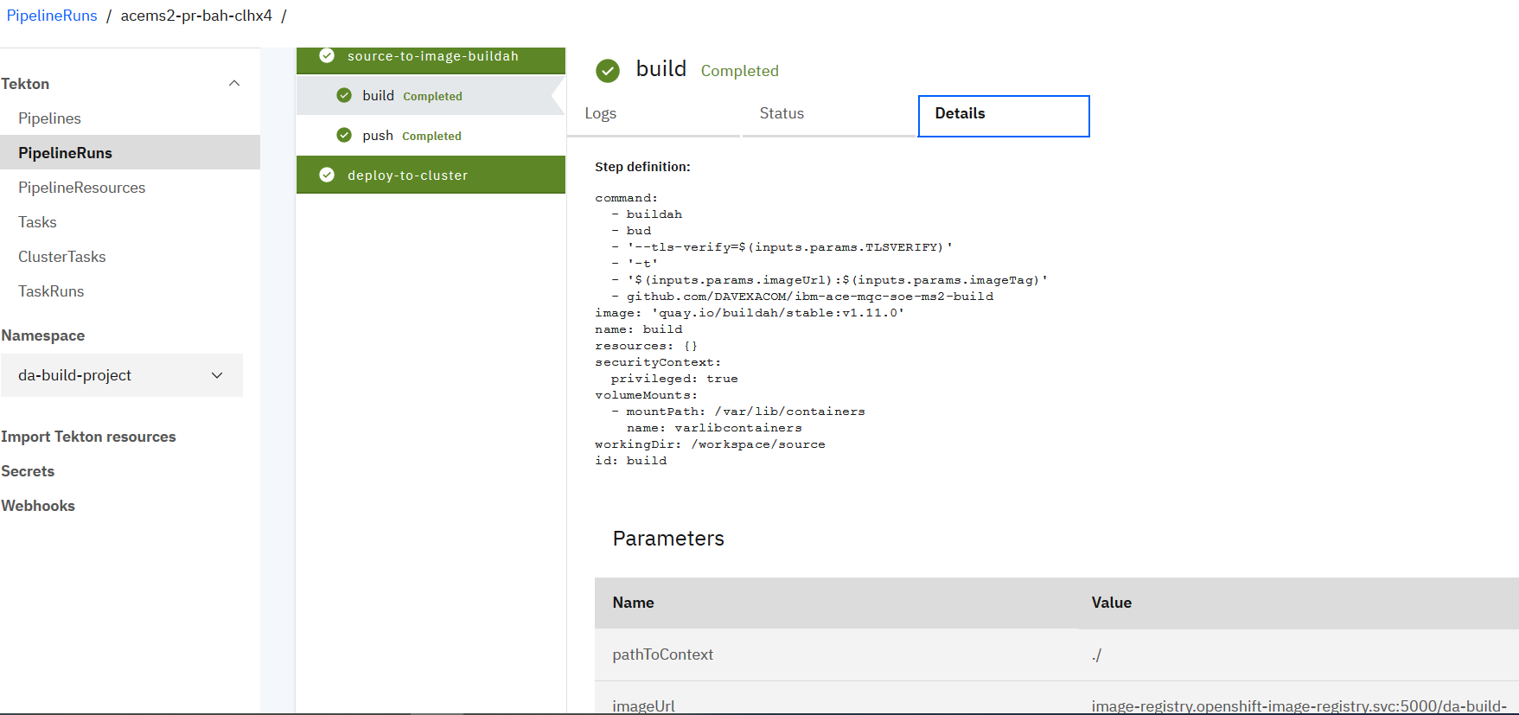

## Exploring the RHOS Console

### Service

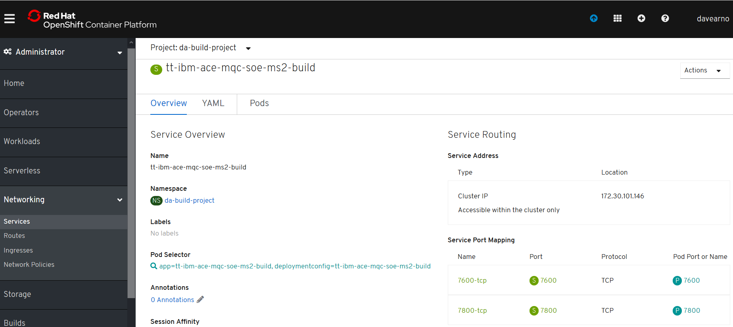

### Route

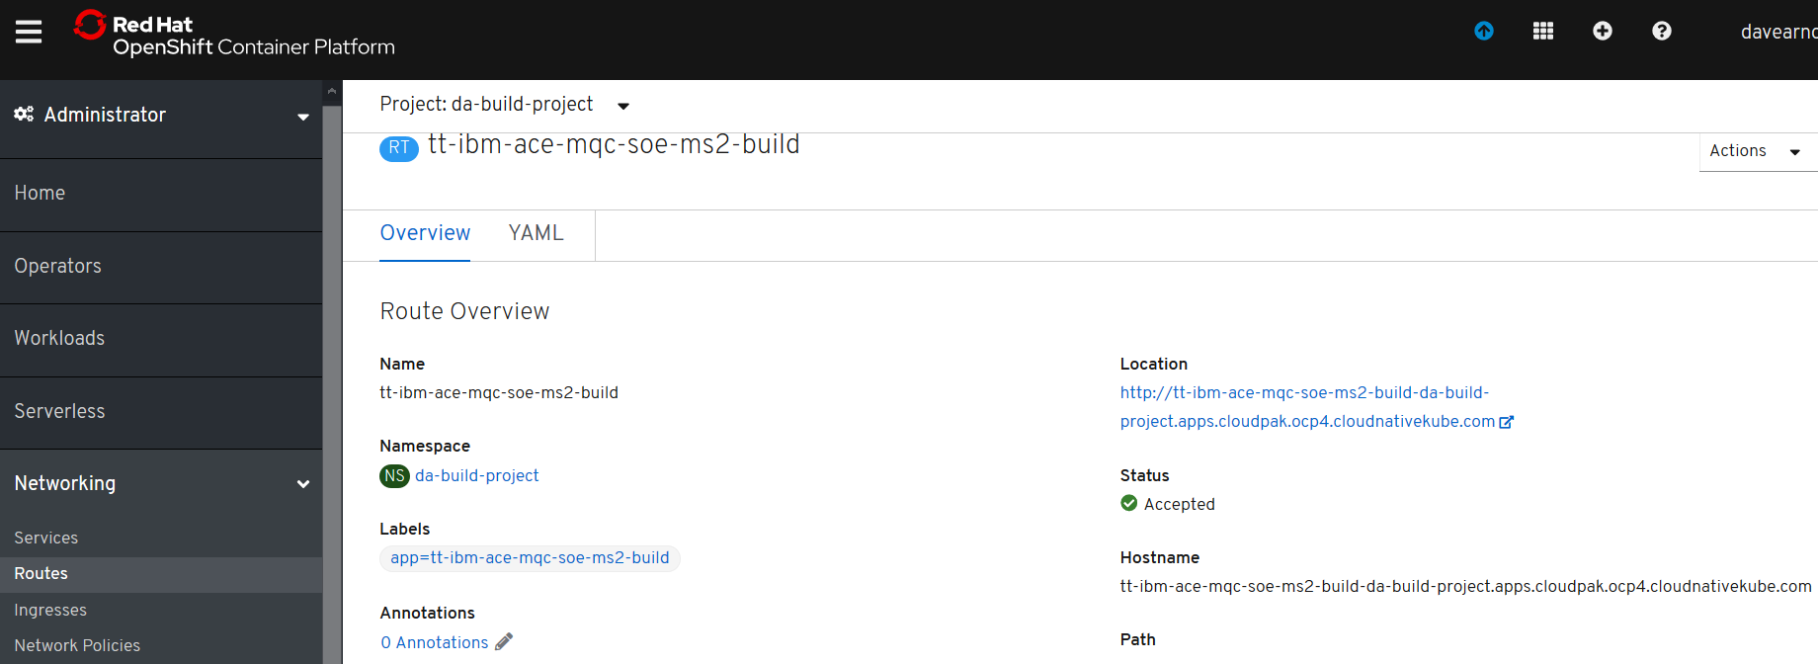

### Image Stream

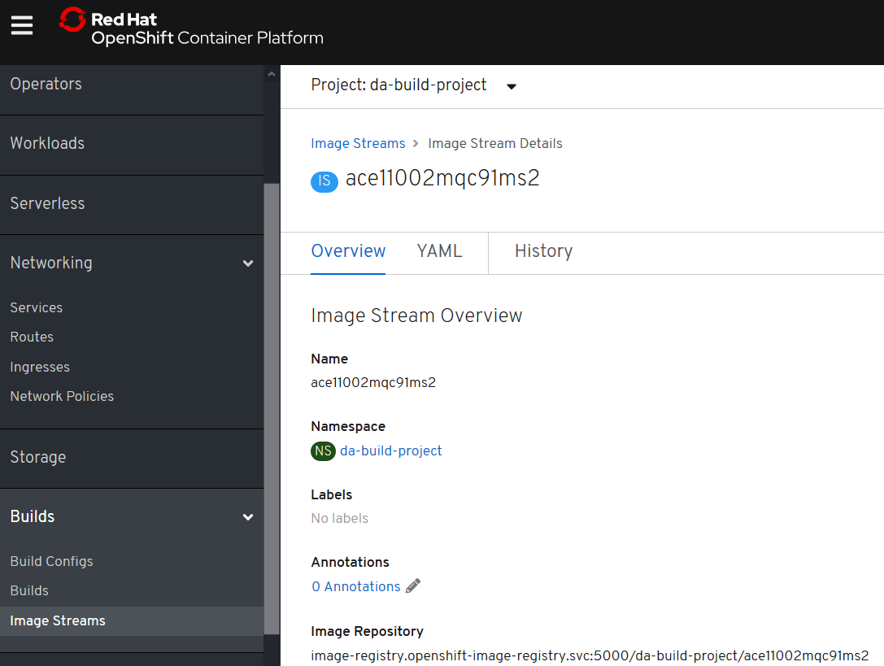

### Deployment - Config PipelineRun Created

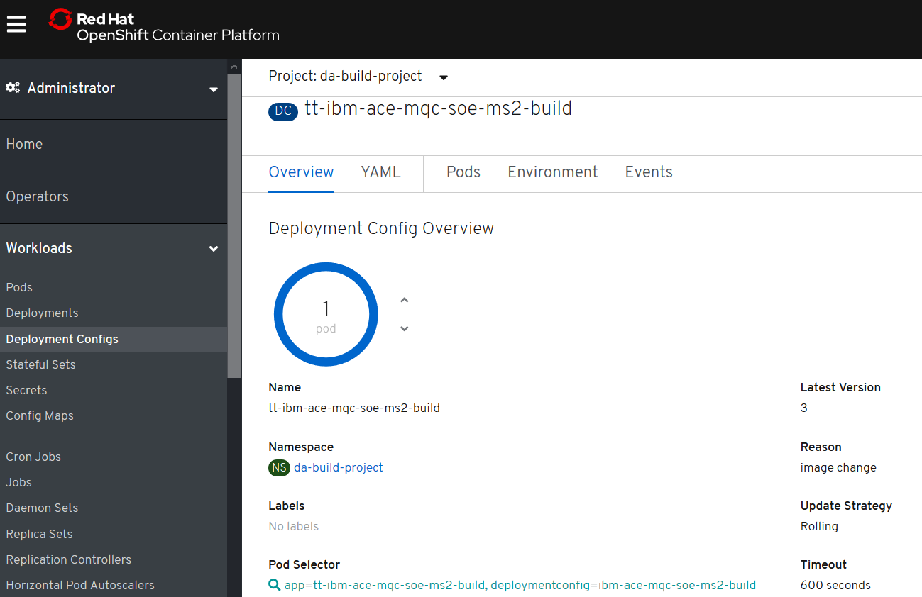

Note: Restarts the pod if the image is updated

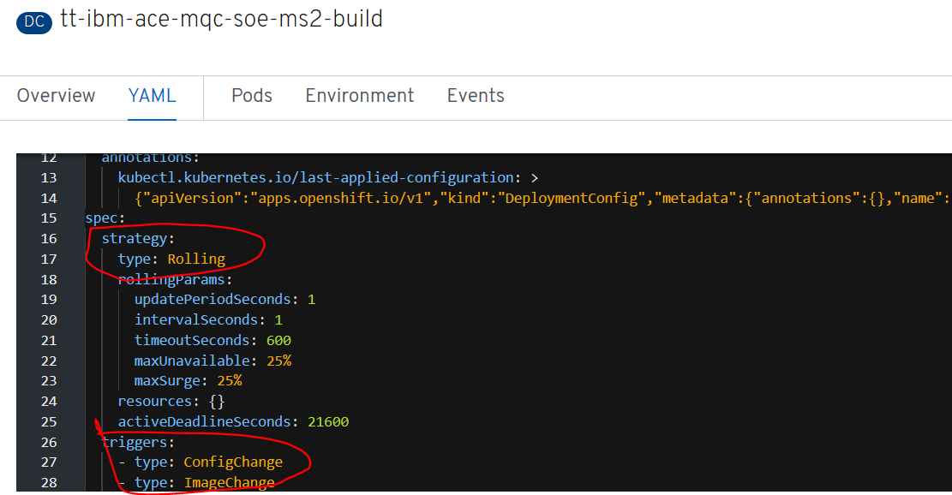

### Pod - PipelineRun Created

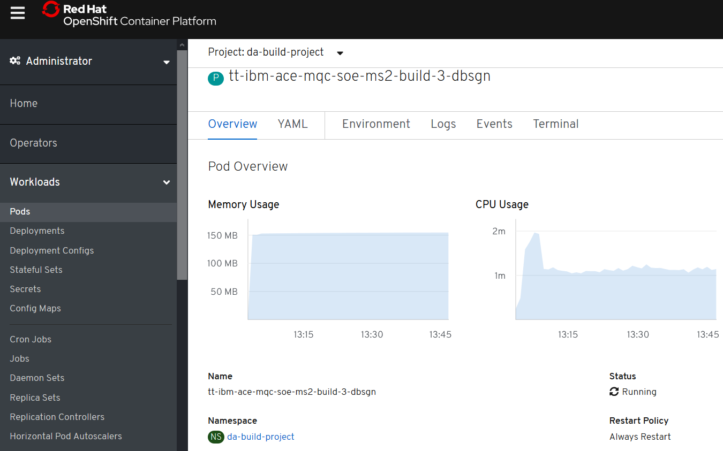

## Testing Tekton created and deployed ACE Micro Service 2

POST

http://tt-ibm-ace-mqc-soe-ms2-build-da-build-project.apps.cloudpak.ocp4.cloudnativekube.com/microservice2/v1/message

with data

{"Messages":["Hello From Test Client"]}

should return

{"Messages":["Hello From Test Client","Hello From MicroService 2 after change tekton test"]}

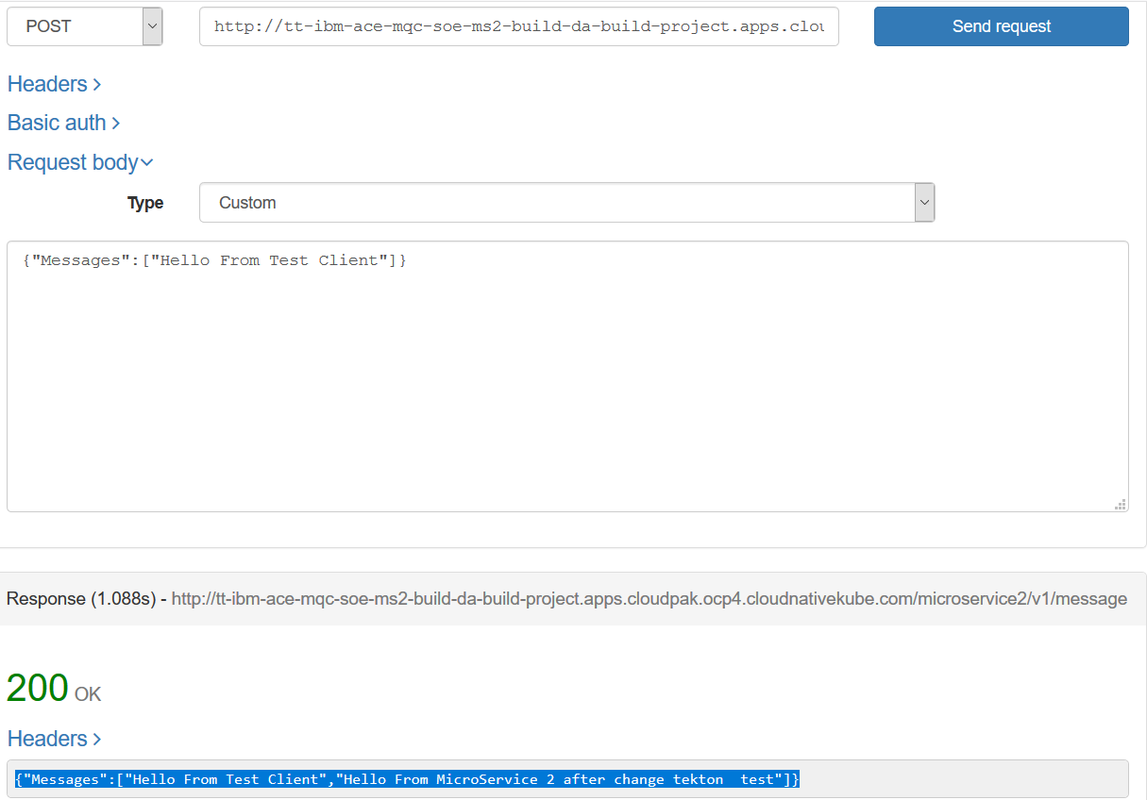

# Appendix A - Building and running MQ custom images on CodeReady on baremetal

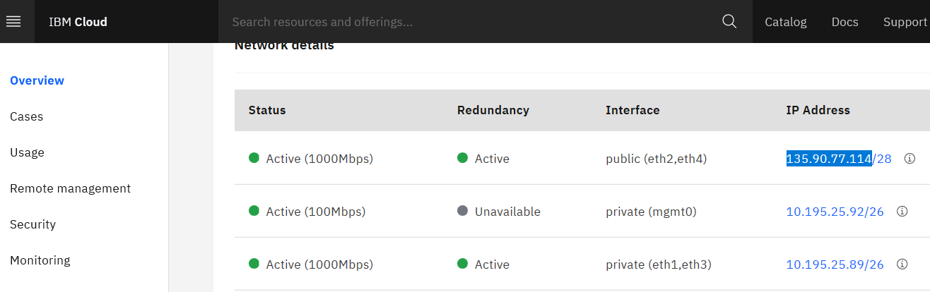

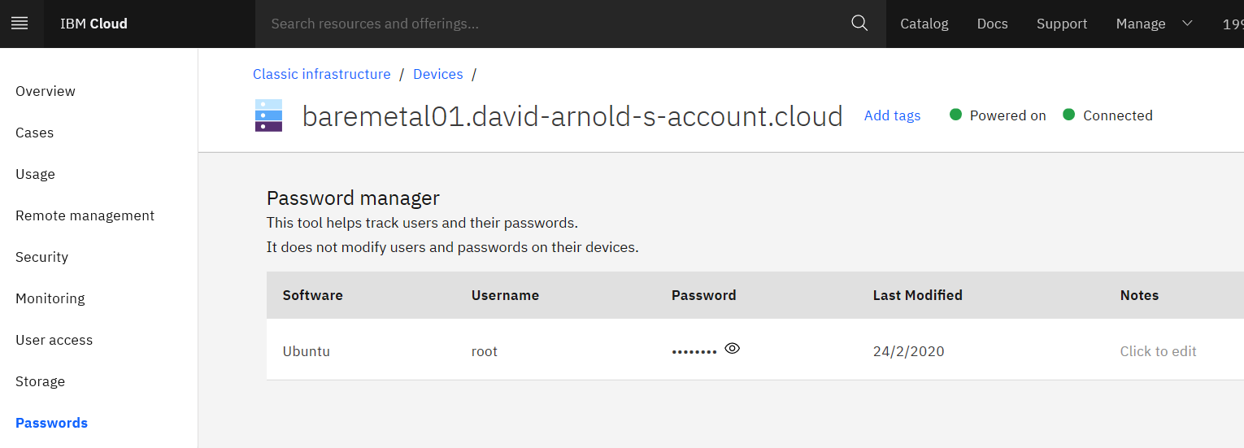

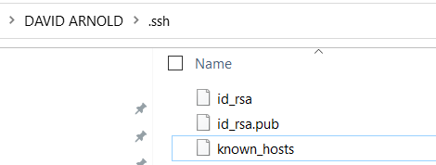

**C:\codeready>ssh root@135.90.77.114**

The authenticity of host '135.90.77.114 (135.90.77.114)' can't be established.

ECDSA key fingerprint is SHA256:0XhakkQVAWZ7fajusyvNF/m+v0mGbW/4kdAo3198uV4.

Are you sure you want to continue connecting (yes/no)? yes

Warning: Permanently added '135.90.77.114' (ECDSA) to the list of known hosts.

Password:

Welcome to Ubuntu 18.04.4 LTS (GNU/Linux 4.15.0-88-generic x86_64)

**root@baremetal01:~# useradd -d /home/arnold arnold**

**root@baremetal01:~# passwd arnold**

Enter new UNIX password:

Retype new UNIX password:

passwd: password updated successfully

(dNpengxx)

**root@baremetal01:~/crc-linux-1.6.0-amd64# useradd --help | grep directory**

-b, --base-dir BASE_DIR base directory for the home directory of the

-d, --home-dir HOME_DIR home directory of the new account

-k, --skel SKEL_DIR use this alternative skeleton directory

-m, --create-home create the user's home directory

-M, --no-create-home do not create the user's home directory

-R, --root CHROOT_DIR directory to chroot into

**root@baremetal01:~/crc-linux-1.6.0-amd64# mkdir /home/arnold**

**root@baremetal01:~/crc-linux-1.6.0-amd64# chown arnold:arnold /home/arnold/**

**root@baremetal01:~/crc-linux-1.6.0-amd64# su arnold**

**$ bash**

**arnold@baremetal01:/root/crc-linux-1.6.0-amd64$ cd ~**

**arnold@baremetal01:~$ ls**

**arnold@baremetal01:~$ pwd**

/home/arnold

## Install Git, libvirt and network-manager

**sudo apt-get install git -y** – install git

**sudo apt install qemu-kvm libvirt-daemon libvirt-daemon-system network-manager**

**root@baremetal01:~# systemctl enable network-manager**

Synchronizing state of network-manager.service with SysV service script with /lib/systemd/systemd-sysv-install.

Executing: /lib/systemd/systemd-sysv-install enable network-manager

**root@baremetal01:~# systemctl start network-manager**

**root@baremetal01:~# systemctl enable libvirtd**

Synchronizing state of libvirtd.service with SysV service script with /lib/systemd/systemd-sysv-install.

Executing: /lib/systemd/systemd-sysv-install enable libvirtd

**root@baremetal01:~# systemctl start libvirtd**

**root@baremetal01:~# wget https://mirror.openshift.com/pub/openshift-v4/clients/crc/latest/crc-linux-amd64.tar.xz**

--2020-02-24 18:54:00-- https://mirror.openshift.com/pub/openshift-v4/clients/crc/latest/crc-linux-amd64.tar.xz

Resolving mirror.openshift.com (mirror.openshift.com)... 54.172.163.83, 54.172.173.155

Connecting to mirror.openshift.com (mirror.openshift.com)|54.172.163.83|:443... connected.

HTTP request sent, awaiting response... 200 OK

Length: 1858998212 (1.7G) [application/x-xz]

Saving to: 'crc-linux-amd64.tar.xz'

crc-linux-amd64.tar.xz 0%[ ] 520.00K 187KB/s

**root@baremetal01:~# tar xf crc-linux-amd64.tar.xz**

root@baremetal01:~# ls

crc-linux-1.6.0-amd64 crc-linux-amd64.tar.xz netplanapply.log

**root@baremetal01:~# cd crc-linux-1.6.0-amd64**

root@baremetal01:~/crc-linux-1.6.0-amd64# ls

crc doc.pdf LICENSE

**root@baremetal01:~/crc-linux-1.6.0-amd64# su arnold**

**root@baremetal01:~/crc-linux-1.6.0-amd64# cp crc /home/arnold/crc**

**root@baremetal01:~/crc-linux-1.6.0-amd64# ls /home/arnold**

crc

add the user to the libvirt group

**root@baremetal01:~/crc-linux-1.6.0-amd64# sudo usermod -a -G libvirt arnold**

add user to the sudoers file

**root@baremetal01:~/crc-linux-1.6.0-amd64# usermod -aG sudo arnold**

**root@baremetal01:~/crc-linux-1.6.0-amd64# su arnold**

**$ bash**

**arnold@baremetal01:/root/crc-linux-1.6.0-amd64$ cd /home/arnold**

**arnold@baremetal01:~$ ls**

crc

**arnold@baremetal01:~$ ./crc setup**

INFO Checking if oc binary is cached

INFO Checking if CRC bundle is cached in '$HOME/.crc'

INFO Checking if running as non-root

INFO Checking if Virtualization is enabled

INFO Checking if KVM is enabled

INFO Checking if libvirt is installed

INFO Checking if user is part of libvirt group

INFO Checking if libvirt is enabled

INFO Checking if libvirt daemon is running

INFO Checking if a supported libvirt version is installed

INFO Checking if crc-driver-libvirt is installed

INFO Checking for obsolete crc-driver-libvirt

INFO Checking if libvirt 'crc' network is available

INFO Checking if libvirt 'crc' network is active

INFO Checking if NetworkManager is installed

INFO Checking if NetworkManager service is running

INFO Checking if /etc/NetworkManager/conf.d/crc-nm-dnsmasq.conf exists

INFO Writing Network Manager config for crc

INFO Will use root access: write NetworkManager config in /etc/NetworkManager/conf.d/crc-nm-dnsmasq.conf

[sudo] password for arnold:

INFO Will use root access: execute systemctl daemon-reload command

INFO Will use root access: execute systemctl stop/start command

INFO Checking if /etc/NetworkManager/dnsmasq.d/crc.conf exists

INFO Writing dnsmasq config for crc

INFO Will use root access: write dnsmasq configuration in /etc/NetworkManager/dnsmasq.d/crc.conf

INFO Will use root access: execute systemctl daemon-reload command

INFO Will use root access: execute systemctl stop/start command

Setup is complete, you can now run 'crc start' to start the OpenShift cluster

Before running the crc start command you will need the image pull secret

[**https://cloud.redhat.com/openshift/install/crc/installer-provisioned**](https://cloud.redhat.com/openshift/install/crc/installer-provisioned)

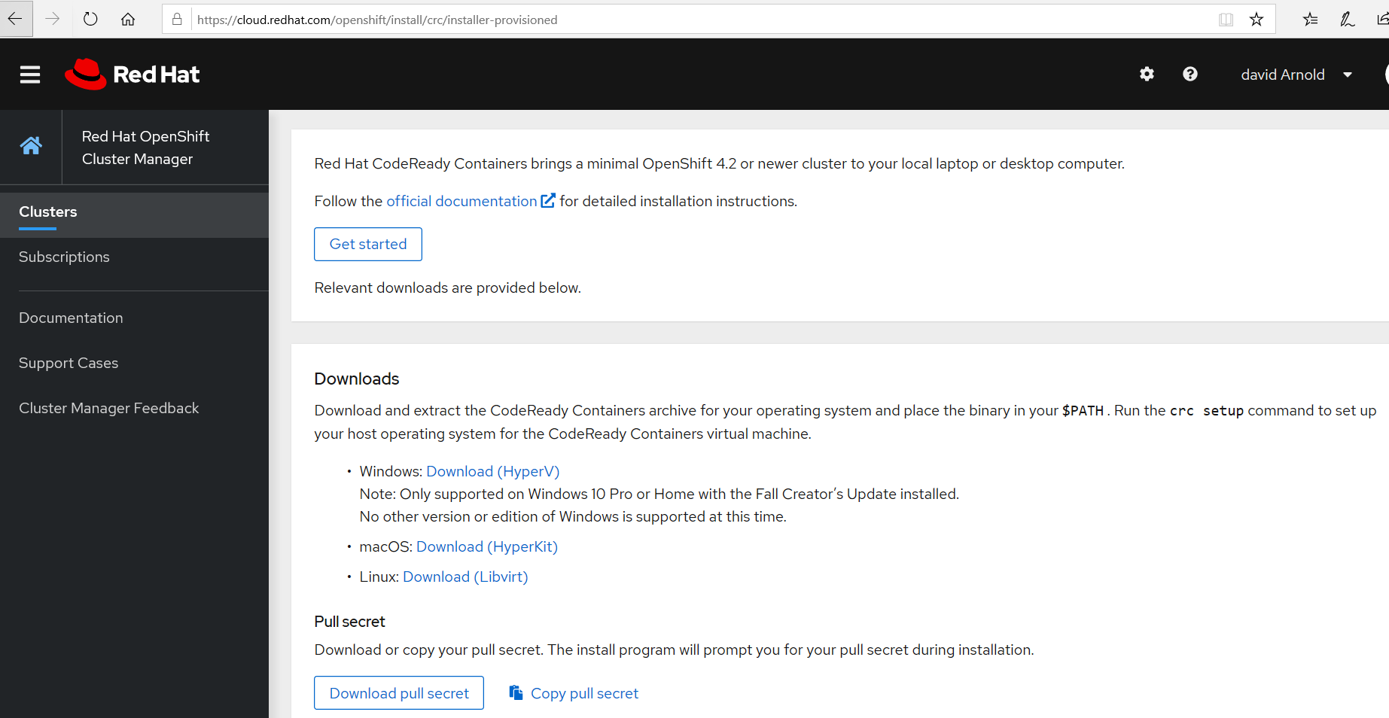

**arnold@baremetal01:~$ ./crc start**

INFO Checking if oc binary is cached

INFO Checking if running as non-root

INFO Checking if Virtualization is enabled

INFO Checking if KVM is enabled

INFO Checking if libvirt is installed

INFO Checking if user is part of libvirt group

INFO Checking if libvirt is enabled

INFO Checking if libvirt daemon is running

INFO Checking if a supported libvirt version is installed

INFO Checking if crc-driver-libvirt is installed

INFO Checking if libvirt 'crc' network is available

INFO Checking if libvirt 'crc' network is active

INFO Checking if NetworkManager is installed

INFO Checking if NetworkManager service is running

INFO Checking if /etc/NetworkManager/conf.d/crc-nm-dnsmasq.conf exists

INFO Checking if /etc/NetworkManager/dnsmasq.d/crc.conf exists

INFO Checking if /etc/NetworkManager/dnsmasq.d/crc.conf exists

? Image pull secret [? for help] ******************************************************************************************************************************************************************************

INFO Extracting bundle: crc_libvirt_4.3.0.crcbundle ...

INFO Creating CodeReady Containers VM for OpenShift 4.3.0...

INFO Verifying validity of the cluster certificates ...

INFO Check internal and public DNS query ...

WARN Failed public DNS query from the cluster: ssh command error:

command : host -R 3 quay.io

err : exit status 1

output : Host quay.io not found: 5(REFUSED)

:

INFO Check DNS query from host ...

INFO Copying kubeconfig file to instance dir ...

INFO Adding user's pull secret ...

INFO Updating cluster ID ...

INFO Starting OpenShift cluster ... [waiting 3m]

INFO

INFO To access the cluster, first set up your environment by following 'crc oc-env' instructions

INFO Then you can access it by running 'oc login -u developer -p developer https://api.crc.testing:6443'

INFO To login as an admin, run 'oc login -u kubeadmin -p 7z6T5-qmTth-oxaoD-p3xQF https://api.crc.testing:6443'

INFO

INFO You can now run 'crc console' and use these credentials to access the OpenShift web console

Started the OpenShift cluster

WARN The cluster might report a degraded or error state. This is expected since several operators have been disabled to lower the resource usage. For more information, please consult the documentation

**arnold@baremetal01:~$ ./crc status**

CRC VM: Running

OpenShift: Running (v4.3.0)

Disk Usage: 8.962GB of 32.72GB (Inside the CRC VM)

Cache Usage: 10.57GB

Cache Directory: /home/arnold/.crc/cache

**arnold@baremetal01:~$ ./crc ip**

192.168.130.11

**arnold@baremetal01:~$ ./crc oc-env**

export PATH="/home/arnold/.crc/bin:$PATH"

# Run this command to configure your shell:

# eval $(crc oc-env)

**arnold@baremetal01:~$ export PATH="/home/arnold/.crc/bin:$PATH"**

**arnold@baremetal01:~$ oc login -u kubeadmin -p 7z6T5-qmTth-oxaoD-p3xQF https://api.crc.testing:6443**

Login successful.

You have access to 54 projects,

**arnold@baremetal01:~$ oc adm policy add-scc-to-user anyuid -z default**

securitycontextconstraints.security.openshift.io/anyuid added to: ["system:serviceaccount:da-mq2:default"]

**arnold@baremetal01:~$ oc login -u developer -p developer https://api.crc.testing:6443**

The server uses a certificate signed by an unknown authority.

You can bypass the certificate check, but any data you send to the server could be intercepted by others.

Use insecure connections? (y/n): y

Login successful.

oc new-project <projectname>

**arnold@baremetal01:~$ oc new-project da-mq2**

Now using project "da-mq2" on server "https://api.crc.testing:6443".

You can add applications to this project with the 'new-app' command. For example, try:

oc new-app ruby~https://github.com/sclorg/ruby-ex.git

to build a new example application in Python. Or use kubectl to deploy a simple Kubernetes application:

kubectl create deployment hello-node --image=gcr.io/hello-minikube-zero-install/hello-node

## YAML for base image Image Stream creation

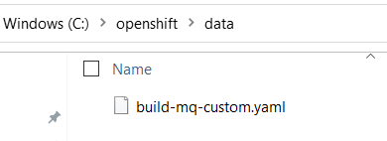

apiVersion: v1

kind: ImageStream

metadata:

name: ibm-mqadvanced-server-integration

spec:

tags:

- name: "9.1.3.0-r4-amd64"

from:

kind: DockerImage

name: davexacom/ibm-mqadvanced-server-integration:9.1.3.0-r4-amd64

**C:\openshift\data>scp build-mq-custom.yaml arnold@135.90.77.114:/home/arnold**

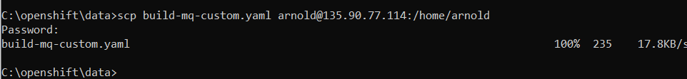

**arnold@baremetal01:~$ ls**

build-mq-custom.yaml crc

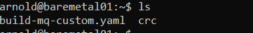

**arnold@baremetal01:~$ oc create -f build-mq-custom.yaml**

imagestream.image.openshift.io/ibm-mqadvanced-server-integration create



**arnold@baremetal01:~$ oc get imagestreams**



**arnold@baremetal01:~$ oc get is**

**arnold@baremetal01:~$ oc describe imagestream ibm-mqadvanced-server-integration**

Name: ibm-mqadvanced-server-integration

Namespace: da-mq2

Created: 2 minutes ago

Labels: <none>

Annotations: openshift.io/image.dockerRepositoryCheck=2020-02-25T02:50:24Z

Image Repository: default-route-openshift-image-registry.apps-crc.testing/da-mq2/ibm-mqadvanced-server-integration

Image Lookup: local=false

Unique Images: 0

Tags: 1

9.1.3.0-r4-amd64

tagged from davexacom/ibm-mqadvanced-server-integration:9.1.3.0-r4-amd64

! error: Import failed (InternalError): Internal error occurred: docker.io/davexacom/ibm-mqadvanced-server-integration:9.1.3.0-r4-amd64: Get https://registry-1.docker.io/v2/: dial tcp: lookup registry-1.docker.io on 172.30.0.10:53: server misbehaving

2 minutes ago

**arnold@baremetal01:~$ ping registry-1.docker.io**

ping: registry-1.docker.io: Temporary failure in name resolution

## Set up resolv.conf, hosts and dasmasq to allow networking

**sudo nano /etc/resolv.conf**

**sudo nano /etc/hosts**

**arnold@baremetal01:~$ cat /etc/resolv.conf**

# Generated by NetworkManager

nameserver 127.0.1.1

nameserver 8.8.8.8

nameserver 8.8.4.4

**arnold@baremetal01:~$ cat /etc/hosts**

127.0.0.1 localhost

127.0.1.1 ubuntu

34.237.62.81 docker.io

# The following lines are desirable for IPv6 capable hosts

::1 localhost ip6-localhost ip6-loopback

ff02::1 ip6-allnodes

ff02::2 ip6-allrouters

135.90.77.114 baremetal01.david-arnold-s-account.cloud baremetal01 debauto

**arnold@baremetal01:/var/lib/libvirt/dnsmasq$ sudo nano default.conf**

##WARNING: THIS IS AN AUTO-GENERATED FILE. CHANGES TO IT ARE LIKELY TO BE

##OVERWRITTEN AND LOST. Changes to this configuration should be made using:

## virsh net-edit default

## or other application using the libvirt API.

##

## dnsmasq conf file created by libvirt

strict-order

user=libvirt-dnsmasq

pid-file=/var/run/libvirt/network/default.pid

except-interface=lo

bind-dynamic

interface=virbr0

dhcp-range=192.168.122.2,192.168.122.254

dhcp-no-override

dhcp-authoritative

dhcp-lease-max=253

dhcp-hostsfile=/var/lib/libvirt/dnsmasq/default.hostsfile

addn-hosts=/var/lib/libvirt/dnsmasq/default.addnhosts

server=8.8.8.8

server=8.8.4.4

**arnold@baremetal01:~$ oc delete is ibm-mqadvanced-server-integration**

## Create Image Stream for MQ base image

**arnold@baremetal01:~$ oc create -f build-mq-custom.yaml**

imagestream.image.openshift.io/ibm-mqadvanced-server-integration created

**arnold@baremetal01:~$ oc get is**

**NAME IMAGE REPOSITORY TAGS UPDATED**

**ibm-mqadvanced-server-integration default-route-openshift-image-registry.apps-crc.testing/da-mq2/ibm-mqadvanced-server-integration 9.1.3.0-r4-amd64 7 seconds ago**

**arnold@baremetal01:~$ oc describe is**

Name: ibm-mqadvanced-server-integration

Namespace: da-mq2

Created: 20 seconds ago

Labels: <none>

Annotations: openshift.io/image.dockerRepositoryCheck=2020-02-25T03:18:30Z

Image Repository: default-route-openshift-image-registry.apps-crc.testing/da-mq2/ibm-mqadvanced-server-integration

Image Lookup: local=false

Unique Images: 1

Tags: 1

9.1.3.0-r4-amd64

tagged from davexacom/ibm-mqadvanced-server-integration:9.1.3.0-r4-amd64

* davexacom/ibm-mqadvanced-server-integration@sha256:0cd8142e68ae76a84b06540fd93caf9f964045dbd35c6d0c7efb309e29f2bbb0

16 seconds ago

## Create new build to build custom MQ image from base image

**arnold@baremetal01:~$ oc new-build https://github.com/DAVEXACOM/ibm-mqadvanced-server-tls-build.git**

--> Found image ee41039 (3 months old) in image stream "da-mq2/ibm-mqadvanced-server-integration" under tag "9.1.3.0-r4-amd64" for "ibm-mqadvanced-server-integration:9.1.3.0-r4-amd64"

IBM MQ Advanced Server

----------------------

Simplify, accelerate and facilitate the reliable exchange of data with a security-rich messaging solution — trusted by the world’s most successful enterprises

Tags: mq messaging

* A Docker build using source code from https://github.com/DAVEXACOM/ibm-mqadvanced-server-tls-build.git will be created

* The resulting image will be pushed to image stream tag "ibm-mqadvanced-server-tls-build:latest"

* Use 'oc start-build' to trigger a new build

--> Creating resources with label build=ibm-mqadvanced-server-tls-build ...

imagestream.image.openshift.io "ibm-mqadvanced-server-tls-build" created

buildconfig.build.openshift.io "ibm-mqadvanced-server-tls-build" created

--> Success

**arnold@baremetal01:~$ oc get builds**

NAME TYPE FROM STATUS STARTED DURATION

ibm-mqadvanced-server-tls-build-1 Docker Git@90f1c2a Complete 35 minutes ago 3m1s

## Create new app to run the custom MQ image as a container

**arnold@baremetal01:~$ oc new-app ibm-mqadvanced-server-tls-build --env LICENSE=accept**

--> Found image f166447 (51 minutes old) in image stream "da-mq2/ibm-mqadvanced-server-tls-build" under tag "latest" for "ibm-mqadvanced-server-tls-build"

IBM MQ Advanced Server

----------------------

Simplify, accelerate and facilitate the reliable exchange of data with a security-rich messaging solution — trusted by the world’s most successful enterprises

Tags: mq messaging

* This image will be deployed in deployment config "ibm-mqadvanced-server-tls-build"

* Ports 1414/tcp, 9157/tcp, 9443/tcp will be load balanced by service "ibm-mqadvanced-server-tls-build"

* Other containers can access this service through the hostname "ibm-mqadvanced-server-tls-build"

--> Creating resources ...

deploymentconfig.apps.openshift.io "ibm-mqadvanced-server-tls-build" created

service "ibm-mqadvanced-server-tls-build" created

--> Success

Application is not exposed. You can expose services to the outside world by executing one or more of the commands below:

'oc expose svc/ibm-mqadvanced-server-tls-build'

Run 'oc status' to view your app.

**arnold@baremetal01:~$ oc expose svc/ibm-mqadvanced-server-tls-build**

route.route.openshift.io/ibm-mqadvanced-server-tls-build exposed





kind: Route

apiVersion: route.openshift.io/v1

metadata:

name: tls-tlsprqm1p

namespace: da-mq

labels:

app: ibm-mqadvanced-server-tls-build

spec:

host: tlsprqm12e-svrconn.chl.mq.ibm.com

subdomain: ''

to:

kind: Service

name: ibm-mqadvanced-server-tls-build

weight: 100

port:

targetPort: 1414-tcp

tls:

termination: passthrough

wildcardPolicy: None

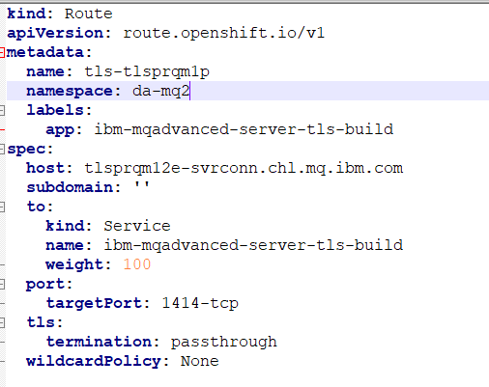

C:\openshift\data>scp create-mq-route.yaml [arnold@135.90.77.114:/home/arnold](mailto:arnold@135.90.77.114:/home/arnold)

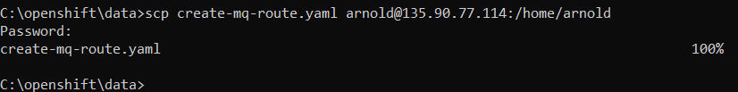

**arnold@baremetal01:~$ oc create -f create-mq-route.yaml**

route.route.openshift.io/tls-tlsprqm1p created

**arnold@baremetal01:~$ oc get routes**

NAME HOST/PORT PATH SERVICES PORT TERMINATION WILDCARD

ibm-mqadvanced-server-tls-build ibm-mqadvanced-server-tls-build-da-mq2.apps-crc.testing ibm-mqadvanced-server-tls-build 1414-tcp None

tls-tlsprqm1p tlsprqm12e-svrconn.chl.mq.ibm.com ibm-mqadvanced-server-tls-build 1414-tcp passthrough None

## Logging in CodeReady on BareMetal in a new session

**C:\Users\DAVIDARNOLD>ssh root@135.90.77.114**

Password:

Welcome to Ubuntu 18.04.4 LTS (GNU/Linux 4.15.0-88-generic x86_64)

Last login: Mon Feb 24 17:24:35 2020 from 202.81.18.30

**root@baremetal01:~# su arnold**

**$ bash**

**arnold@baremetal01:/root$ cd /home/arnold**

**arnold@baremetal01:~$ ./crc status**

CRC VM: Running

OpenShift: Running (v4.3.0)

Disk Usage: 14.74GB of 32.72GB (Inside the CRC VM)

Cache Usage: 10.57GB

Cache Directory: /home/arnold/.crc/cache

**arnold@baremetal01:~$./crc oc-env**

export PATH="/home/arnold/.crc/bin:$PATH"

# Run this command to configure your shell:

# eval $(crc oc-env)

**arnold@baremetal01:~$ export PATH="/home/arnold/.crc/bin:$PATH"**

**arnold@baremetal01:~$ oc login -u kubeadmin -p 7z6T5-qmTth-oxaoD-p3xQF https://api.crc.testing:6443**

**arnold@baremetal01:~$ oc adm policy add-scc-to-user anyuid -z default**

securitycontextconstraints.security.openshift.io/anyuid added to: ["system:serviceaccount:da-mq2:default"]

**arnold@baremetal01:~$ oc login -u developer -p developer https://api.crc.testing:6443**